2008青海省中考英语试题
英 语本试卷满分1 20分，答题时间1 20分钟。
I．听力测试(共四大题，每大题5分，满分20分)
A．听句子，选择正确的应答语。每句读两遍。(每小题1分，计5分)
1. A. A radio. B. A fridge. C. A washing machine.
2. A. For half an hour. B. In 2003. C. About 300 metres.
3. A. I hope so. B. Thanks a lot. C. I think so.
4. A. Yes,he is. B. No,he isn't. C. He's a waiter.
5. A. I'm sorry to hear that. B. Oh,I know. C. It doesn't matter.
B．听对话，根据内容和问题提示，选择正确图画。对话读一遍。(每小题1分，计5分)
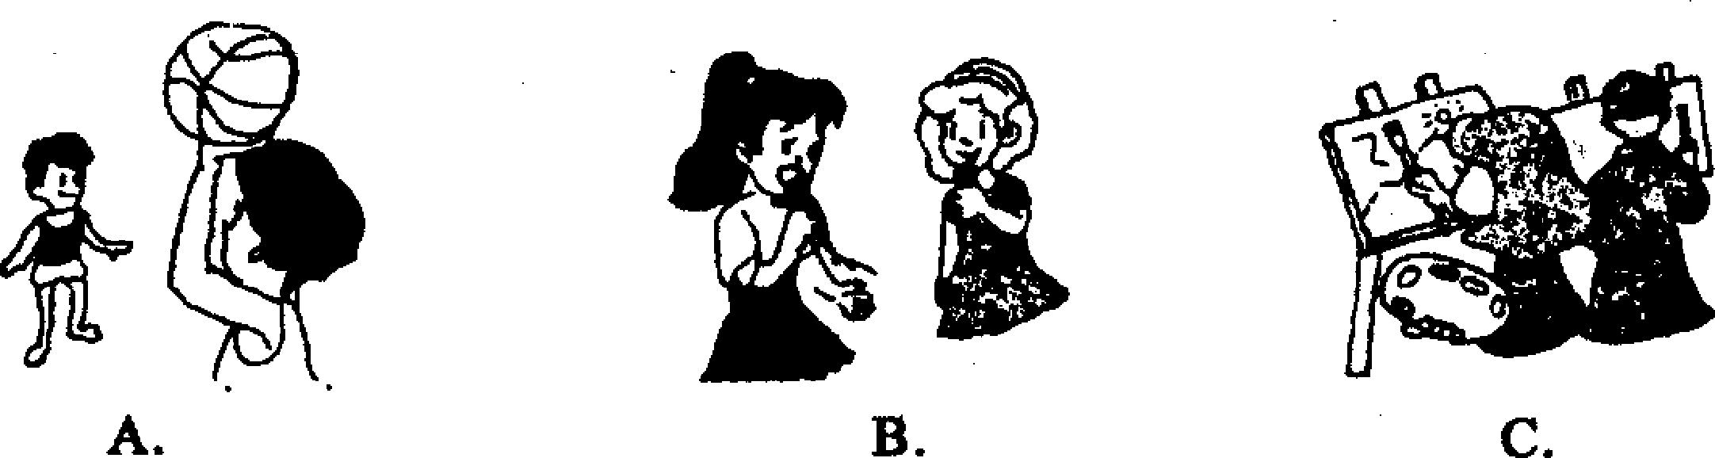
6. What are the children doing?
.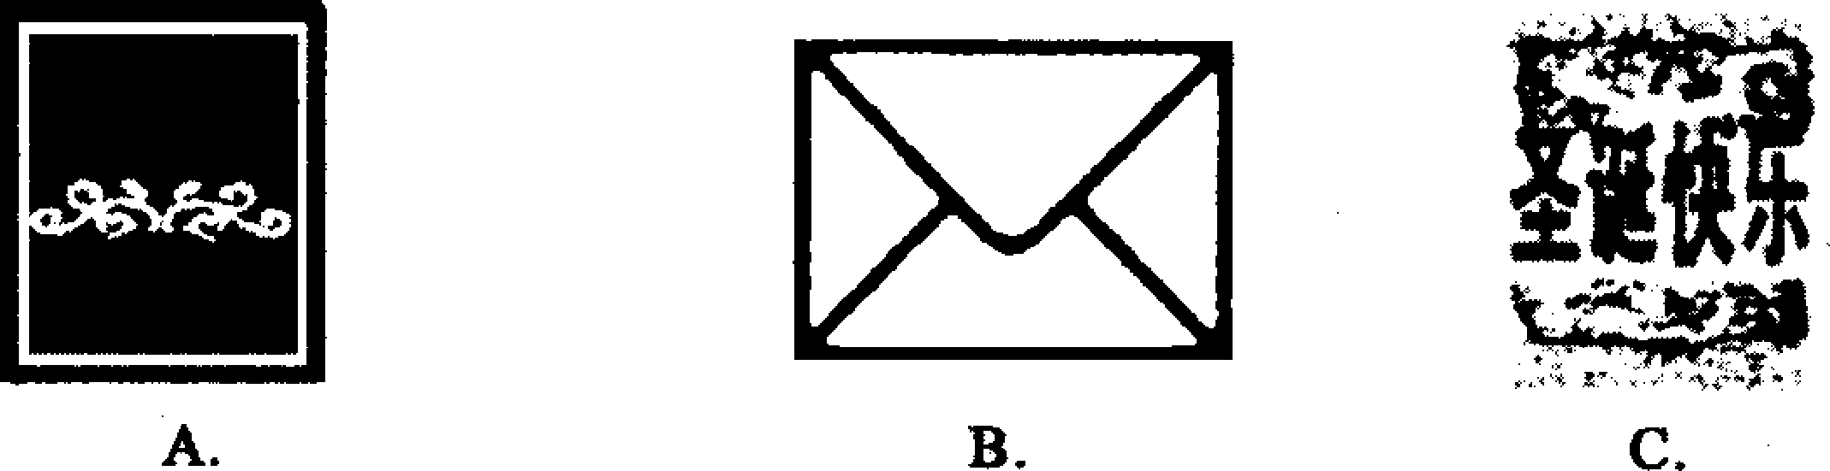
7. What has the man got from his wife?
.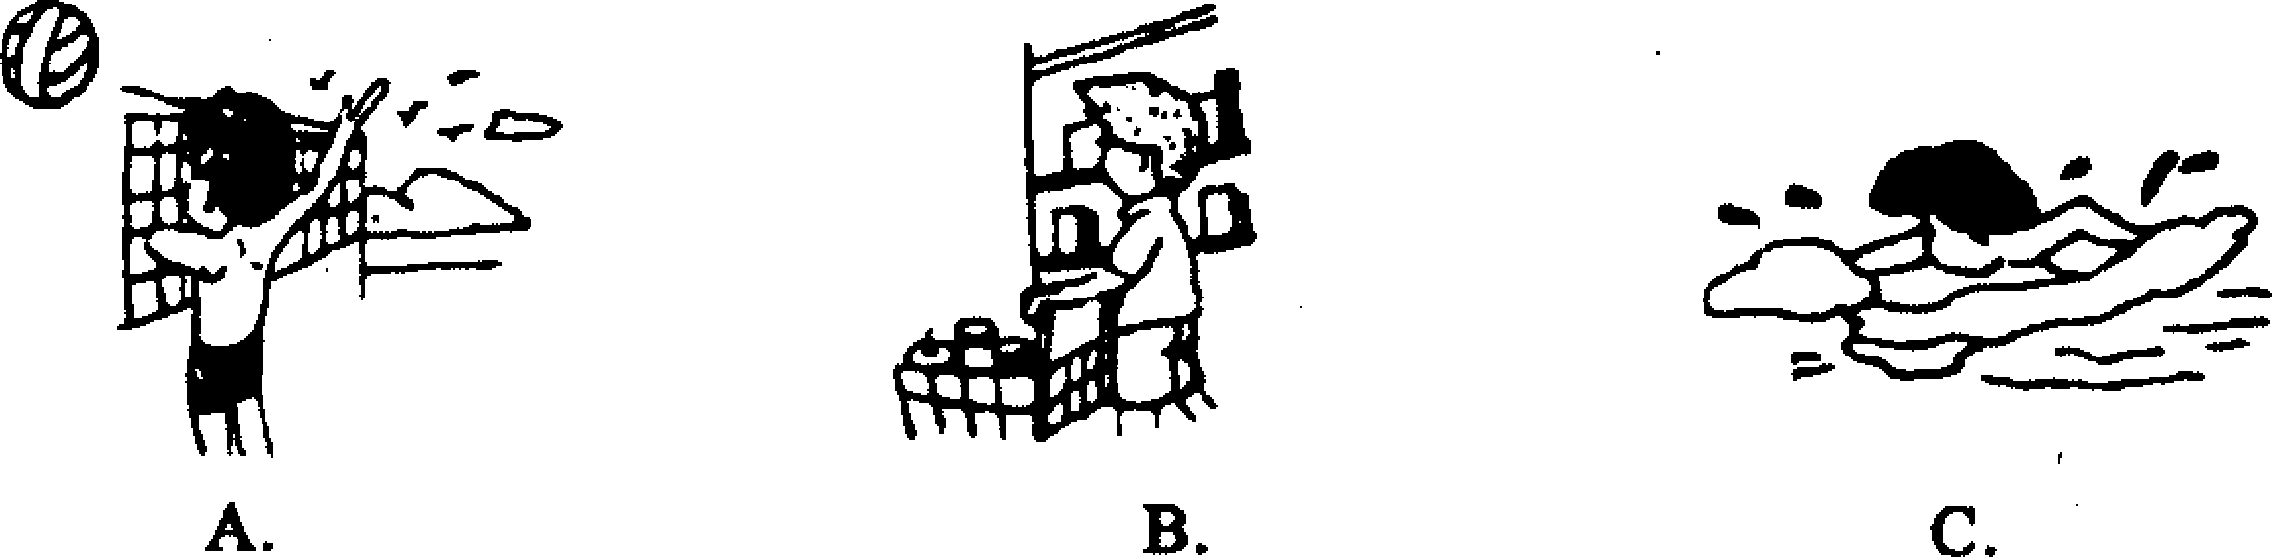
8. What would Tom like to do?
.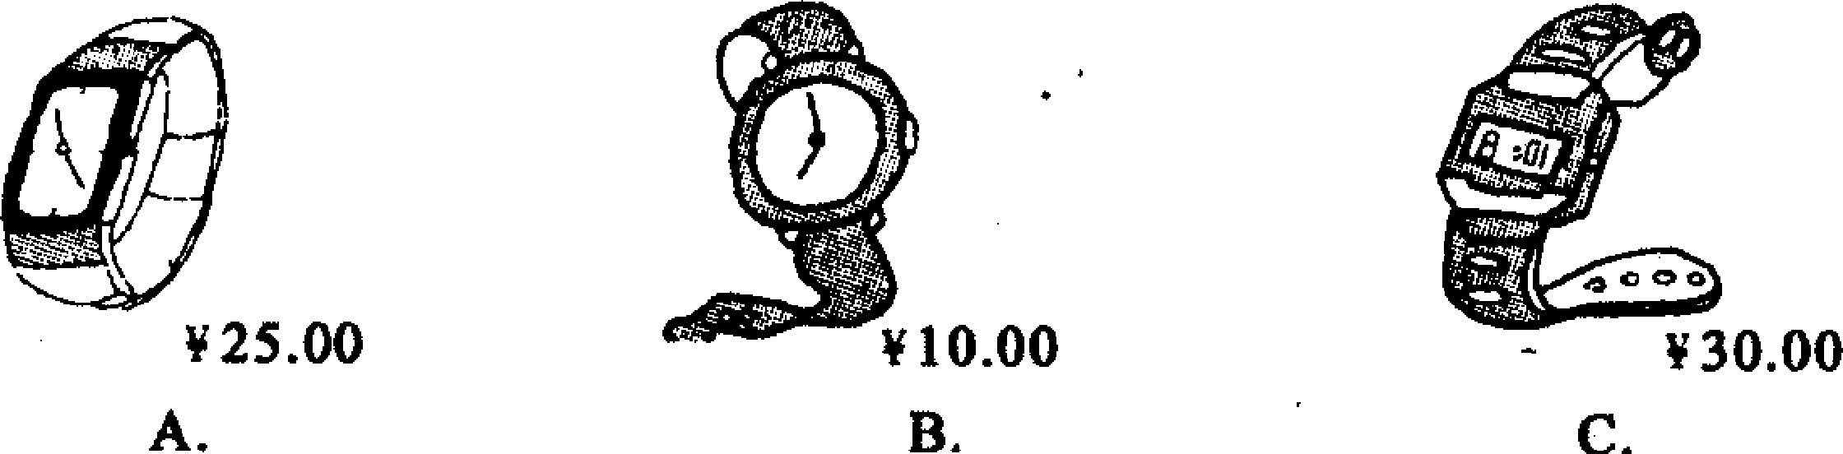
9. How much is Betty's watch?
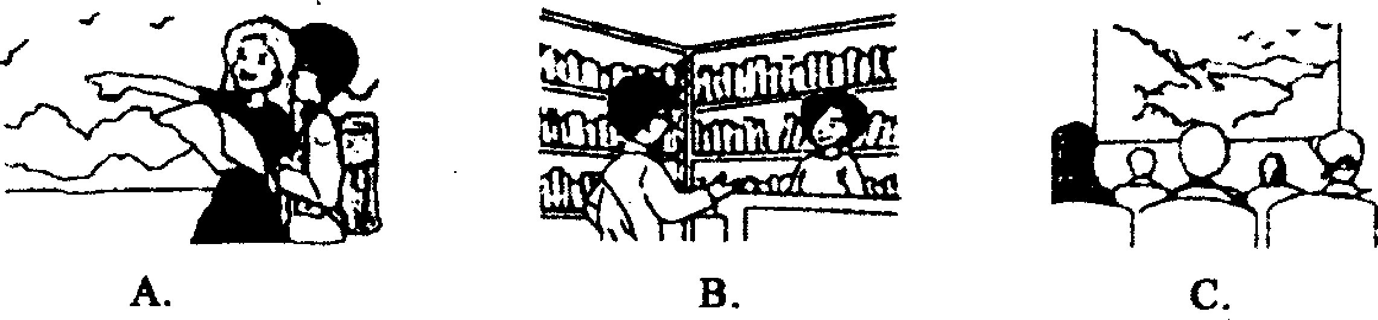
10. Where's the man now?
C．听短文，判断句子的正(T)误(F)。短文读两遍。(每小题1分，计5分)
11. Mrs Green was crying because someone had picked her flowers.
12. Her neighbour's daughter picked her flowers.
13. The girl's grandfather was ill in bed.
14. The girl needed money to pay for medicine.
15. We can see that Mrs Green is very kind.
D．听对话，完成下面的表格。对话读三遍。(每小题1分，计5分)
Instructions for the trip
Leaving Xining, Qinghai Arriving in Beijing
Date: ________ 16 Time:__________19
Time:__________17 Returning to Qinghai
Flight No:_________18 Date.__________20
16.________ 17.________ 18.________ 19. _______ 20.
Ⅱ．单项选择(共1 5小题，每小题1分，满分1 5分)
从A、B、C三个选项中选出一个可以填入空白处的最佳答案。
21. He gave my sister________useful book yesterday.
A. an B. a C. X
22. I will meet my best friend________the morning of May 1st.
A. in B. on C. at
23.—Oh, there's someone in the room.
—________must be my brother.
A. He B.This C.It
24. The story is hard to understand________there are no new words in it.
A. but B. so C. though
25. —What do you think of her spoken English? —Oh, no one speaks________.
A. better B. well C. best
26. Could you tell me________?
A. When will Mary come back B. When Mary comes back
C. When Mary will come back
27. —Must I finish the work today?
—No, you_______. You________finish it tomorrow.
A. mustn't;must B. needn't;may C. can't;may
28. —Linda,pass my glasses to me,please. I can ______ read the words in the newspaper.
—With pleasure.
A. hardly B. nearly C. clearly
29.—Oh, your skirt looks beautiful!
A. Don't say that B. Thank you C. I don't think so
30. —Will you come on Monday or Tuesday?
—I'm afraid________day is possible. I'll be busy next week.
A. either B. neither C. both
31. He________our school for two weeks..
A. left B. has left C. has been away from
32. We are not sure if it ________ tomorrow. If it ________, our sports meeting
will be put off.
A. will rain;rains B. rains; will rain C. will rain; will rain
33. If you still have any other questions,please________your hands.
A. put up B. put down C. put on
34. —How do you like your Chinese teacher?
A. Yes, I like him very much B. He is very kind
C. I enjoy his class
35. —Do you mind my smoking here?
—________. Look at the sign. It says,"No smoking".
A. Of course not B. No, I don't C. You'd better not
Ⅲ．完形填空(共10小题，每小题1分，满分10分)
阅读短文，从A、B、C、D四个选项中找出一个正确的选项填空，使短文完整、通顺。
Billy is a boy of fifteen. His parents died three years ago. One day when he
was walking in the street» he 36 a wallet. He returned it to the owner, Mr Baker. He gave his 37 to the boy. As the boy had no job, Mr Baker made him work for him in his 38 . Billy worked so hard that Mr and Mrs Baker were 39 with him.
Mr Baker loved planting 40 . The week before last, he brought a few trees home, planted them in the 41 himself and watered them every day. Several days 42 , he had to leave for another city. Before he started, he said to Billy, "Take good care of these trees. Some boys near our house always want to steal them. ""Don't 43 about them, sir. "answered Billy, "I'll try my best to watch them. "Six days passed and Mr Baker came back. He asked, " 44 anyone ever come to steal the trees?""No» sir. "said Billy. "To stop someone from stealing the trees, I 45 them up six days ago. I have hidden ( 藏) them for almost a week!"
36. A. bought B. found C. carried D. wanted
37. A. wallet B. pity C. thanks D. excuses
38. A. office B. factory C. town D. home
39. A. pleased B. angry C. bored D. sad
40. A. grass B. flowers C. vegetables D. trees
41. A. garden B. office C. city D. room
42. A. ago B. later C. before D. after
43. A. think B. talk . C. learn D. worry
44. A. Did B. Does C. Has D. Will
45. A. sent B. pulled C. put D. picked F.
Ⅳ．阅读理解(共三节1 5小题，每小题2分，满分3 O分)
A
阅读下面短文，从每题A、B、C、D四个选项中选出最佳答案。
One day a poor man was cutting a big piece of wood near a river. Suddenly his old axe(斧子)fell into the water. He felt very sad because he lost his only axe. Then all at once a beautiful fairy(仙女)came out and asked the man what was the . matter.
"I have lost my axe, "he said. "It fell into the water when I was cutting the wood. "
The fairy showed him a gold(金)axe and asked, "Is this yours?"
"No，"said the man.
The fairy then showed him a silver(银)axe and asked again,"Is this yours?"
"No,"again answered the man.
Then she showed him the old axe.
"Yes, that is mine,"called out the happy man.
"I know it well enough," said the fairy, "I only wanted to see if you would tell me the truth, and now I'll give you the gold axe and the silver axe besides your own one. "
46. One day when the man was cutting something,________.
A. he fell into the water B. his axe dropped into the river
C. his axe fell into a lake D. he saw a beautiful fairy
47. The man was sad because________.
A. he was poor and had no other axes
B. he could not go on working
C. he liked his axe very much
D. his axe was a gold axe
48. The fairy gave him a gold axe and a silver axe, but he didn't take them. Because he________.
A. did not like them
B. did not know they were made of gold and silver
C. was very rich
D. knew these axes were not his
49. At the end of the story the man had________.
A. only one axe B. two axes C. three axes D, many axes
50. The fairy helped the man because he was________man.
A. an old B. a young C. a poor D. an honest(诚实的)
B
下面是一张戏票，请你仔细阅读，然后判断所给句子，正确的写“T’’，错误的写“F’’。
Paulie Theatre
Name of the show : Soul of dance
Date: 19 :30,March 2
Number:16,Row 9,1st F
Price: ¥80
★Children below 1. 2M are not allowed to enter the theatre. Children above 1. 2M should enter with tickets only.
★tPlease.check the date and seat number when you buy your ticket. Once the ticket has been sold out,there is no refund(退票).
★No smoking in the theatre. Dangerous things are not allowed in the theatre. Sometimes a security (安全) check is necessary.
★The use of cameras, videos and tape recorders are not allowed in the theatre.
★Please turn off your beepers(传呼机) , mobile phones or set them to vibration mode(振动模式).
★Please check your seat number and be seated before the performance begins. If you arrive after the show begins, please wait outside the performance hall, enter quietly into the hall during the interval (幕间休息) and take a free seat.
51.I can get my ticket refunded if I'm not pleased with my seat.
52. Sometimes there are security checks before people enter the theatre.
53. It's not allowed to leave my mobile phone on while I am watching the show.
54. If I arrive after the show begins, I should hurry to my seat. 55.I can take photos in the theatre if I like.
C
阅读下面短文，根据短文内容完成下列各题。(每空1词)
We each have a memory. That's why we can remember things after a long time. Some people have a very good memory and they can easily learn many things by heart, but some people can only remember things when they say or do them again and again.
A good memory helps one learn a language well. Everybody learns his own language when he is a small child. He hears the sounds, remembers them and then he learns to speak. Some children are living with their parents in foreign countries. They can learn two languages easily because they hear, remember and speak the two languages every day. In school it is not easy to learn a foreign language because the students have little time for it and they have to learn other subjects,too.
Our memory can get better and better if we do more and more exercises. Do you want to learn a foreign language well? If so, you must do a lot of listening and speaking.
56. We can remember things after a ________ time because we each have a _______.
57. A man with a________memory can learn many________ by heart.
58. If a child often hears, remembers and________ two languages every day he or
she can________these languages easily.
59. At school,it is not easy for the________to learn a foreign language well because they have ________ time for it and they have to learn other subjects, too.
60. If we want to learn a foreign language well, we must ________ a lot of ________and speaking.
56. ________ ________ 57. ________ ________
58, ________ ________ 59. ________ ________.
60. ________________
V．补全对话(共5小题，每小题1分，满分5分)
根据下面的情景内容，从所给的选项中选出最佳答案。
A:Good morning. 61
B: Yes,please. I'd like to buy a tie for my father.
A:62______
B;Blue. My father likes blue best. A: How about this one?
B:Oh, it's very nice. 63______
A;50 yuan.
B:That's too expensive, I can't afford it. 64______
A: Yes. This light blue one is only 30 yuan.
B;Well,this one looks very good. And the price is OK. 65______
A. How much is it? B. I'll take it.
C. What colour do you want? D. Do you have a cheaper one?
E. What about the yellow one? F. Can I help you?
Ⅵ．词汇知识(共10小题，每小题1分，满分10分)
A)根据句意及所给的首字母，英语释义或汉语提示写出正确的单词。
66. You can look up the word in the d________if you don't know it.
67. Don't________(fail to remember)to call me when you get there.
68. Mobile phones are________(流行的，普遍的)in the modern world.
69. Don't________water. Can't you see the sign "Save Water"?
70. They won the basketball match yesterday. The________was 5 : 3.
B)用所给词的适当形式填空。
71. We are very________(surprise)at the news.
72. Several_________(foreign) visited our school yesterday.
73. Doctors often tell us________(drink)more water every day.
74..The boss left his office________(angry)without saying a word.
75. We will have the meeting on the________(twelve)floor.
66. ________ 67. ________ 68. ________ 69. ________ 70. ________
71. ________ 72. ________ 73. ________ 74. _._______ 75. ________
Ⅶ．改写句子(共5小题，每空一词，每小题2分，满分10分)
76. He writes to his mother once a month. (对画线部分提问) ________________does he write to his mother?
77. It is exciting news. (改为感叹句) ________________news it is!
78. Mike broke the window yesterday. (改为被动语态) The window__________by Mike yesterday.
79. I go to school on foot every day. (改写为同义句) I__________school every day.
80.1 don't know French,she doesn't know French,either.( 改写为同义句) ________she________I know French.
76._________________77.______________ 78._________________
79._________________80._________________
Ⅶ．补全短文(共5小题，每小题1分，满分5分)
根据已给出的首字母补全短文，每空一词。
Someone asks w____81 we learn English in China. Because it is one of the
world's m____82 important languages and it is also widely used in the modern
world. If you travel all over the world, you'll find English everywhere. It's widely used for business between different countries. And three quarters of the world's books and newspapers are w____83 in English. If you know English, you can enjoy so many good books. It's really a bridge to so much knowledge.
So we must do more listening ，speaking, r ____84 and writing. If you work
hard on English, it's not d____85 to learn it well.
81. ________ 82. ________ 83. ________ 84. ________ 85. ________
Ⅸ．书面表达(共两节，A节5分，B节10分，满分1 5分)
A)假定你叫王丽，三年的初中学习生活即将结束．你能用英语写出几句对老师表达感谢和祝福的话语吗?
要求：1．不少于四句；2．不要使用真实姓名、校名、地名等，否则不得分。
Dear Miss/Mr Li，
B)假定你是初三(1)班的李霞，你五月十四日晚上在阅览室里丢失了一个绿色书包，内有两本英语书，一个铅笔盒，一个MP3及自行车钥匙。你非常着急。
请你根据以上提示，用英语写出一则5 O词左右的寻物启事。
Found

青海省答案
1.B 2. C 3.B 4.C 5.. A 6.,C 7.C 8. A 9. A 10. B 11. T 12. F 13. F 14. T 15. T
16. September 30 17.14:45 18. CA694 19.16:50 20. October 7
21. B 22. B 23. C 24. C 25. A 26. C 27. B 28. A 29. B 30. B 31.C 32. A 33. A 34. B 35. C 36.B 37.C 38. D 39. A 40. D 41. A 42. B 43. D 44.C 45. B 46. B 47. A 48. D 49. C 50. D
51. F 52. T 53. F 54. F 55. F 56. long;memory 57. good;things 58. speaks ;learn 59. students;little 60. do;listening 61. F 62. C 63. A 64. D 65. B 66. dictionary 67. forget 68. popular 69. waste
70. sc ore 71. surprised 72. foreigners 73. to drink 74. angrily
75. tw elfth 76. How often 77. What exciting 78. was broken 79. walk to
80. Ne ither.. . nor 81. why 82. most 83. written 84. reading 85. difficult
A) A possible version: Dear Miss/Mr Li,
Thank you for teaching us so well. You're so kind to me. I'll never forget you. Wish you happy,healthy and young for ever. Every thing goes well. Best wishes!
From Wang Li
B) A possible version:
Found
I left a green school bag in the reading-room on the evening of May 14. There are two English books, a pencil-box, an MP3 player and the key to the bike in it. Now I'm very worried about it. Will the finder return it to Li Xia of Class 1, Grade 3? Thanks a lot!

天仁英语教师资源交流网

