湖北黄冈罗田县第一中学2008年自主招生考试英语试题
本卷满分为120分 考试时间 100 分钟
- 单项选择（共25题，总分25分）
- — Excuse me , is this seat taken ?
--- __________. That man got his books and left a few minutes ago .
A I’m afraid so B I don’t think so C. I don’t know . D. I hope not.
2. --- __________ is the population of your city ?
--- About two million.
A. How B What C. How many D. How much
3. ---- What about the color of the shirt ?
---- oh , ________ I don’t like it.
A. that’s beautiful B. it’s ok C. that’s too bright D. that’s all right.
4. Would you mind ________ the door ?
A. I closing B. to close C. me closing D. my close
5. ----- Have all the students know that our class will visit the factory this afternoon.
----- Yes , Every student ________ about it.
A. have told B. have been told C. has told D. has been told
6. How long ______ the film _____ when you got there ?
A. has ,begun B. had, begun C. has , been on D. had, been on
7.______ exciting news ! We’re never had _______ long vacation before.
A. What, such a B. What an , such a C. How , such a D. What ,so a
8. ______ the bad weather , the swimming match had been put off.
A, Because B. Thanks to C. With the help of D. For
9. ---- I wonder if it _____ tomorrow.
---- Don’t worry, if it _______ , we’ll stay at home.
A. rains, rains B. will rain ,rains C. rains , will rain D. will rain, will rain
10. I couldn’t agree with ________ at the meeting .
A. that you said B. which you said C. all what you said D. what you said
11. --- Mum , could you buy me a dress like this ?
--- certainly, we can buy _____ one than this , but _____ this.
A. a better, better than B. a worse , as good as
C. a cheaper , as good as D. a more important , not as good as
12. Since you’re ____ danger, why not ask ______ help?
A. in, for B. in, to C. with , for D. with, to
13 --- Shall we go skating tomorrow ?
---- _________.
A. you’re all right B. It’s very kind of you C. You are right D. That’s a good idea
14. Jenny gave us _____ on how to improve English .
A. some advices B. many advices C. some advice D. an advice
15. ______ China is ______ old country with _____ long history.
A. /,an, a B. The , an , a C. / , an, the D. / , the , a
16. Why not _______ Tom _______ his English.
A. help, improve B. to help, improve C. help, improving D. to help, improving
17. --- Must I five the dictionary back to the library now ?
---- No, You _______. You can ______ it for another two weeks.
A. needn’t ,know B. needn’t , keep C. mustn’t , lend D. mustn’t , keep
18 He is wearing his sunglasses to _____ himself from the sun.
A. prevent B. stop C. keep D. protect
19 Look , the teacher as well as all his students _______ playing games on the playground.
A are B. is C. has been D. have been
20. ---- Ann has made great progress recently .
---- ______ and _______.
A. So has she , so have you B. So has she , so you have
C. So she has , so you have D. so she has , so have you.
21 There used to be a church here , ______ ?
A. don’t there B. used not there C. didn’t there D. didn’t it
22. The digital camera cost ______ that I didn’t buy it.
A. so much B. so little C. such much D. such little
23. ---- Who taught _______ French ?
----- Nobody , she learned all by ______.
A. herself, her B. she , herself C. her , herself D. her ,she
24. Mick , your T-shirt has _____, why don’t you buy a new one ?
A. worn out B. broken out C. sold out D. run out
25 You need friends to _____ , or we will feel ________.
A. chat, alone B. chat with , lonely C. speak, lonely D. talk with, alone
第二节 单词拼写 （根据句意和首字母提示完成单词，共15小题，满分15分）
26 --- Has he ever a__________ at the party?
--- Yes , I saw him last night .
27. We all regard it as an i____________（鼓舞） for us to continue our trip on foot.
28, The local ___________ (政府) has take actions to call on people to plant trees.
29. Zhongguancun is home to many _________(海外的) Chinese .
30. The m_________ （神秘的）stone which can predict typhoon(预测台风) attract many people’s attention.
31. E—mail English is s_________（应该） to be used on mobile phones.
32. _________(逐渐地), the wind died down and everything became worse.
33. After he pulled the two boys out of water, he felt e__________.（精疲力竭的）
34. This kind of camera is p________ in an American factory.
35. The prisoners a________ （企图）to escape , but failed..
第三节:完形填空(共20小题，满分20分)
阅读下面短文，掌握其大意，然后从36—55各题的四个选项（A、B、C和D）中，选出可以填入空白处的最佳选项。

A little boy invited his mother to attend his school’s first teacher-parent meeting. To the little boy’s ____36___ ,she said she would go. This ____37 __ be the first time that his classmates and teacher ___38 ___ his mother and he felt ashamed of her __ 39 . Although she was a beautiful woman, there was a scar(疤痕)that __ 40 __ nearly the right side of her face. The boy never wanted to __41 __ why or how she got the scar.
At the meeting, the people were __ 42 __ by the kindness and natural beauty of his mother in spite of the scar, but the little boy was still __43__and hid himself from everyone, __44 __ a conversation between his mother and __ 45__.
The teacher asked __46 __ ,“How did you get the scar on your face?”
The mother answered,“__ 47 __ my son was a baby, he was in a room that caught fire. Everyone was __48 _ afraid to go in because the fire was __ 49__ ，so I went in. As I was running toward his bed, I saw a piece of wood coming down and I placed myself over him trying to protect him. I was knocked senseless but __ 50 __ , a fireman came in and saved both of us.” She touched（摸着） the __ 51__ side of her face. “This scar will be ___52___,but to this day, I have never __ 53 what I did.”
At this point, the little boy came out running toward his mother with tears in his eyes. He held her mother in his arms and __54 __ a great sense of the sacrifice(牺牲)that his mother had made for him. He held her hand tightly for the ___ _55 __of the day.
36. A. enjoyment B. disappointment C. surprise D. excitement
37 .A. would B. could C. should D. must
38. A. noticed B. greeted C. accepted D. met
39 .A. look B. appearance C. clothes D. smile
40. A. included B. passed C. covered D. decorated
41. A. talk about B. think about C. care about D. hear about
42. A. impressed B. surprised C. excited D. comforted
43. A. surprised B. sad C. happy D. embarrassed(尴尬)
44. A. listening to B. looking at C. hearing D. watching
45. A. understanding B. the parents C. the teacher D. his classmates
46. A. carefully B. seriously C. nervously D. anxiously（焦急的）
47. A. As B. When C. Since D. While
48. A. so B. much C. quite D. too
49. A. out of control B. under control C. in control D. over control
50. A. surely B. hopefully C. luckily D. unluckily
51. A left B. crying C. wiped D. burned
52. A. ugly B. lasting (持久的) C. serious D. frightening
53. A. forgot B. recognized C. considered D. regretted
54. A. felt B. realized C. enjoyed D. told
55. A. others B. other C. rest D. following
第四节 阅读理解 （共20小题，满分40分）
A
Any mistake made in the printing of a stamp raises its value to stamp collectors. A mistake on one inexpensive postage stamp has made the stamp worth a million and a half times its original value. The mistake was made more than a hundred years ago in the British colony of Mauritius, a small island in the Indian Ocean. In 1847 an order for stamps was sent to a London printer -----Mauritius was to become the fourth country in the world to issue（发行） stamps.
Before the order was filled and delivered, a ball was planned at Mauritius’ Government House, and stamps were needed to send out the invitations. A local printer was instructed to copy the design for the stamps. He accidentally printed the words “Post Office” instead of “Post Paid” on the several hundred stamps.
Today there are only twenty-six of these misprinted stamps left fourteen One Penny Orange-Reds and twelve Two Penny Blues. Because of the Two Penny Blue’s rareness and age, collectors have paid as much as ＄16 ,800 for it.
56.Over a century ago, Mauritius ________.
A. was an independent country B. belonged to India
C. was one of the British colonies D. was a small island in the Pacific Ocean
57. The mistake on the stamps was made ________.
A .in Mauritius B. at Mauritius Government House
C. in a post office D. in London
58. Stamp collectors have paid ＄16， 800 for ________.
A. fourteen One Penny Orange-Reds B. twelve Two Penny Blues
C. one One Penny Orange-Red D. one Two Penny Blue

B
WHY IS THE SUN IMPORTANT？
The sun is a huge, hot, bright star. It is important because without it there would be no life on Earth. The sun gives us light and heat.
All living things need light and heat from the sun to live. Plants need light and heat to grow. They use the light from the sun to make food. We cannot make our own food, but plants can. All the food we eat comes from plants in a food chain(链)which starts with the sun. For example,

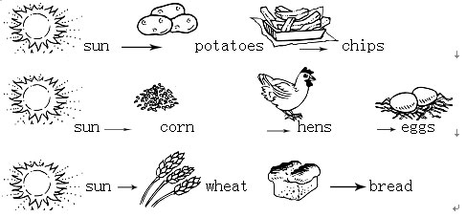
Animals need sunlight, too. Just like us, their food comes from a food chain which begins with the sun and the plants.
sun→ leaf→ caterpillar(毛虫)→bird
sun→ seaweed(海藻)→small fish→ whale(鲸)
Sunlight means we can see during the day. If there was no sun, it would be dark all the time. Even when the sky is cloudy, the sunlight is very strong and it shines through the clouds.
59.Which words tell us what the sun is like？
A. Huge.(大的) B. Hot. C. Bright. D. All above.
60.What are the two main things the sun gives us？
A. Light and heat. B. Heat and eggs. C. Corn and light. D. Wheat and bread.
61.Why can we still see during the day when the sky is cloudy？
A. Because we can see all day and all night.
B. Because the sun can't give us light all day long.
C. Because the sunlight can shine through the clouds.
D. Because we can't see at night.
62. All the food we eat comes from ______. And it starts with the _____.
A. plants; earth B. a food chain; sun
C. food; sun D. plants; star
63. In what way do you think the sun cannot be harmful(有害的)？
A. The sun can do harm to your eyes and skin.
B. It can make rivers too dry.
C. Without it there would be no life on Earth.
D. Hot sun on dry land can cause fires.
C
“How can I learn English well?” This is a question many students ask. In my opinion, the most effective way is to learn lessons by heart. If you can recite the text and write it out, you’ve learned it fairly well. And if you can tell, in your own words, what the lesson says you’re a very successful learner indeed. Your English will be quite perfect.
This is a difficult task. However, if you try to learn by heart only part of each lesson, you’ll find it not half so hard as you might have thought. Learning this way, you will make rapid progress. Of course, writing is also necessary. It helps you a lot on our way to success in English.
Equally important is to feel the language. You should be able to laugh at jokes and be shocked at bad news. When using English, try to forget your mother tongue, instead of helping you, your own language gets in your way. So, never try to see English through translation.
64. In the writer’s opinion, the most effective way in learning English is ____.
A. to practise speaking, writing and feeling it
B. to forget your own native language
C. to translate everything into his own language
D. to memorize the English words and grammatical rules
65. “Instead of helping you, your own language gets in your way.” This sentence means that memorizing your own language can ________.
A. help you to study English well B. stop you learning English well
C. make English easy to learn D. help you notice mistakes
66. Equally important is to feel the language. “to feel the language” here means________.
A. to get a knowledge of English by touching
B. to be able to read and write English
C. to translate English into your own by imagining
D. to be able to understand and enjoy the language

D
Festival activities programme （节日活动）
TIME AND PLACE
October 24——30
at Kerry Centre Hotel
Classroom area
1) English Taster Lesson
2) Food health-keeping method presentation Computer area
3) E-Photography and TechnoMusic
4) Education Software Demonstration
Internet Training area
SINA and Capital On- Line will provide Internet training for the public. The focus(焦点) will be on browsing the Internet; how to find useful information on the web and how to design an easy Web page.
Foyer activity area
5) The students from Beijing TV University for the Aged will provide a calligraphy (a kind of writing show)
6) Children activities
Lectures
21st Century, the educational weekly of China Daily, will invite experts from English- speaking countries to hold lectures from 18:30 to 20:30 on October 27 to 29 and in the daytime on October 30.
67. A 70 -year- old teacher wants to see how to use writing brush well, he should go to ________.
A. Classroom area B. Computer area
C. Internet Training area D. Foyer Activity area
68. A person who is interested in internet can go to ____________.
A. Computer area at 9 .m. Oct. 30 B. Internet Training area at 11 a. m. Oct. 24
C. Classroom area at 8:00 p. M. Oct. 26 D. Lectures at 9:00 p. m. Oct. 29
69. The students of English Department（英语系） have a chance to learn English at __________.
A. 9:00—9:45 a .m. Oct. 27 B. 15:00—15:45 Oct. 30
C. 17:15—18:00 Oct. 28 D. 12:00—12:45 Oct. 25
70. The word "browsing" in the passage probably means ____________.
A. smelling everywhere B. going here and there
C. listening everywhere D. reading here and there

E
It was at least two months before Christmas when nine-year-old Almie Rose told her father and me that she wanted a new bicycle. As Christmas drew nearer, her desire for a bicycle seemed to fade（消退）, or so we thought. We bought her a lovely doll, and a doll house. Then, much to our surprise, on December 23rd, she said that she “really wanted a bike more than anything else.” But it was just too late. With such a lot of preparations to do for the Christmas dinner we did not have the time to buy our little girl a bike. So, here we were Christmas Eve around 9:00 p.m., with Almie and her six-year-old brother, Dylan, sleeping in their beds. Now we could only think of the bicycle and the disappointment of our child. “What if I make a little bicycle out of clay (泥) and write a note that she could trade（交易，交换 ） the clay bike in for a real bike?” her dad asked. So he spent the next four hours making a tiny clay bike. On Christmas morning, we were excited for Almie to open the little gift box with the beautiful red and white clay bike and the note. Finally, she opened it and read the note aloud. “Does this mean that I can trade in this bike that Daddy made me for a real one?” I said, “Yes.” Almie had tears in her eyes when she replied, “I could never trade in this beautiful bicycle that Daddy made me. I'd rather keep this than get a real bike.” At that moment, we would have moved heaven and earth to buy her every bicycle in the world!

71Choose the right time order of the following events.
A The girl asked for a new bike.
B The girl opened the little gift box.
cThe parents bought the girl a modern and popular doll.
dThe father made the girl a bike with clay.
eThe girl would rather keep the clay bike than get a real one .
Aa, b, c, e, d Ba, c, d, b, e
Ca, c, b, d, e Da, b, d, c, e
72Which of the following statements is true according to the passage?
AThe parents wanted the girl to have the clay bike for ever.
BTears were in the girl's eyes because she didn't like the present at all.
CThe girl never lost her desire for a bike.
DThe parents paid little attention to the daughter's desire for a bike.
73Why did Dad make the clay bicycle?
AHe wanted his daughter to buy a real one . BHe didn't want to disappoint his daughter.
CHe thought his daughter would like it . DHe wanted to give his daughter a surprise.
74What can we know from the last sentence?
AThe parents were sad and encouraged.
BThe parents felt neverous and shy.
CThe parents were moved and felt proud of the girl
DThe parents felt unhappy for the girl.
75. Which do you think is the best title （标题）for the story?
A. A lovely little girl B. A great and serious father
C. A clay bike D. Christmas shopping

第四节 书面表达 （满分25分）
请根据下面四幅图画内容，写一篇短文，记述昨天发生在你叔叔身上的事。
注意：1.词数100左右。
2.词汇：吊销驾照 revoke a driving license
(图画见答题卡)

答 题 卡

1 【A】【B】【C】【D】 2 【A】【B】【C】【D】 3 【A】【B】【C】【D】 4 【A】【B】【C】【D】 5 【A】【B】【C】【D】
6 【A】【B】【C】【D】 7 【A】【B】【C】【D】 8 【A】【B】【C】【D】 9 【A】【B】【C】【D】 10【A】【B】【C】【D】
11【A】【B】【C】【D】 12【A】【B】【C】【D】 13【A】【B】【C】【D】 14【A】【B】【C】【D】 15【A】【B】【C】【D】
16【A】【B】【C】【D】 17【A】【B】【C】【D】 18【A】【B】【C】【D】 19【A】【B】【C】【D】 20【A】【B】【C】【D】
21【A】【B】【C】【D】 22【A】【B】【C】【D】 23【A】【B】【C】【D】 24【A】【B】【C】【D】 25【A】【B】【C】【D】

36【A】【B】【C】【D】 37【A】【B】【C】【D】 38【A】【B】【C】【D】 39【A】【B】【C】【D】 40【A】【B】【C】【D】
41【A】【B】【C】【D】 42【A】【B】【C】【D】 43【A】【B】【C】【D】 44【A】【B】【C】【D】 45【A】【B】【C】【D】
46【A】【B】【C】【D】 47【A】【B】【C】【D】 48【A】【B】【C】【D】 49【A】【B】【C】【D】 50【A】【B】【C】【D】
51【A】【B】【C】【D】 52【A】【B】【C】【D】 53【A】【B】【C】【D】 54【A】【B】【C】【D】 55【A】【B】【C】【D】

56【A】【B】【C】【D】 57【A】【B】【C】【D】 58【A】【B】【C】【D】 59【A】【B】【C】【D】 60【A】【B】【C】【D】
61【A】【B】【C】【D】 62【A】【B】【C】【D】 63【A】【B】【C】【D】 64【A】【B】【C】【D】 65【A】【B】【C】【D】
66【A】【B】【C】【D】 67【A】【B】【C】【D】 68【A】【B】【C】【D】 69【A】【B】【C】【D】 70【A】【B】【C】【D】
71【A】【B】【C】【D】 72【A】【B】【C】【D】 73【A】【B】【C】【D】 74【A】【B】【C】【D】 75【A】【B】【C】【D】

26__________________ 27_________________ 28_________________ 29_________________ 30____________________
31__________________ 32_________________ 33__________________ 34________________ 35____________________
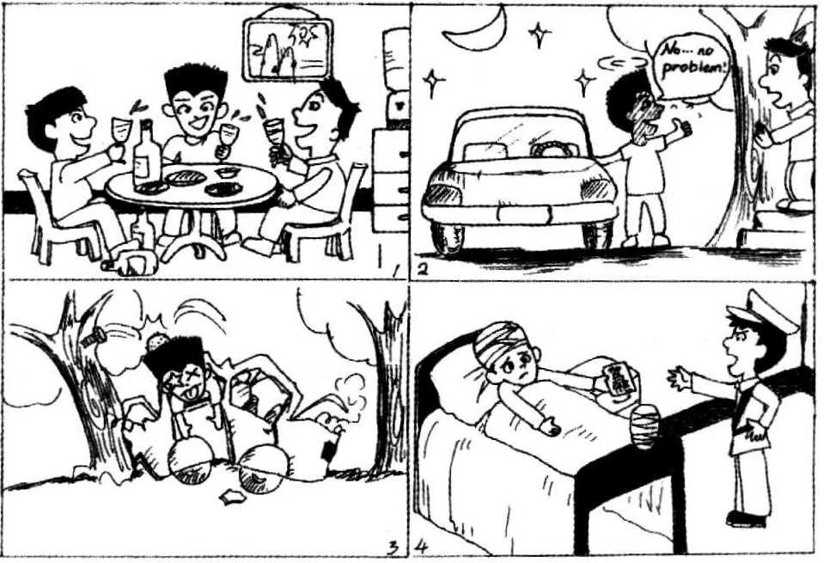
______________________________________________________________________________________________________________________________________________________________
_______________________________________________________________________________
__________________________________________________________________________________________________________________________________________________________________________________________________________________________________________________________________________________________________________________________________________________________________________________________________________________________________________________________________________________________

参考答案
第一题 1—5 BBCCD 6—10 DABBD 11—15 CADCA 16—20 ABDBD 21—25 CACAB
第二节 26 appeared 27 inspiration 28 government 29 overseas 30 mysterious
31 supposed 32 Gradually 33 exhausted 34 produced 35 attempted
第三节 完形填空
36-40 BADBC 41-45AADAC 46-50ABDAC 51-55DBDAC
51-55 C A D DA 56----60 CBCA B 61--65DDBBD 71-75 BCBCC
第四节 书面表达
One Possible Version:
My uncle will never forget what happened to him yesterday.
Towards the evening, he was invited to an inn. He enjoyed his dinner with his friends, drinking a lot of beers. As a result, he got drunk. He insisted on driving home after the meal, although his friends tried to persuade him not to.
A few minutes later, he was winding his way on the street. And then his car ran into a tall tree. Fortunately, he was still alive, though seriously injured. The police came to the scene, and he was taken to hospital. Naturally, he had to stay in hospital for several days. Worse still, his driving license was revoked. How he regretted what he had done!

参考答案
第一题 1—5 BBCCD 6—10 DABBD 11—15 CADCA 16—20 ABDBD 21—25 CACAB
第二节 26 appeared 27 inspiration 28 government 29 overseas 30 mysterious
31 supposed 32 Gradually 33 exhausted 34 produced 35 attempted
第三节 完形填空
36-40 BADBC 41-45AADAC 46-50ABDAC 51-55DBDAC
51-55 C A D DA 56----60 CBCA B 61--65DDBBD 71-75 BCBCC
第四节 书面表达
One Possible Version:
My uncle will never forget what happened to him yesterday.
Towards the evening, he was invited to an inn. He enjoyed his dinner with his friends, drinking a lot of beers. As a result, he got drunk. He insisted on driving home after the meal, although his friends tried to persuade him not to.
A few minutes later, he was winding his way on the street. And then his car ran into a tall tree. Fortunately, he was still alive, though seriously injured. The police came to the scene, and he was taken to hospital. Naturally, he had to stay in hospital for several days. Worse still, his driving license was revoked. How he regretted what he had done!

天仁英语教师资源交流网

