荆州市2008年初中升学考试英语试题

第一卷 选择题（六大题，共75分）
Ⅰ.听力图片判断（共5分，每小题1分）
根据你听到的内容从每小题的三幅图片中选出正确选项，每小题听一遍。
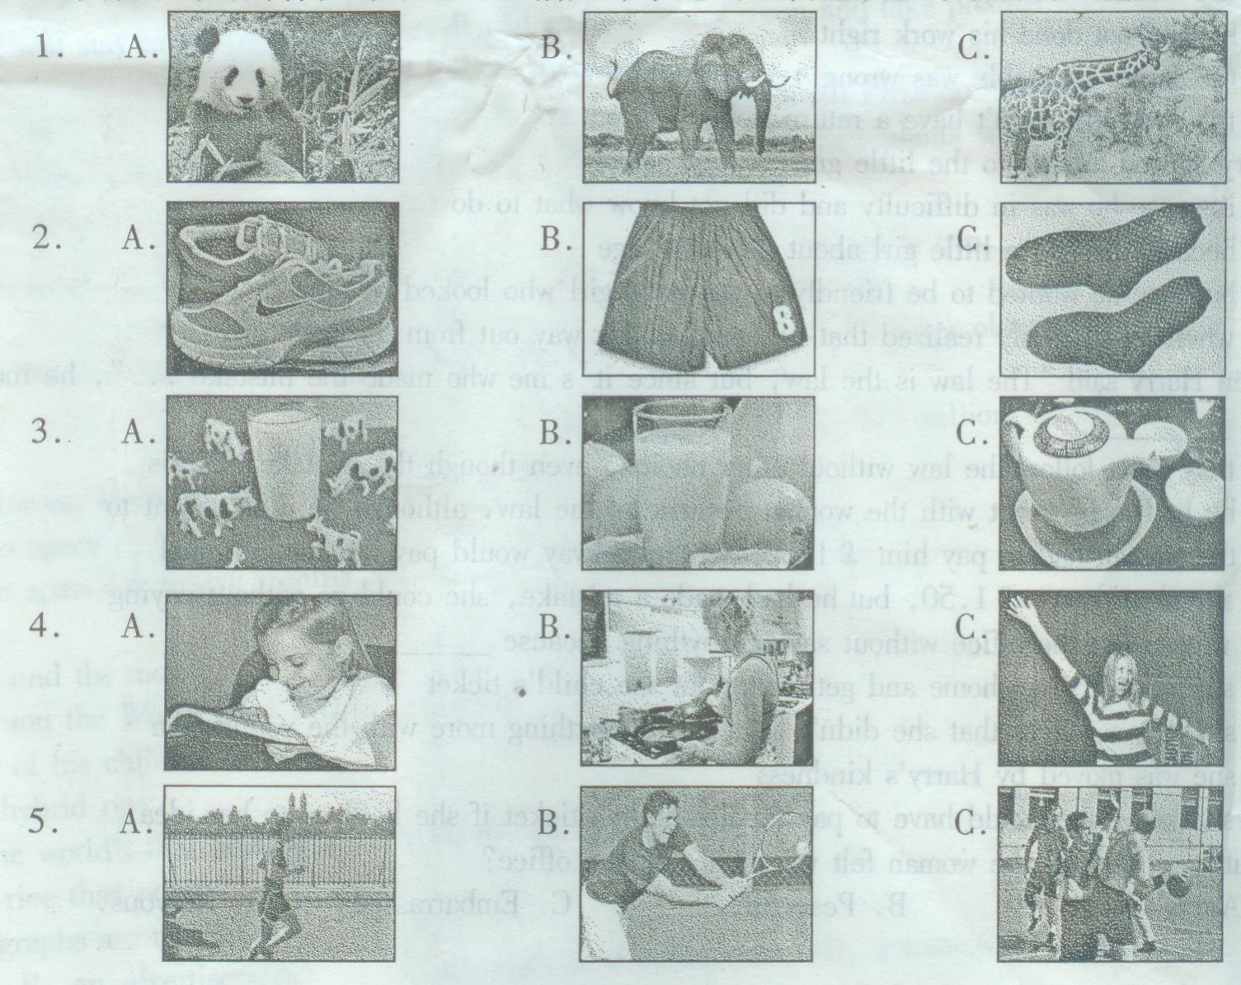
Ⅱ.听力对话理解（共5分，每小题1分）
根据你听到的小对话从每小题的三个选项中选出正确答案。每小题听两遍。
6. Where does the conversation probably take place?
A. In a classroom. B. In an office C. In a hospital
7. What are the man and woman doing ?
A. They’re watching TV B. They’re talking about a sports program
C. They’re talking about a movie.
8. Where does the woman tell the man to get into the supermarket?
A. From the entrance B. From the exit C. From the window
9.What does the man want to do?
A. He wants to mend his trousers
B. He wants the woman to mend his trousers
C. He wants the woman to mend his shirt
10. Who’s looking for Lily?
A. The man B. Her boss C. One of her friends
Ⅲ.听力篇章理解。（共10分，每小题1分）
听下面A 、B篇的两段对话和C篇的一段独白，并从每小题的三个选项中选出一个正确答案。对话或独白听两遍。
（A）
11.What are the man and woman doing?
A. They are talking on the phone.
B. They are having their summer holiday.
C. They are watching the weather report.
12. What’s the weather like in Sanya now?
A. Hot and dry. B. Hot and wet. C. Wet and cool.
13. Where are Mike’s family going to spend their holiday?
A. In Guangdong B. In Guangxi C. In Hainan.
(B)
14.Where is the girl from?
A. America. B. Canada. C. England
15. Why does the girl come to China?
A. To see her parents. B. To go traveling C. To find a job
16. What will the girl do next year?
A. She will work in China.
B. She will work in Japan
C. She will stay in her own country.
17. Why will they have to start early tomorrow?
A. It’s a long way to Cheater.
B. There’s only one bus to go to Cheater
C. They will have an early breakfast
18. When will the bus leave?
A. Before 8:30 B. At 8:30 C. After 8:30
19. Where is the first place they will visit?
A. An old palace. B. A beautiful park C. An old market
20. How much should one pay for the palace?
A. ￡3.15 B. ￡3.50 C. ￡8.00
Ⅳ.单项填空（共10分，每小题1分）
从每小题的四个选项中选出一个能填入题中相应空白处的最佳答案。
21. Which of the underlined parts has a different pronunciation?
A. cheap B. great C. easy D. least
22. —How was the evening party yesterday?
—We enjoyed ___________ very much.
A. us B. ourselves C. its D. itself
23. Which is __________, an elephant or a tiger?
A. strong B. stronger C. strongest D. the strongest
24. My mother __________ when I got home.
A. cook B. cooks C. cooked D. was cooking
25.— You see, a man is cutting a tree on the moon.
— It_________ be true. The teacher says there is no air on the moon.
A. can’t B. may not C. shouldn’t D. mustn’t
26.—I’m afraid the meeting has begun.
—Don’t worry. It _______ until the bell ________.
A. doesn’t begin/ rings B. won’t begin/ will ring
C. won’t begin/ rings D. doesn’t begin/ will ring
27. If you are famous, people will watch you _________ and follow you everywhere.
A. all the time B. by the time C. on time D. at times
28.— How have you been recently?
—So far, so good. I’ve __________ my own company.
A. put out B. put on C. put off D. put up
29.—Are you ready to order, sir?
—____________
A. Yeah, probably. B. No, thanks.
C. Let me look at the menu first. D. I am afraid I have no time.
30. When something is on fire. People throw sand (沙子) on it to put out the fire. The main use of the sand is to ___________.
A. protect the thing on fire.
B. add weight to the thing on fire.
C. keep the air away from the thing on fire.
D. lower the temperature of the thing on fire.
Ⅴ.完形填空（共15分，每小题1分）
先阅读短文，然后从文后每小的四个选项中选出一个可以填入短文中相应空白处的最佳答案。
Agatha Christic would never forget the night when she met a robber(抢劫者) many years ago.
That evening, she went to a birthday party which 31 until two o’clock in the morning. Agatha walked in the 32 street alone. Suddenly from the back of a dark 33 a tall man with a sharp knife in his right hand ran out at her. “Good 34 ,lady,” the man said in a low voice, “I don’t think you wish to 35 here!” “What do you want ?” “ Your earrings. Take them off!”
Agatha suddenly had a 36 idea. She tried to cover her necklace with the collar (衣领) of her overcoat while she used 37 hand to take off both of her earrings and then quickly 38 them on the ground.
“Take them and let me go, ” she said. The robber thought that the girl didn’t like the earrings at all, only trying to 39 the necklace. It would cost 40 , so he said, “Give me your necklace.”
“Oh, sir. It doesn’t 41 much. Please let me wear it.”
“I’m not that 42 , Quick!”
With shaking 43 Agatha took off her necklace. As soon as the robber left, she picked up her earrings and ran as 44 as she could to one of her friends.
The earrings cost 480 pounds and the necklace the robber had taken away cost 45 six pounds.
31. A. ended B. stayed C. stopped D. lasted
32.A. busy B. quiet C. noisy D. wide
33.A.part B. block C. building D. street
34.A.moring B. afternoon C. evening D. night
35. A. die B. escape C. fight D. stay
36. A. funny B. safe C. brave D. bright
37. A. other B. others C. the other D. another
38. A. handed B. threw C. passed D. put
39. A. own B. keep C. have D. protect
40. A. cheap B. expensive C. more D. less
41. A. weigh B. take C. spend D. cost
42. A. afraid B. angry C. silly D. bad
43. A. hands B. feet C. head D. body
44. A. much B. early C. carefully D. fast
45. A. really B. already C. only D. hardly
Ⅵ.阅读理解（共30分，每小题2分）
先阅读短文，然后根据短文内容从文后每小题的四个选项中，选出一个能完成所给句子或回答所提问题的正确答案
（A）
WHERE TO STAY IN BOSWELL?
TOUR GUIDE TO OUR BEST HOTELS

FIRST HOTEL Address:222 Edward Road Telephone:414-6433
The number of rooms:120 Single room: $25 Double room: $35
Special attractions: Air-conditioned rooms. French restaurant. Swimming pool. Shops. Coffee shop and bar. Telephone, radio and television in each room. Close to the city center.
FAIRVIEW HOTEL Address: 129 North Road Telephone:591-5620
The number of rooms: 50 Single room: $12 Double: $18
Special attractions: Close to the airport. Telephone in each room. Bar. Restaurant. Garage. Swimming pool.
ORCHARD HOTEL Address: 233 Edward Road Telephone:641-6446
The number of rooms:120 Single room: $15 Double $20
Special attractions: Facing First Hotel. European restaurant. Coffee shop. Television. Nightclub.
OSAKE HOTEL Address: 1264 Venning Road Telephone:643-8200
The number of rooms:180 Single room: $30 Double $50
Special attractions: Air-conditioned rooms. Japanese and Chinese restaurants. Swimming pool. Large garden. Shops.
46. If you want to eat Chinese food, you will go to the restaurant in _________.
A. Fairview Hotel B. First Hotel
C. Orchard Hotel D. Osaka Hotel
47. The cheapest price for a single room is _______ in ______ in Boswell.
A. $ 12 / First Hotel B. $ 15 / Osaka Hotel
C. $ 12/ Fairview Hotel D. $25 / Orchard Hotel
48. The total number of the room is the best hotels in Boswell is _______
A. 120 B.170 C.290 D.470
49. If a Japanese traveler likes to eat in a French restaurant, ________ is the right place for him to go to.
A. 233 Edward Road B. 1264 Venning Road
C.222 Edward Road D. 129 North Road
50. Which hotel faces Orchard Hotel?
A. First Hotel B. Osaka Hotel
C. Fariview Hotel D. No hotel
(B)
HAVE you ever thought of being able to fly around the world in a few hours though it is about 40,000 kilometers? Now, maybe you can. Last Saturday, the American X-43A airplane made its first flight. It reached a speed of 8,000 kilometers an hour. This makes it the fastest plane in the world. X-43A is only three to four meters long, but it’s very heavy: it weighs 1,270 kilos.
HOW old can an insect be? 400 million years! Last Wednesday, scientists found the world’s oldest insect fossil(化石) in Britain. The fossil shows that the body of the insect was as big as a piece of rice and had wings(翅膀). In the past, people thought the earliest insect was 380 million years old.
THERE will be a new “star” in the sky soon. China plans to send a satellite(卫星) into space be September 2009. It will stay in space for one year. It will go around the moon and take pictures. It must be very expensive, right? That’s for sure －1.4 billion yuan!
YUAN Longping, the father of hybrid rice (杂交水稻), won the World Food Prize on Monday. Yuan developed the world’s first popular and widely grown hybrid rice. Hybrid rice plants can make more rice than the ones people grew before.
51. If the X-43A goes round the Eath, it will take about _______ hours to finish the trip.
A.3 B.5 C.8 D.12
52. The newly-found insect fossil showed that the earliest insect was _______ years older than believed.
A.10 million B.400 million C.20 million D.380 million
53. Which of the following about the new star is NOT true?
A. It will go into space by September 2008.
B. It will stay in space for twelve months.
C. It costs a lot.
D. It will go around the moon.
54.Yuan Longping won the World Food Prize because he ______.
A. is the father of his children
B. likes to eat hybrid rice
C. developed the world’s first popular and widely grown hybrid rice
D. grows more rice than others
55. The above paragraphs are taken from _______.
A. a story B. an advertisement
C. an explaining writing D. a newspaper
(C)
Having returned from her round trip, the angry woman stood outside the ticket office of the station. “The railway owes me ￡12，” she said to Harry Jenks, the young man working at the office. “You sold me a ticket for May 22nd, but there was no ship to Jersey that night. So my daughter and I had to stay in a hotel. It cost me￡12. ”
Harry was worried. He remembered selling the woman a return ticket. “come into the office, Madam,” he said politely. “I’ll just check the Jersey timetable for May 22nd.”
The woman and her little girl followed him inside. She was quite right, as Harry soon discovered. There was no sailing on May 22nd. How could he have made such a careless mistake? He shouldn’t have sold her a ticket for that day. Wondering what to do, he smiled at the child. “You look sun burnt,” he said to her. “Did you have a nice holiday in Jersey?”
“Yes, ” she answered, shyly. “The beach was lovely. And I can swim too!”
“That’s fine,” said Harry. “My little girl can swim a bit yet. Of course, she’s only three…”
“I’m four,” the child said proudly. “I’ll be four and a half.”
Harry turned to the mother. “I remember your ticket, Madam, ”he said . “But you didn’t get one for your daughter, did you?”
“Er, well…” the woman looked at the child. “I mean… she hasn’t started school yet. She’s only four.”
“A four-year-old child must have a ticket, Madam. A child’s return ticket to Jersey costs… let me see…￡13.50. So if the railway pays for you hotel, you will owe ￡1.50. The law is the law, but since it’s me who made the mistake…”
The woman stood up, took the child’s hand and left the office.
56. Harry was worried because __________.
A. the woman was angry with him
B. he had not done his work right
C. the Jersey timetable was wrong
D. the little girl didn’t have a return ticket
57. Harry started talking to the little girl ________.
A. because he was in difficulty and did not know what to do
B. because he had a little girl about the same age
C. because he wanted to be friendly to the little girl who looked so nice
D. when he suddenly realized that he could find a way out from the little girl.
58.When Harry said “The law is the law, but since it’s me who made the mistake…,”he meant that _________.
A. they must follow the law without other choice, even though the mistake was his
B. he had to be strict with the woman because of the law, although he didn’t want to
C. the woman had to pay him￡1.50 and the railway would pay her for the hotel
D. she should pay￡1.50, but he had made a mistake, she should go without paying
59. The woman left the office without saying anything because_______.
A. she wanted to go home and get money for the child’s ticket
B. she was so angry that she didn’t want to say anything more with the young man
C. she was moved by Harry’s kindness
D. she knew she would have to pay for her child’s ticket if she held on to her idea
60. What do you think the woman felt when she left the office?
A. Angry B. Peaceful C. Embarrassed D. Nervous
第二卷 非选择题（四大题，共45分）
Ⅶ.完成句子（共10分，每小题2分）
根据括号内的汉语和句末括号内的英语单词提示完成句子。
61. She ______________(穿上) her coat and went out.(put)
例：When we _______(起床)early in the morning, it was still dark.(get)
答案： got up
62. We should be allowed ______________(自己作决定).(make)
63. More attention ___________(应放在) the needs of the poor.(pay)
64. Great changes ________________(发生了) in my hometown these years.(take)
65. I don’t know __________________________(他与……相处得怎样) with the others now.(get)
Ⅷ.补全对话（共10分，每小题1分）
阅读对话，根据对话内容在每一个空白处填入一个适当的词，将其填到对话后面各题号后的横线上。
A: Excuse me. Can you 66 me the way to the nearest post office? I want to post a letter.
B: Yes. Just go along and 67 right. It’s down the Central Street on the left.
A: Is it 68 from here?
B: No, it isn’t. it’s quite near. It will take you only five 69 to go there on foot.
A: By the 70 ,where is the bookstore?
B: The bookstore? It’s on Eighth Avenue. It’s 71 to the supermarket.
A: Can I walk there?
B: Yes, you can. But it will take you 72 an hour to walk there. You had better take a bus there.
A: 73 bus shall I take?
B: No, 66.
A: Many 74 for your kindness.
B: It’s my 75 .
66._________ 67._________ 68._________ 69._________ 70._________
71._________ 72._________ 73._________ 74._________ 75._________
Ⅸ.阅读答题（共10分，每小题2分）
阅读短文，并根据短文内容回答问题。注意：第76-79小题必须各用一个完整的句子回答；第80小题可用1—3个句子回答。
A terrible explosive noise was heard, immediately followed by strong shaking of the classroom building. Mrs Li Lan, a country school teacher in Sichuan, who was giving a class, could hardly keep on her feet, and many of her pupils made panic cries. Mrs Li realized at once that it must be a powerful earthquake hitting the area. Though she herself was scared, she managed (设法) to make the children calm down, opened the door right away and told the children to leave the classroom and get down to the playground as quickly as possible.
When all the children had left, she followed them to the first floor. The earth still kept moving violently (巨烈地). Some of the buildings nearby were falling down, and a great number of falling stones were rolling down from the hills behind the school. Suddenly, she found a little boy fell over and was hit by a big stone right on his body. She forgot the danger she was facing and ran over, trying to push the stone away. The stone was so big that it was not easy for her to move it. She kept pushing until the boy was pulled out, carrying him to the center of the playground. The boy was later sent to hospital and saved.
76. What kind of disaster(灾难) happened in the story?
____________________________________________________________
77.What were the children doing when the disaster happened?
____________________________________________________________
78. What was Mrs Li’s action when she saw the boy under the stone?
____________________________________________________________
79. Did Mrs Li fear death in the face of great danger?
____________________________________________________________
80. What do you want to say after you finish reading the story?
____________________________________________________________
Ⅹ.书面表达（共15分）
请以“My hometown”为题，按以下内容要求写一篇80个词左右的短文。
- 家乡的环境等基本情况；
- 家乡的人们及其主要活动；
- 对家乡的简要评价。
My Hometown
____________________________________________________________
____________________________________________________________
____________________________________________________________
____________________________________________________________
____________________________________________________________
____________________________________________________________
____________________________________________________________
____________________________________________________________

荆州市2008年初中升学考试英语试题
参考答案及评分要求
Ⅰ.听力图片判断（共5分，每小题1分）
1.A 2.C 3.A 4.B 5.C
Ⅱ.听力对话理解（共5分，每小题1分）
6.C 7.A 8.B 9.B 10.B
Ⅲ.听力篇章理解（共10分，每小题1分）
11.A 12.B 13.C 14.C 15.A 16.B 17.A 18. B 19. A 20.B
Ⅳ.单项填空（共10分，每小题1分）
21.B 22.B 23.B 24.D 25.A 26. C 27.A 28.D 29. C 30.C
Ⅴ.完形填空（共15分，每小题1分）
31.D 32.B 33.C 34.A 35.A 36.D 37.C 38.B 39.B 40.C 41.D
42.C 43.A 44.D 45.C
Ⅵ.阅读理解（共30分，每小题2分）
46.D 47.C 48.D 49.C 50.A 51.B 52.C 53.A 54.C 55.D
56.B 57.A 58.D 59.D 60.C
Ⅶ.完成句子（共10分，每小题2分）
61.put on 62. to make our own decision(s) 63. should be paid to
64. have taken place 65. how he is getting along (on)
评分要求：每小题语法错误扣1分，词语错误（含拼写）扣0.5－1分
Ⅷ.补全对话（共10分，每小题1分）
66.show(tell) 67. turn 68. far 69. minutes 70. next(close) 72. about(around, almost, nearly) 73. Which 74. thanks 75. pleasure
Ⅸ.阅读答题（共10分，每小题2分）
76. A powerful earthquake hit (happened in)Sichuan(Province). 77.They were having a chlaa. 78.She ran over,(pushed the stone away)and saved the boy(carried the boy to the center of the playground). 79.No,she didn’t. 80.Answers vary.
评分要求：每小题回答的内容和语言正确，给2分；语言错误（含拼写和标点）最多扣1分，内容错误给0分；第76—79小题必须各用一个完整的句子回答，使用不完整句子的简略回答视为部分正确，扣1分；与本参考答案内容相近的答案应视为正确；第80小题可用1—3个句子回答，与短文主题相关的答案应视为正确。
Ⅹ.书面表达（共15分）
- 评分要求：
- 叙述内容完整、正确、清晰，语言连贯流畅，拼写、标点无误，词数符合要求，给满分15分。
- 表达内容扣分原则：主要内容残缺，语言不够连贯流畅可酌情扣1—12分；表达内容不知所云，给1—3分；未能传达任何信息，给0分；少于60个词或超过100个词均扣1分。
- 语言错误扣分标准：最多扣5分。一个语法结构错误（包括时态、语序、主要词语等）扣1分；冠词、介词、拼写、修饰语、大小写、标点等每个错误扣0.5分。
- 书写要求规范、清楚。对于字迹潦草、模糊难辨的书写，可酌情扣1—2分。
- one possible version
My hometown is a small village not far from the Changjiang River.A road runs through it,leading to the nearest.You can see houses behind green trees along both sides of the road.
There are about 300 people in the village.All of them are very friendly.In busy seasons most of them do farm work in the fields.The village is famous for its fruits.When summer comes,many businessmen drive here to buy them.
My hometown is becoming more and more beautiful.I love my hometown very much.
(89words)

天仁英语教师资源交流网

