湖北省十堰市2007年初中毕业生学业考试
英 语 试 题

温馨提示：
你手中的试题共四部分，六道大题，满分120分, 考试时间120分钟。请你在答题前，先把学校、考号和姓名分别填在密封线内的矩形框内, 将选择题的答案填在每小题前的括号内，非选择题的答案直接写在试题相应的横线上, 并请用蓝、黑钢笔或圆珠笔答题。

题 号 | Ⅰ | Ⅱ | Ⅲ | Ⅳ | Ⅴ | Ⅵ | 总 分 | 总分人 | 复分人
得 分

第一部分 听力理解部分（一道大题，共25分）
得分 | 评卷人
Ⅰ 听力测试（本题四节，每小题1分，共25分）

第一节：请听5组小对话及对话后的问题，选择能正确回答所提问题的图画选项。每段对话及对话后的问题均读两遍。
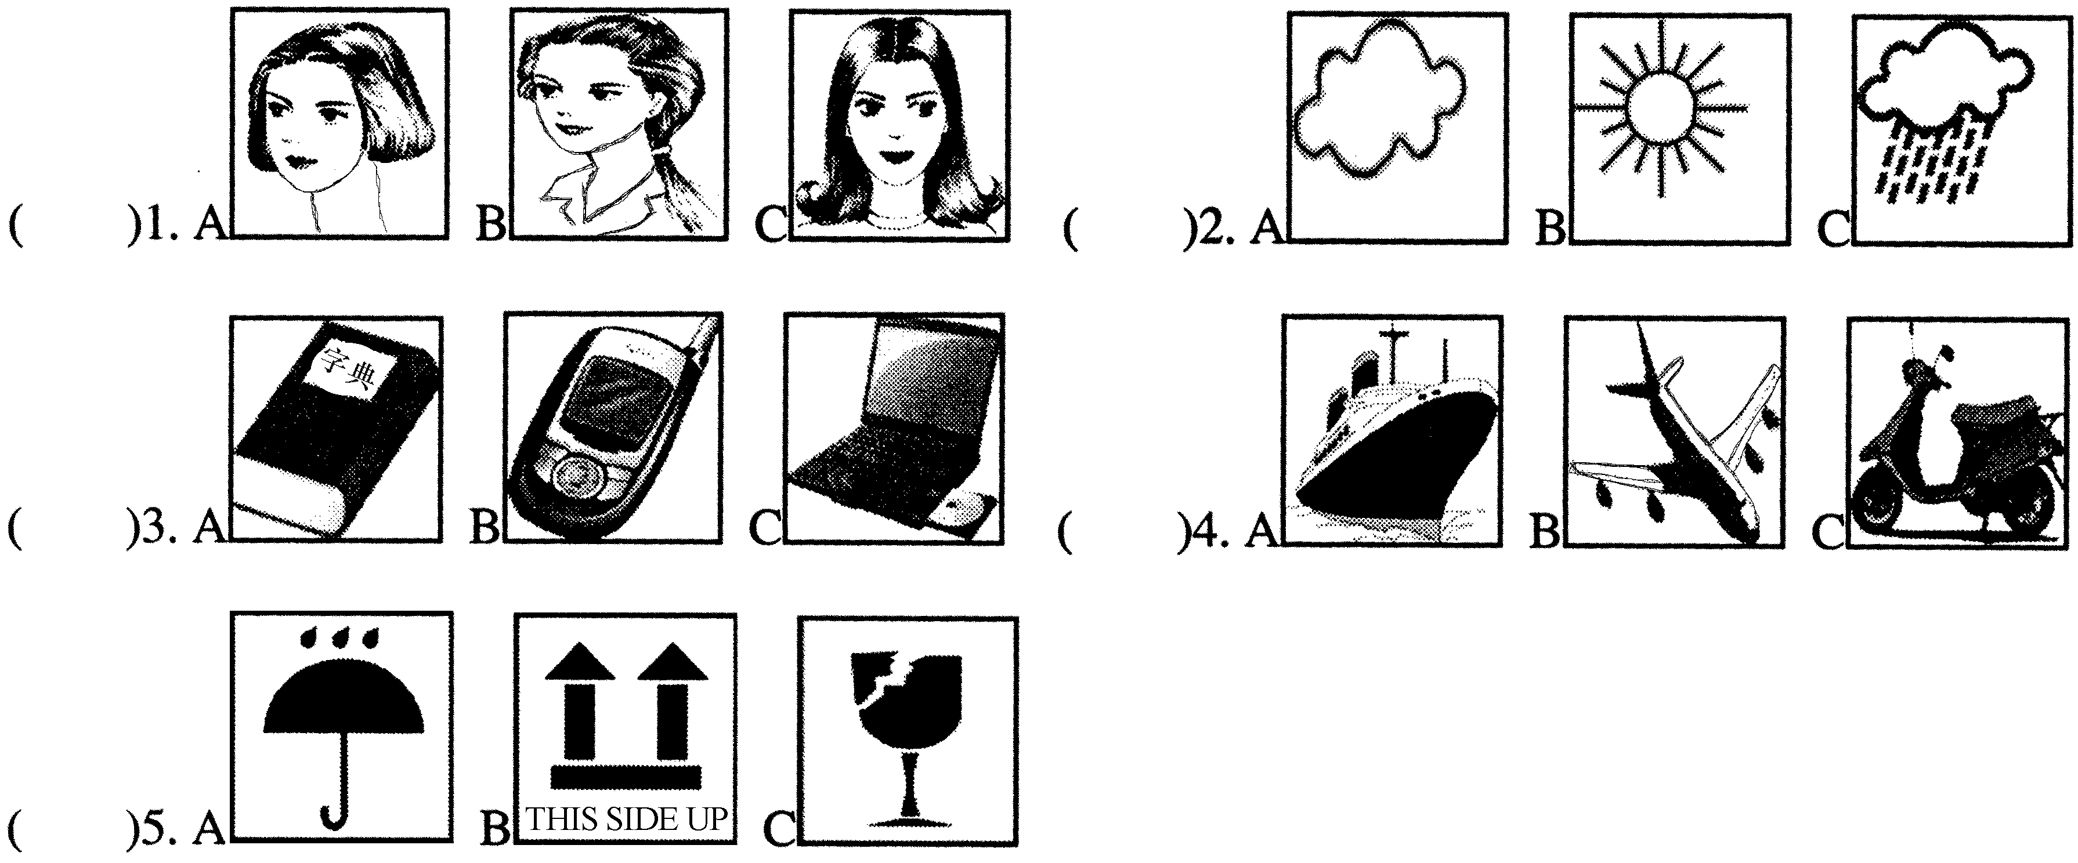

第二节：请听每组大对话，并按要求作答。
听第6段对话，回答第6和7小题。对话读两遍。
( ) 6. Who does Mike want to invite?
A. Mary. B. Julia. C. Kate.
( )7. What time does the party begin?
A. 7:00p.m. B. 8:00p.m. C. 9:00p.m.

听第7段对话，回答第8和9小题。对话读两遍。
( ) 8. What are they talking about?
A. Slowing down the population.
B. Saving the environment.
C. Spending holidays.
( ) 9. What’s the last way?
A. Saving money. B. Riding a bike. C. Shopping without plastic bags.
听第8段对话，回答第10-12小题。对话读两遍。
( ) 10. What size does the woman want?
A. Size 36. B. Size 37. C. Size 38.
( ) 11. What colour does the woman like best?
A. Red. B. White. C. Blue.
( ) 12. How much are the shoes?
A. 200yuan. B. 150yuan. C. 100yuan.
听第9段对话，回答第13-15小题。对话读两遍。
( ) 13.What is Paul finding difficult?
A. Maths homework. B. Physics homework. C. English homework.
( ) 14.Why do they work together?
A. Because they like keeping busy.
B. Because they want to help each other.
C. Because the teacher asks them to do it.
( ) 15. How often do they meet for the study group?
A. Three times a week. B. Twice a week. C. Once a week.
第三节：请听短文，并根据其内容选择正确答案。短文读两遍。
( ) 16. What is the girl?
A. A reporter. B. A student. C. A teacher.
( ) 17. What happened to the girl?
A. Lost her way. B. Made much money. C. Met a robber.
( ) 18. What did the girl learn from the unusual lesson?
A. To protect herself. B. To make friends. C. To improve her English.
( ) 19.What has become a big problem in the schools according to the reading?
A. Students’ spirit. B. Students’ safety. C. Students’ health.
( ) 20. Which one of the following is RIGHT?
A. The bad man robbed the girl of much money.
B. About 2000 students have learned how to protect themselves.
C. Most such lessons tell students to do something to prevent danger.
第四节：任务型听力。请听一段材料，并根据其内容完成信息记录表。材料读两遍。

Name of the Museum: City Science Museum
Things to remember: ◆◆◆◆◆◆◆◆◆◆
Don’t touch (21) _______________________ in the museum.
No (22) _____________________!
No (23) _____________________!
Time to meet: (24)__________________________pm
Place to meet: (25)__________________________ the museum
第二部分 语言知识运用（两道大题，共30分）
得分 | 评卷人
Ⅱ 单项选择 （本题一节，每小题1分，共15分）
从所给的A、B、C、D四个选项中,选出可以填入空白处的最佳选项。
( ) 26. This is ______ story that I have told you before.
A. an B. a C. the D. 不填
( ) 27.—Are these story-books yours?
—No, they’re not ______. They’re Alice’s.
A. she B. mine C. her D. me
( ) 28.—Everything is ______at night markets.
—Really? That’s to say I don’t need a lot of money to have a good time.
A. cheap B. bad C. tired D. dear
( ) 29.—Why didn’t you tell him about the meeting?
—He had rushed out of the room ______I could say a word.
A. before B. until C. when D. after
( ) 30. There will be ______students in our class in two weeks, so we need a bigger classroom.
A. few B. more C. many D. fewer
( ) 31. A mobile phone is never allowed into the classroom during the school time, ______?
A. hasn’t it B. has it C. is it D. isn’t it
( ) 32. Every year large numbers of businessmen ______to Shiyan to buy heavy trucks.
A. comes B. have come C. came D. come
( ) 33.—Would you please go hiking with me tomorrow?
—Sorry, I ______. I’ll have to meet my cousin in the train station.
A. can’t B. won’t C. mustn’t D. needn’t
( ) 34.―Has the match started?
―Started？Finished！Guo Yue______.
A. is winning B. was winning C. has won D. will win
( ) 35.Those kinds of Chinese medicines______ cool and dry following the instructions.
A. must be kept B. should place C. will be eaten D. should carry
( ) 36.―I don’t know ______. Can you tell me?
―In the school hall.
A. where we’ll have a party B. when will we have a talk
C. when we’ll have a meeting D. where are we going to see the film
( ) 37.—Are you still busy?
—Yes, I______ my work, and it won’t take long.
A. just finish B. am just finishing
C. have just finished D. had just finished
( ) 38. The foreigners have gone to the farm______ we worked last year.
A. what B. who C. that D. on which
( ) 39.—Would you like some more soup?
—______. It is delicious, but I’ve had enough.
A. Yes, please B. No, thank you C. Nothing more D. I’d like some
( ) 40.—We enjoyed ourselves very much in the party last night!
—______.
A. Well done B. It’s OK with me C. That’s right D. I’m glad you did

得分 | 评卷人
Ⅲ 完形填空 （本题一节，每小题1分，共15分）
通读下面短文，掌握其大意，然后从所给的A、B、C、D四个选项中选出一个最佳选项。
I often watched a little girl playing basketball on the playground near my house. She would (41) shooting over and over again, sometimes until (42) . One day I asked her (43) she practiced so hard. She said, “I like basketball. I want to play for the top basketball team. I want to be the (44) . My daddy told me if the dream is big enough, the facts don’t count.”
I watched her (45) those high school years. One day, I saw her (46) on the grass, head in her arms. I walked to her and asked what was wrong. “Oh, (47) ,” she said. “I am just too short.” The coach told her that she was too (48) to play for a top team. She was very (49) . I asked her if she had talked to (50) about it yet. She told me that her father said those coaches were (51) . They just did not understand the powerof a (52) . He told her that nothing could (53) her but one thing—her own attitude (54) she really wanted to play for a good basketball team. He told her again, “If the dream is big enough, the facts don’t count.” The next year, she (55) to join the NCAA women’s basketball team.
It’s true: If the dream is big enough, the facts don’t count.
注：⑴ count重要 ⑵ coach 教练 ⑶ power力量 〔4〕attitude 态度 〔5〕NCAA全美大学生体育协会

( ) 41. A. practice B. hate C. mind D. forget
( ) 42. A. past B. light C. dark D. future
( ) 43. A. how B. when C. where D. why
( ) 44. A. kindest B. best C. cleverest D. tallest
( ) 45. A. through B. by C. across D. for
( ) 46. A. reading B. playing C. sitting D. smiling
( ) 47. A. everything B. nothing C. great D. dangerous
( ) 48. A. thin B. fat C. tall D. short
( ) 49. A. proud B. glad C. sad D. lazy
( ) 50. A. himself B. herself C. her dad D. her coach
( ) 51. A. good B. wrong C. strong D. frustrated
( ) 52. A. dream B. team C. pleasure D. knowledge
( ) 53. A. follow B. choose C. expect D. stop
( ) 54. A. if B. whether C. as D. because
( ) 55. A. refused B. asked C. was refused D. was asked

第三部分 阅读理解部分（一道大题，共35分）

得分 | 评卷人
Ⅳ 综合阅读 （本题四节，共35分）

第一节：阅读下面网上聊天的即时消息，选择最佳选项完成下列各题。（10分）
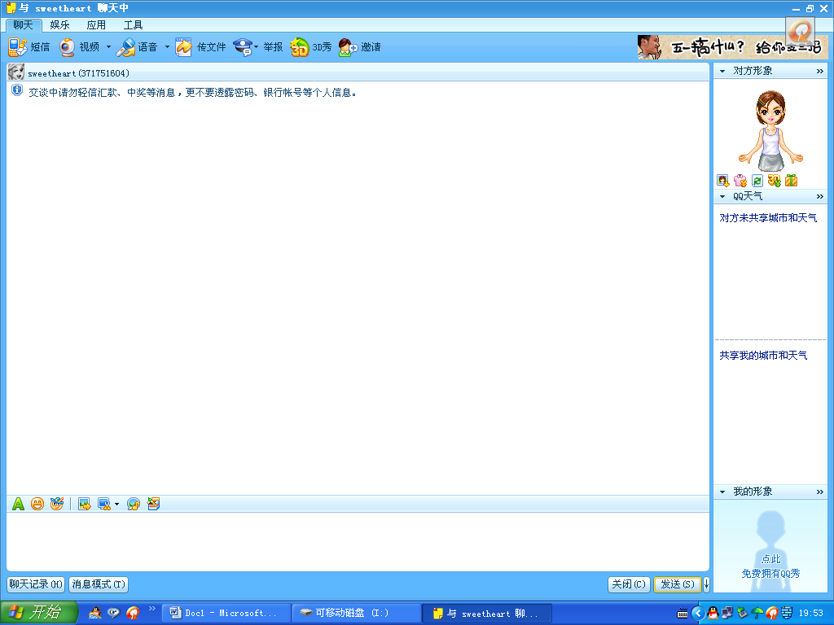
Thanks. It’s funny. Computer can do much, but they break all the time!
SEND
( )56. Where is Erin?
A. At home. B. At an Internet Café. C. At school. D. At a computer store.
( )57. What's the problem with the computer?
A. It has virus. B. It runs slowly. C. It doesn't work. D. It is too old.
( )58. What does Coco think of Erin's problem?
A. Funny. B. Afraid. C. Great. D. Sorry.
( )59._________, so she can't take the computer back to the store.
A. The store is full of busy people B. The computer is over a year old
C. The store doesn’t do a very good job D. The store closed over a year ago
( )60. _________ say(s) computer can do much but they break all the time.
A. Erin B. Neither of them C. Coco D. Both of them

第二节：阅读短文，选择最佳选项完成下列各题。（10分）
Valentine’s Day just passed and it made me remember a middle school student I know who may be in love.
I think there are two ideas of middle school “love”. One is temptation: Girls dress beautifully and act giggly. Boys are popular and attractive.
Then there is the other kind: attraction that may or may not be love. The student I know is like that. She has a friend called John whom she has feelings for, but she can't decide if it’s love or friendship. In her words:
“I wonder whether he is my ideal boyfriend. I want someone cool and kind who holds the same values as me. He isn’t any of these. So sometimes I wonder if I'm only attracted and deciding to break up with him now. But he is attractive, and he isn’t foolish. He may not be an “A” student, but he’s intelligent and clever. I wonder if I only pity him for the hard times he has had. He knows how to make me laugh. We both sing and act. We had several classes together last year. He can be very sweet.”
I’m moved by this because it’s hard to find a student who has such real thoughts. It seems that everyone thinks only of how “hot” someone is, without acting more wisely.
For some people, Valentine’s Day might mean nothing. But for others, it could mean a lot. What about you, young man?
注：⑴Valentine’s Day情人节 ⑵ temptation诱惑 ⑶ ideal理想的 ⑷ values 价值 ⑸ wisely明智地
( ) 61. In the writer's idea, two kinds of students’ “love” are_______.
A. temptation and attraction B. temptation and feelings
C. temptation and friendship D. friendship and attraction
( ) 62. The underlined(画线的) sentence implies (暗示) that the writer _______.
A. is loved by the girl now B. holds the same values as the girl
C. agrees with the girl’s words D. doesn’t care about the girl’s thoughts
( ) 63. The word “hot” in the reading means _______.
A. kind B. clever C. sweet D. attractive
( ) 64. Which of the following is NOT mentioned in the passage?
A. It’s true that the writer is the girl’s teacher.
B. John is attractive though he isn’t a top student.
C. The girl has feelings for one of her friends called John.
D. The girl wonders whether it’s love or friendship between John and her.
( ) 65.The story is probably a page from a_______.
A. postcard B. newspaper C. novel D. notice

第三节：阅读下面的短文，完成测试任务。（5分）
1. The weather report, a story about the Pop stars and different cultures are examples of messages from the media. Examples of media are television, radio, newspapers and books and the telephone. The media that can reach many people at once are called mass media.
2. It is not difficult to think of other messages we receive through the mass media. Every day we get hundreds of them. Think about ads, for example. We see and hear these messages almost everywhere we go. Ads are important messages. Even though they sometimes make us feel rather angry, they help us know things well.
3. Most of us get more information from the media than from the classroom. Think, for a moment, about how you learn about news and events. Do you learn them from other people or the media? What about international news? What is the most important place of information for you? People who are asked this question usually answer, “Television.”
4. Think of all the messages you received today. Perhaps you read a newspaper during breakfast, or maybe you read ads on billboards on your way to school. Did you listen to a weather report or the sports news on the radio this morning? Now you are reading, and that’s to say you’re getting information through a very important medium of mass.
5. The mass media are important to us because they shape our decisions and opinions.
注：⑴media 传媒 ⑵ mass media大众传媒 ⑶ billboards 露天广告 ⑷ shape 影响

从所给的3个选项中分别为第2和第4段选择1个正确的小标题。其中一项多余。
( ) 66. Paragraph2: ◆
A. Television-A Rich Place of Information
B. Ads as Important Messages from the Mass Media
C. Different Kinds of Messages One May Receive Each Day

( ) 67. Paragraph4: ◆

从所给的5个选项中选择3个正确的选项，分别完成下列句子。其中两项多余。
( ) 68. Each day we get a lot of messages from ◆ .
( ) 69. For most people television is the most important ◆ .
( ) 70. The mass media are important to us because they shape ◆ .
A. our messages B. place of information C. many examples
D. the mass media E. our decisions and opinions
第四节：任务型阅读。请根据短文内容，完成下列任务。（10分）
When you are worried or stressed, what do you do about it?
These days, a student website in Foshan opened for kids to let their anger and stress out. Students can write whatever they want online.
Lots of students wrote their stories. Some wrote something about their teachers. Others wrote about their quarrels with their classmates. Many of them used ① words. Some even wrote down the real names of their targets.
Parents don’t like the idea. They said it could be against the law. Ms Cheng is the mother of a Junior2 boy. She said she wouldn’t let her son write on the Internet. “Saying bad things about others won’t help solve the problem. Children should talk to their parents,” she said.
Ren Yi, 16, from Liaoning, said he didn’t agree with using bad words either. But he said releasing stress online wasn’t a bad thing. “You don’t have to use your real name. ② knows you. You can let out as much as you want,” he said.
Song Yinan, 14, from Shanxi thinks it has two sides. The good side is if others see your story, they may give you help. But the bad side is that if kids don’t control themselves, things could become worse.
注：⑴stressed有压力的 ⑵ targets目标 ⑶ law法律 ⑷release释放

71. 请根据短文内容，补全①、②两处所缺单词 (词数不限) ，并将答案填在下面的横线上。
① ______________ ② ______________
72. 请根据下列句子的意思及首字母提示，从短文中各找出一个恰当的单词填空。
① Ms Huang, the PE teacher told us our next match was a a Japanese team.
② Elsa loses herself in playing computer games . She can’t c herself though she knows it’s bad.
73. 请把短文中画线的句子翻译成汉语。
_________________________________________________
请根据短文内容或生活实际回答74、75小题。
74. Did Ren Yi agree with releasing stress online?
_________________________________________________
75. How do you solve it when you’re worried or stressed?
________________________________________________________________

第四部分 语言综合运用（二道大题，共30分）

得分 | 评卷人
Ⅴ 词句运用 （本题两节，每小题1分，共15分）

第一节：根据汉语提示，结合句子意思，在横线上写出恰当的单词或词组。
76. Some people _________________（当作）the pets as their family members.
77. Next year the_________________（二十九）Olympic Games will be held in Beijing.
78. It is not easy for me to finish the work_________________(独自) in such a short time.
79. Thank you very much for sending me so many wonderful___________________（邮票）.
80. Not many families can afford to send their children ___________________（出国求学）.

第二节：选择单词，用其适当的形式填空，使短文意思正确、通顺。（每词限用一次）
back child stay free they have happily like different be
There are many different kinds of animals in the zoo. We see the zookeepers give (81)________ food to eat. They don’t (82)________ to find food for themselves. They just eat, walk and sleep all day. So many of us think that the animals there (83)_________ happy. But most of them are sad. Why? They aren’t (84)________!
Animals (85)________ monkeys and tigers usually live freely and (86) ________ in forests or mountains. Tigers, for example, run, jump and play with their (87)________ and catch small animals for food. But now they have to (88)________ in the small rooms in the zoo. Their life there is (89)________ from their life in the forests.
Now all of us think animals should go (90)________ to the forests. Do you think it is true?

得分 | 评卷人
Ⅵ 初级写作 （本题两节，共15分）

第一节：请按要求描述出Rose一天的生活片段。
(A) 请根据前三幅图画，在下面空白处填入恰当的内容。(3分)
Rose likes her weekend. Last Sunday morning she_________________ first, then one hour later she played tennis _________________ .In the afternoon she _________________on Moon Lake …
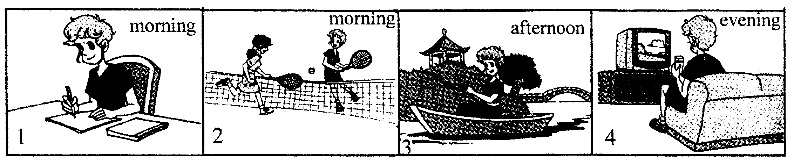
(B) 请结合第四幅图画，用一或两句话续写结尾，使上下文连贯、完整。(2分)
_______________________________________________________________________________
第二节：下面是学校留言板上的两则信息，根据其内容，请你以William的名义, 针对其中一位同学遇到的问题，提出你的建议。要求：1.任选其中一则信息进行回复，并注意补全文首的称呼；2. 建议合理，文意通顺；3.词数：70左右。(10分)
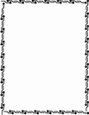
My mom always buys me clothes I don’t like! But I usually don’t tell her. I’m worried I’ll hurt her feelings. Sometimes I tell her what I want to wear. But what she buys is still what she wants me to wear. What should I do?
Henry
Xiao Fei used to be my best friend. We told each other everything. But a few weeks ago, I found that she was telling all my secrets to others. I am so hurt. I thought Xiao Fei was my friend! What should I do?
Sally

Dear ________,
_____________________________________________________________________________
____________________________________________________________________________________________________________________________________________________________________________________________________________________________________________________________________________________________________________________________________
William
湖北省十堰市2007年初中毕业生学业考试
英语试题参考答案及评分说明
Ⅰ 1. A 2. C 3. A 4. B 5. B
6. C 7. B 8. A 9. C 10. A 11. B 12. A 13. C 14. B 15. C
16. B 17. C 18. A 19. B 20. C
21. anything/(the) things/(the)objects/(the)inventions/(the)old inventions
22. smoking
23. photos/pictures
24. two(o’clock)/ 2 (o’clock)
25. outside
Ⅱ 26. C 27. B 28. A 29. A 30. B 31. C 32. D 33. A 34. C 35. A
36. A 37. B 38. D 39. B 40. D
Ⅲ 41. A 42. C 43. D 44. B 45. A
46. C 47. B 48. D 49. C 50. C
51. B 52. A 53. D 54. A 55. D
Ⅳ 56. B 57. C 58. D 59. B 60. A
61. A 62. C 63. D 64. A 65. B
66. B 67. C 68. D 69. B 70. E
71. ① bad/terrible/rough/dirty/boring/worse/the worst/…
② Nobody/No one/None of them
72. ① against ② control
73. 讲别人的坏话(坏事)无助于问题的解决。
74. Yes, he did. /Yes.
75. I’ll talk with my friends. /I’ll release stress online. /I’ll listen to music. / …
Ⅴ 76. regard/ treat/ have / look on / think of …
77. twenty-ninth/29th
78. alone/(all)by myself
79. stamps
80. to study abroad/to be abroad for study/to go abroad for study/to study in a foreign country/to study in foreign countries/ …
81. them 82. have 83. are 84. free 85. like
86. happily 87. children 88. stay 89. different 90. back
Ⅵ 第一节:One possible version:
(A) 请根据前三幅图画，在下面空白处填入恰当的内容。
Rose likes her weekend. Last Sunday morning she did (finished) her homework/ wrote (finished) a letter/ reviewed (went over) her lessons/ kept diaries (a diary)/ … first, then one hour later she played tennis with her friend (classmate, Sandy…)/on the playground/in the park/… .In the afternoon she went boating/ was in a boat/ went for a boat/ rowed (the boat)/ … on Moon Lake. …
(B)请结合第四幅图画，用一或两句话续写结尾，使上下文连贯、完整。
In the evening Rose watched TV at home. (How relaxed she is! / She had a good time toady.) / In the evening Rose was drinking tea while she was watching TV. (What a great weekend she had!) /…
第二节：Possible versions:
Dear Henry,
If your mom thinks the clothes you like are not good for you, you’d better not change her mind. But you should have a say in what you wear. Share your ideas with her when you go shopping. Try this, “I like this T-shirt because they’re comfortable,” or “I don’t like gray things” Focus on the clothes, not your mom’s taste. With a little time and effort, you’ll be able to get what you want.
William
Dear Sally,
Don’t get anger too soon. Think twice. Your friend might be careless. Something important to you may not be the same to her. Did she tell other people because she didn’t realized that she was doing something wrong? Tell her how you feel and ask her why she told others about your secrets. If she knew her actions would hurt you, it’s time to put an end to your friendship.
William
（1）1~55小题，每小题1分，与本答案不符的不给分。其中21~25小题，单词大小写有误不扣分；
（2）56~65小题，每小题2分，与本答案不符的不给分；
（3）66~70小题，每小题1分，与本答案不符的不给分；
（4）71~75小题，每小题2分；
71小题, 按空给分，每空1分，与本答案相符, 可给满分。除上述答案外，如有其它答案，符合试题要求，确实正确，经商定后可给分, 单词大小写有误不扣分；
72小题, 按空给分，每空1分，与本答案不符的不给分；
73小题，与本答案相符, 可给满分。 如有其它表述，符合试题要求，经商定后可给分；
74小题, 与本答案不符的不给分；
75小题, 可参考本答案, 允许考生根据自己的生活实际, 有不同的表述, 但得符合试题求，表意清楚、结构正确，如所写句子有时态、单词大小写或拼写等错误，一处不扣分，每两或三处扣1分，四处以上不给分；
（5）76~80小题，按空给分，每空1分，与本答案相符, 可给满分。如有其他答案，未改变句意，符合试题要求，确实正确，经商定后可给分；
（6）81~90小题，按空给分，每空1分，与本答案不符的不给分；
（7）第六大题评分要求：
第一节：
(A)部分，满分3分，按空给分，每空1分，与本答案相符, 可给满分。除上述答案外，如有其它答案，符合试题要求，确实正确，经商定后也可给满分。每空所填写的内容如有时态、单词大小写或拼写等错误，一处不扣分，每两或三处扣1分，四处以上该空不给分；
(B)部分，满分2分，可参考本答案, 允许考生根据自己对图画的理解, 有不同的表述, 但得符合试题要求，表意清楚、结构正确，如所写句子有时态、单词大小写或拼写等错误，一处不扣分，每两或三处扣1分，四处以上不给分；
第二节：根据短文所属档次，按以下五档给分：
A 档：（10~9分）叙述清楚切题，内容充实，表达清楚，行文连贯，语言无误，书写规范，符合词数要求。
B档：（8~7 分）叙述清楚切题，内容充实，表达较清楚，行文比较连贯，语言错误较少，书写较规范，少于或超过规定的词数10℅以上。
C档：（6~5 分）叙述较清楚切题，内容较充实，表达较清楚，行文比较连贯，语言错误较多，书写不规范。
D 档：（4~3 分）语言错误多，行文不连贯，主题不突出，书写不规范。
E 档：（2~0 分）仅写出几个单词，无完整的句子可读。
音乐（15”）

十堰市2007年初中毕业生学业考试英语试题听力测试

本部分共25小题，约用20分钟时间。

第一节：请听5组小对话及对话后的问题，选择能正确回答所提问题的图画选项。每段对话及对话后的问题均读两遍。

（停顿5”）
No. 1
Woman: Which girl is Lucy?
Man: The one with the shortest hair standing there.
Question: Which one is Lucy?
（停顿5”）
Woman: Which girl is Lucy?
Man: The one with the shortest hair standing there.
Question: Which one is Lucy?
（停顿5”）
No.2
Woman: Did you go to Wudang Mountain with your friend Maria last Sunday?
Man: No. We had to stay in the hotel because of the heavy rain.
Question: How was the weather last Sunday?
（停顿5”）
Woman: Did you go to Wudang Mountain with your friend Maria last Sunday?
Man: No. We had to stay in the hotel because of the heavy rain.
Question: How was the weather last Sunday?
（停顿5”）
No. 3
Woman: Where have you been, John? Someone called you, but you weren’t in.
Man: I’ve been to the bookshop.
Question: What did the man probably buy?
（停顿5”）
Woman: Where have you been, John? Someone called you, but you weren’t in.
Man: I’ve been to the bookshop.
Question: What did the man probably buy?
（停顿5”）
No. 4
Woman: Here’re the tickets. We’ll leave for Hong Kong tomorrow morning.
Man: Good .Let’s meet at the airport.
Question: How will they go to Hong Kong?
（停顿5”）
Woman: Here’re the tickets. We’ll leave for Hong Kong tomorrow morning.
Man: Good .Let’s meet at the airport.
Question: How will they go to Hong Kong?
（停顿5”）
No. 5
Woman: Look at the sign, please make sure that the box’s right side up.
Man: OK.
Question: Which sign are they talking about?
（停顿5”）
Woman: Look at the sign, please make sure that the box’s right side up.
Man: OK.
Question: Which sign are they talking about?
（停顿20”）

第二节：请听每组大对话，并按要求作答。
听第6段对话，回答第6和7小题。对话读两遍。
Man: Hello. May I speak to Kate?
Woman: This is Kate. Is that Mike speaking?
Man: Yes, I’m calling because I want to invite you to a party. At our new house.
Woman: New house? Really?
Man: Yes, we’ve moved. That’s why we’re giving the party. Can you come?
Woman: I’d love to. And when does the party start?
Man: At eight o’clock, this Sunday evening.
Woman: All right. See you then.
（停顿10”）

Man: Hello. May I speak to Kate?
Woman: This is Kate. Is that Mike speaking?
Man: Yes, I’m calling because I want to invite you to a party. At our new house.
Woman: New house? Really?
Man: Yes, we’ve moved. That’s why we’re giving the party. Can you come?
Woman: I’d love to. And when does the party start?
Man: At eight o’clock, this Sunday evening.
Woman: All right. See you then.
（停顿15”）
听第7段对话，回答第8和9小题。对话读两遍。
Man: Hi, Tina. Would you like to help save the environment?
Woman: Sure, but I don’t know what I can do.
Man: Well, first you can start by turning off the lights.
Woman: Yes. That’s easy. Sometimes I turn off the lights without thinking. What’s next?
Man: Second, you can ride a bike. Don’t take a bus or a taxi if you don’t have to.
Woman: That will save money, too. What else?
Man: Try to recycle paper.
Woman: Mm, newspapers, magazines, mail…We get a lot of paper at home. Good idea.
Man: And last, take a bag when you go shopping. Don’t use plastic bags.
Woman: OK. My parents do most of the shopping. I’ll tell them.
（停顿10”）
Man: Hi, Tina. Would you like to help save the environment?
Woman: Sure, but I don’t know what I can do.
Man: Well, first you can start by turning off the lights.
Woman: Yes. That’s easy. Sometimes I turn off the lights without thinking. What’s next?
Man: Second, you can ride a bike. Don’t take a bus or a taxi if you don’t have to.
Woman: That will save money, too. What else?
Man: Try to recycle paper.
Woman: Mm, newspapers, magazines, mail…We get a lot of paper at home. Good idea.
Man: And last, take a bag when you go shopping. Don’t use plastic bags.
Woman: OK. My parents do most of the shopping. I’ll tell them.
（停顿15”）
听第8段对话，回答第10~12小题。对话读两遍。
Man: What can I do for you, madam?
Woman: I’d like to buy a pair of running shoes. What do you have in size 36?
Man: I’ll see what I have…Ah, here you are.
Woman: Thanks. Oh, they’re red. I don’t like this colour. Do you have any other colours?
Man: I have these in both blue and white.
Woman: The blue one looks good. But I like the white ones better.
Man: OK. You’d better try them on.
Woman: Great. They’re very comfortable. How much do they cost?
Man: They cost 200 yuan.
Woman: Um…Though they are a bit expensive, I will take them.
（停顿10”）
Man: What can I do for you, madam?
Woman: I’d like to buy a pair of running shoes. What do you have in size 36?
Man: I’ll see what I have…Ah, here you are.
Woman: Thanks. Oh, they’re red. I don’t like this colour. Do you have any other colours?
Man: I have these in both blue and white.
Woman: The blue one looks good. But I like the white ones better.
Man: OK. You’d better try them on.
Woman: Great. They’re very comfortable. How much do they cost?
Man: They cost 200 yuan.
Woman: Um…Though they are a bit expensive, I will take them.
（停顿15”）
听第9段对话，回答第13~15小题。对话读两遍。
Woman: Hi, Paul, what’s wrong?
Man: Hi, Linda. I’m finding the English homework really difficult.
Woman: Why don’t we work together? It will help us both.
Man: That sounds great. How about meeting after school today?
Woman: Good idea! We should tell the others in the class. Perhaps they would like to join us.
Man: Yes, and I think we can start a study group. Let’s try to meet in our classroom every Monday afternoon after school.
Woman: Great!
（停顿10”）
Woman: Hi, Paul, what’s wrong?
Man: Hi, Linda. I’m finding the English homework really difficult.
Woman: Why don’t we work together? It will help us both.
Man: That sounds great. How about meeting after school today?
Woman: Good idea! We should tell the others in the class. Perhaps they would like to join us.
Man: Yes, and I think we can start a study group. Let’s try to meet in our classroom every Monday afternoon after school.
Woman: Great!
（停顿20”）

第三节：请听短文，并根据其内容选择正确答案。短文读两遍。
Man:
A fifteen-year- old girl was walking towards her home. Suddenly a man stopped her and shouted, “Give me your money!” Her hands were caught by the man. But quickly, she took back her arms and started to make a loud high noise for help. The man ran away without getting any of her money.
Her school has taught students an unusual lesson—protection for years. Luckily the girl has just learned how to escape from an attack. During this time, about 5,000 students have learned how to protect themselves.
Students’ safety has become a big problem. Nearly half of the students say they are worried about robbery on the way to and from school.
Students should learn how to save their lives and most such lessons tell students to do something to prevent danger. Students practice what to do if they are attacked by a bad person. They also learn how to work together and build team spirit.
（停顿15”）
Woman:
A fifteen-year- old girl was walking towards her home. Suddenly a man stopped her and shouted, “Give me your money!” Her hands were caught by the man. But quickly, she took back her arms and started to make a loud high noise for help. The man ran away without getting any of her money.
Her school has taught students an unusual lesson—protection for years. Luckily the girl has just learned how to escape from an attack. During this time, about 5,000 students have learned how to protect themselves.
Students’ safety has become a big problem. Nearly half of the students say they are worried about robbery on the way to and from school.
Students should learn how to save their lives and most such lessons tell students to do something to prevent danger. Students practice what to do if they are attacked by a bad person. They also learn how to work together and build team spirit.
（停顿20”）
第四节：任务型听力。请听一段材料，并根据其内容完成信息记录表。材料读两遍。
Man:
Ladies and gentlemen,
We are going to visit the biggest science museum in London—City Science Museum. It was built in 1965.There are many old inventions on display. They were all invented hundreds of years ago. And there are many new inventions, too! They are really amazing! You can go inside and have a look at them. Can I help you to remember that when you go inside please don’t touch anything? And you are not allowed to smoke in the building. Photos are not allowed either. The museum is open from 9am to 5pm. So let’s meet here at 2pm this afternoon—outside the museum. Any questions?
（停顿15”）
Woman:
Ladies and gentlemen,
We are going to visit the biggest science museum in London—City Science Museum. It was built in 1965.There are many old inventions on display. They were all invented hundreds of years ago. And there are many new inventions, too! They are really amazing! You can go inside and have a look at them. Can I help you to remember that when you go inside please don’t touch anything? And you are not allowed to smoke in the building. Photos are not allowed either. The museum is open from 9am to 5pm. So let’s meet here at 2pm this afternoon—outside the museum. Any questions?

听力测试到此结束。请大家继续做笔试部分。

天仁英语教师资源交流网

