2007年江苏省淮安市英语中考试题
第I卷(选择题，共65分)
1．听力测试(共15小题，每小题l分；满分l 5分)
(A)听四组短对话，根据对话内容，将下列图重新排列顺序。(听两遍)
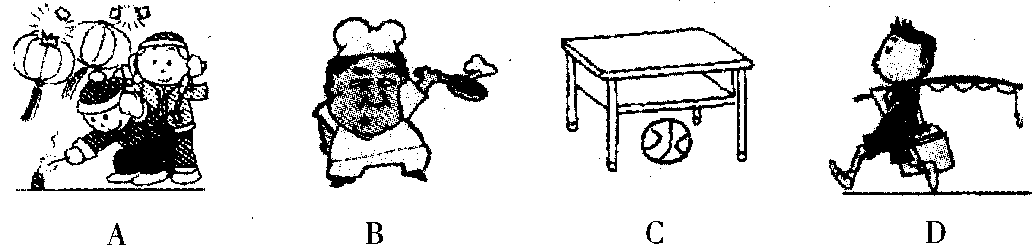
1. 2 .3. 4.
(B)听两组长对话和对话后的问题，选择正确答案。(听两遍)
听第一段对话，回答第5、6、7小题。
5. What is the girl's favourite hobby?
A. Reading. B. Singing. C. Dancing.
6. What can the girl play?
A. The piano. B. The violin. C. The guitar.
7. Which school team is the boy on?
A. Basketball team. B. Volleyball team. C. Football team.
听第二段对话，回答第8、9、10小题。
8. How will the man go to the City Library?
A. By car. B. By bus. C. On foot.
9. How often do the buses come?
A. Every five minutes. B. Every twenty minutes. C. Every ten minutes.
10. Where is the City Library?
A. It is far away from the Red Star Station.
B. It is next to the Red Star Station.
C. It is beside No. 4 Bus Stop.
根据听到的短文，选择最佳答案。(听两遍)
11. When Kitty's father came to see her, she was_________in the classroom.
A. having a meeting B. studying English
C. chatting with classmates
12. Kitty's father told her_________ and everything was fine at home.
A. to study hard B. to call back home C. to take care of herself
13. There was ._________in the bag.
A. an MP3 B. a dictionary C. a Walkman
14. Kitty's family was not so_________.
A. rich B. small C. big
15. At the end of the story, we can see that Kitty was_________.
A. sad B. grateful C. nervous
II．单项选择(共15小题，每小题l分；满分l 5分)
( )16. I have _________classmate from England. We often help each other.
A. a B. an C. the
( ) 17. Our teacher told us the earth_________around the sun.
A. turns B. turned G. turn
( ) 18. Last weekend my parents took_________to the zoo. I had a wonderful time there.
A. mine B. I C. me
( ) 19. The_________question is very difficult. I failed to work it out.
A. five B. fifteen C. fifth
( )20. —_________will the teacher be back? I have a question to ask him.
—In ten minutes, I think.
A. How soon B. How long C. How far
( )21. This basket of vegetables_________2 kilos. They are fresh.
A. weigh B. weighs C. are weighed
( )22. If you want to post a letter, youll need a_________.
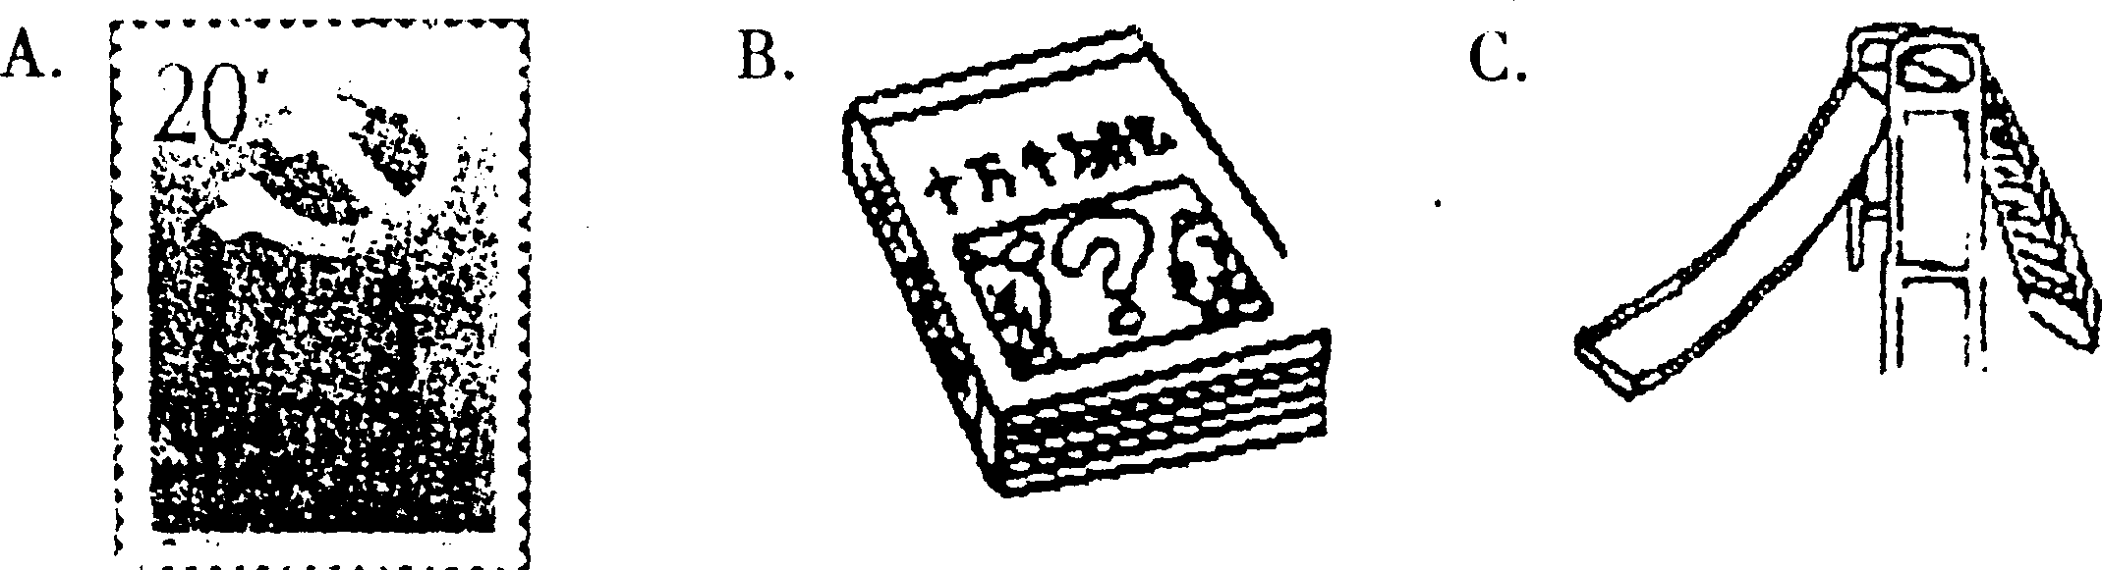
( )23. My sister doesn't like her new sweater. It makes her_________.
A. rather look silly B. look rather fat C. look rather nice
( )24. —May I speak to Mr Li, please?
—Sorry, he_________ Beijing. I think he will return tomorrow.
A. has been to B. has gone to C. goes to
( )25. She sang_________beautifully that everyone screamed.
A. such B. so C. very
( )26. It's summer now. Nick _________ something cold.
A. used to drink B. is used to drink C. is used to drinking
( )27. _________amazing! A 94-year-old woman from Changshu saved a 4-year-old boy.
A. How B. What C. What a
( )28. Which do you enjoy_________your holiday, going touring or staying at home?
A. spending B. to spend C. spend
( )29. —Must I clean the classroom right now?
—No, you_________.
A. don't B. must C. needn't
( )30. I prefer skiing to_________. The snow makes me excited.
A. cycles B. cycling G. cycled
Ⅲ．完形填空(共15小题，每小题l分；满分l5分)
阅读下面短文，掌握其大意，然后从各题所给的四个选项中选出一个最佳答案。
(A)
Alice's mother is badly ill. She wishes to go back, so she goes to her teacher, Mr Green. The following is the dialogue between them.
Alice: Excuse me, Mr Green. I'd like to have a few days 31
Mr Green; What's the matter, Alice?
Alice: My mother is ill and my father is not at home these days. I have to 32 her.
Mr Green: Oh, dear! I am 33 to hear that. Is there anything that I can do for you ?
Alice; No, thanks. The doctor says my mother is badly ill. She has a high fever, coughs day and night, and she has to be 34 for a few days.
Mr Green: I see. How long will you be away?
Alice: I hope to be back next Wednesday.
Mr Green.- All right. But you must write a note for leave.
Alice: OK. I'll write it at once, Mr Green.
Mr Green: Don't worry about your 35 , Alice. I'll certainly help you when you get back.
Alice: Thank you, Mr Green. It's very kind of you.
( )31. A. up B. off C. in D. on
( )32. A. look after B. look up C. look at D. look into
( )33. A. glad B. sad C. happy D. sorry
( )34. A. at work B. at school C. in hospital D. on duty
( )35. A. home B. deskmate C. lessons D. school
(B)
Have you ever had problems in your life and didn't know how to be happy? If so, you will find the book ' Being a Happy Teenager ' 36 . In the book, the writer, Andrew Matthews, tells us how to 37 a happy life and he also answers the questions of teenagers.
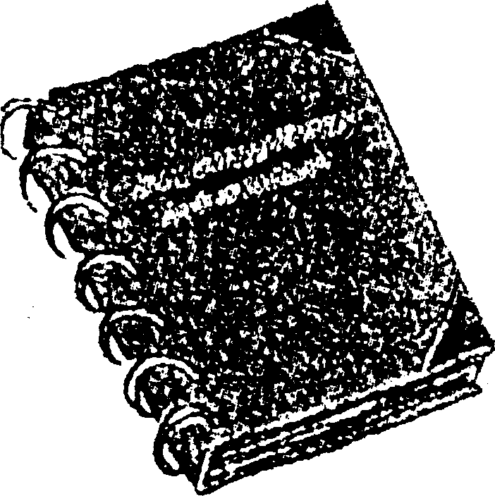
The book deals with many subjects, such as problems with parents, friends or teachers. The book says we should stop 38 with others and learn to forgive. The book teaches us some skills. For example, you can turn 39 you have learned into pictures to make your memory better.
Many teenagers think that happiness comes from a good exam result or praise (表扬) from other people. But you can still be happy 40 there are no such 'good ' things.
Success comes from a 41 attitude( 态度) . If you can learn from problems, you will have suceess in the future.
Some school students have such problems as being too tall 42 too short. But Matthews says that happiness comes from thinking in a positive( 积极的) 43 . If you are tall, maybe you will be a basketball 44 ; if you are short, your clothes and shoes take 45 room(空间) in your bedroom! This is Matthews' most important lesson: you choose to be happy!
( )36. A. useful B. useless C. harmful D. unhelpful
( )37. A. like B. meet C. mark D. live
( )38. A. being happy B. to be angry C. being angry D. to be unhappy
( )39. A. which B. what C. how D. why
( ) 40. A. before B. even though C. until D. that
( )41. A. good B. bad C. poor D. boring
( ) 42. A. but B. and C. so D. or
( )43. A. road B. way C. class D. idea
( )44. A. worker B. actor C. player D. singer
( )45. A. less B. more C. most D. much
Ⅳ．阅读理解(共l5小题，A篇每小题2分，B、C两篇每小题1分；满分20分)
阅读下面短文，从所给的四个选项中选出一个最佳答案。
(A)
Nearly every girl likes beautiful dresses and sometimes a dress may have a beautiful story behind it. Xiao Yan was born in a small village. When she was 8, she left it to live with her parents in a town. She often used impolite words when she was unhappy. Sometimes she rolled ( 滚动) on the ground. All the people around didn't like her.
Her parents tried to tame ( 驯服) her by beating and kicking, but failed. Finally, they became disappointed ( 失望的) with her.
One day, her neighbour, a woman teacher, gave Xiao Yan a beautiful snowwhite dress. She liked it very much as soon as she saw it. She put on the dress and looked like another person. ' My girl, this is the most beautiful dress, and the girl who wears it will be the most beautiful one in the world, ' the kind neighbour said, touching her head gently. From then on, the girl no longer abused( 辱骂) or hit others, even less rolled on the floor. She became lovely because she believed only the most beautiful girl had the right to wear the most beautiful dress.
In fact, everybody has a beautiful * dress' hidden somewhere in his or her heart. The only thing is that some people don't realize it. Similarly, beauty is a powerful force(力量) that is sometimes not seen by many of us.
( )46. Xiao Yan was born_________.
A. in a big city B. in a small city C. in a big village D. in a small village
( )47. When the girl's parents couldn't tame her, they were_________.
A. disappointed B. pleased C. bored D. surprised
( )48. One day, the neighbour gave the girl_________.
A. a picture of Snowwhite B. a beautiful snowwhite dress
C. a pretty doll D. a white skirt
( )49. The dress had influence on ( 对……影响) the girl. She_________.
A. wore it every day B. became a lovely girl
C. still hit others D. became the most beautiful girl in the world
( )50. From the last paragraph, we know that ' beauty' here is_________.
A. a powerful force B. a useful word C. a helpful book D. a careful girl
(B) China and Korea ( 韩国) are close neighbours with a good relationship. This year is the China-Korea Exchange Year*. So many meetings and activities, including celebration concerts and shows, will be held throughout 2007. It is certain that the Korean Wave will continue the whole year and more people from the two countries will visit each other.
To meet their needs, Asiana, one of the Asia's growing airlines(航空公司) , spreads its wings, from Beijing to Pusan, Korea's second largest city. With a huge network, passengers around the world are happy with their service. Of course this will help people from China and Korea better understand each other.
Scheduler (时刻表)
Route | Day | Time
Pusan—Beijing | Tuesday/Thursday/Sunday | Departure (出发:l 1:00 Arrival: 12:30
Beijing—Pusan | Tuesday/Thursday/Sunday | Departure: 16:50 Arrival: 18:30
Asiana also flies between Seoul (首尔 ) and Beijing/Shangha.
( )51. The year_________is the ' China-Korea Exchange Year'.
A. 2006 B. 2008 C. 2007 D. 2005
( )52. The sentence ' spreads its wings from Beijing to Pusan' here means *_________'
A. a huge bird flies from Beijing to Pusan
B. a huge wing connects Beijing and Pusan
C. a superman wants to fly from Beijing to Pusan
D. a new airline is open from Beijing to Pusan
( )53. From the schedule, you can NOT fly from Pusan to Beijing on_________.
A. Tuesday B. Saturday C. Thursday D. Sunday
( )54. The flight from Beijing to Pusan needs_________.
A. 90 minutes B. 120 minutes C. 110 minutes D. 100 minutes
( )55. From the schedule, we know passengers can fly from Seoul to_________.
A. Pusan and Beijing B. Pusan and Shanghai
C. Beijing and Shanghai D. only Pusan
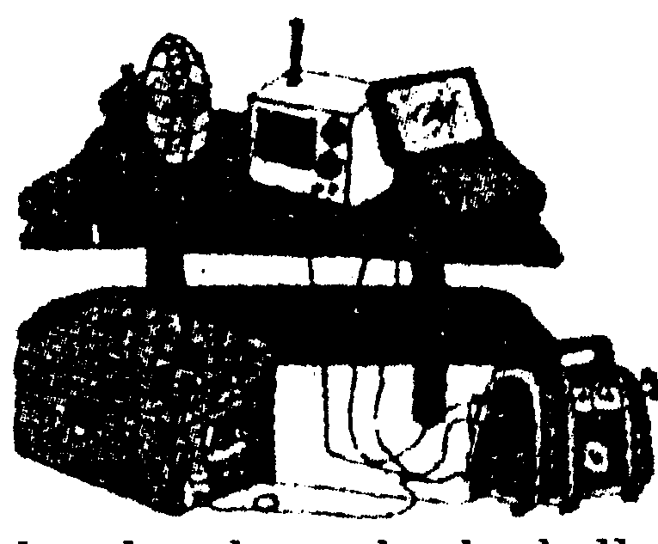
(C)
We see with our eyes and taste with our tongues (舌头). Ears are for hearing, skin is for feeling and noses are for smelling. Would anyone say that ears can smell, or that tongues can see? Actually, yes. Paul Bach-y-Rita, a scientist at the University of Wisconsin, believes that the senses can be changeable. For example, a tongue can be used for seeing. The brain( 大脑) , as we know, is a complex organ( 复杂的器官) . Even when part of it is hurt, it will try to carry out the same function by sending the function to another area of the brain.
A college student was asked to take part in an experiment. In the experiment, his eyes were covered with a small video camera. The camera was connected to a long plastic line which went into his mouth. A computer would change the video's picture. The picture would travel through the plastic line as an electric current ( 电流) , reaching the electrodes ( 电极板) inside the student's mouth. The scientist would roll a ball towards his right side, left side, or centre, and the student would have to catch it. When the scientist rolled the ball; pain passed over the
student's tongue. From the position( 位置) of the pain on the tongue, the student reached out his hand and caught the ball.
If the brain can see a ball through a camera and a wet tongue, blindness and deafness can be overcome(克服).
( )56. How many senses are talked about in the first paragraph?
A. 4 B. 5 C. 3 D. 2
( )57. What was done with the student's eyes in the experiment ? His eyes were_________.
A. badly hurt B. hit blind by others
C. covered with dark glasses D. covered with a video camera
( )58. In the experiment, a computer was used to_________.
A. change the video's picture B. surf the Internet
C. send e-mails D. collect data
( )59. What is the right order according to(根据) the experiment?
①D The scientist rolled a ball.②The student caught the ball.
③The student felt pain on his tongue.
④The scientist connected the camera to a long plastic line.
a. ①②③④ b. ②①④③ c. ④①③② d.④③①②
( )60. What could be the best title for the passage?
A. Senses Are Important B. An Interesting Experiment
C. A Famous Scientist D. Senses Are Changeable
第Ⅱ卷(非选择题，共70分)
V．听力测试．(共10小题，每小题l分；满分l 0分)
根据听到的短文，完成下列表格，每空限填一个单词。(听两遍)
It is reported that about half the school students in China do not have breakfast. Recently, a reporter from CCTV had an interview, about that with 4 students from different places.
Students | Age | Actions | Reasons
Liu Ming | sixteen | didn't 1 breakfast | to save money to play computer games
Li Ting | 2 | didn't 3 to have breakfast | to keep slim
Zhang Hua | sixteen | missed breakfast | to have more minutes in bed because of 4 homework every night
Wang Li | fifteen | had 5 time for breakfast | to do 6 as her parents were disabled
Bad results | (l)feel 7 and tired all the morning  (2)have di fficulty 8 things  (3)be bad 9 health
Suggestion | You 10 have breakfast every day!
Ⅵ．单词拼写(共8小题，每小题l分；满分8分)
根据句意和所给汉语，写出相应的单词。
11. The_________( 外套) is cheap and it fits him very well.
12. I hosted a concert on_________Day(教师节 ). Many students gave performances at it.
13. Litde Tom can dress_________(他自己) without his mother's help.
14. Uncle Wang was_________(不能) to speak good Japanese when he was in Japan.
15. The day that we had looked forward to________(到了). We could have a good rest.
16. _________(拿) some coffee here, please. Thank you!
17. The maglev(磁悬浮) train is now the_________(最快的) train in the world. Shanghai is the first to use it in China.
18. In_________( 七月) the Grade 9 students will have a farewell party after they finish their school studies.
Ⅶ．句型转换(共7小题，每空1分；满分l4分)
根据第一句的意思，完成第二句，使其意思相同或相近。每空限填一个单词。
19. Let's go to the cinema tonight, shall we? ___________________going to the cinema tonight?
20. How much will you spend on the comic book?
How much will you__________________the comic book?
21. Faye Wang held a charity party in order to raise money for their Smile Angel Foundation(嫣然天使基金会). Faye Wang held a charity party__________________they could raise money for their Smile Angel Foundation.
22. Did you visit your grandparents last night? ' Kate asked.
Kate asked me _________ I had visited my grandparents the night_________.
23. We must protect pandas well, or they will die out. Pandas will die out_________they are well_________.
24. Aunt Zhou reminded Xiao Qiang that it was dangerous to swim in that river. Aunt Zhou reminded Xiao Qiang ________ the danger of_________in that river.
25. Tom has a nice watch which his friend gave him on his birthday.
Tom has a nice watch_________ by his friend_________ a birthday gift.
Ⅷ．阅读下列短文，根据要求完成下列问题(共10小题，每小题2分；满分20分)
阅读上面短文，回答下列问题。
(A)
If you ask me what my future ambition(雄心) is, I won't say any great words to show I am a man with great minds. I may just tell you: My ambition is to save our earth!
You must be surprised to hear that. I will tell you the reason. It's because I once had a terrible dream. In the dream, I couldn't see anyone. Deserts nearly took up ( £ #) the very little farmland. I felt thirsty, but there was no water. Though I cried * Help' again and again, there was no answer. .. . Suddenly, I woke up and realized that it was only a dream. However, it is coming true. That's all our human beings' ( A^-H ffi ) faults. We must save our earth.
Long ago, human beings already began destroying(>8fc£f) the earth. They killed animals, cut trees, and invented cars. Many animals have now become endangered, and many forests have disappeared. Cars are also giving out waste gas into the air.
Our life is getting better now, but at the same time, we are beginning to suffer from the bad results: The weather is getting worse and the natural resources are running out. Luckily, we human beings have taken some actions: The birth rate ( 出生率) is under control; more trees are being planted. ... However, not everyone has taken that seriously.
I hope human beings will all be civilized(文明的). I will try to save our earth together with everybody else. That's what I want to do in the 21st century.
阅读上面短文，回答下列问题
26. What is the writer's ambition?
27. Why did the writer have the ambition?
28. Did human beings begin destroying the earth long ago?
29. What actions have human beings taken?
30. What else can you do to make our earth a better place?
(B)
Children all over the world like to celebrate their birthdays. American children are of no difference. They usually celebrate with a party. ( 1) 他们邀请朋友参加生日聚会。 The party may not be held on the right date of their birthday if it comes on a school day. (2) It may held on the weekend instead.
Today two kinds of parties are the most popular. One is held at home. ( 3 ) Parents decorate the house beautiful with balloons and coloured paper. They prepare a special birthday meal. The children play games. The other kind is held away from home. Some are at a special restaurant. The children eat pizza and ice cream. The waiters, who serve the food, also sing and tell jokes to the children. Other parties may be held at a park, or at a movie theatre, or in some other places.
(4) 每个生日聚会都有一个上面带有蜡烛的蛋糕。 There is one candle for each year of a birthday boy's or girl's age. When the candles are lighted(点燃) , everyone sings the special birthday song: HAPPY BIRTHDAY TO YOU.
As Americans grow older, their birthday parties change. In fact, many people stop having them. (5)They say they would like to forget how old they are. Yet they do like to keep the happy birthday parties of their childhood in mind.
Our school has several different P. E. activities, such as.. .
31．将(1)处的汉语译成英语。
32．将(2)处的英语译成汉语。
33．将(3)处的英语译成汉语。
34．将(4)处的汉语译成英语。
35．将(5)处的英语译成汉语。
Ⅸ．书面表达(满分l 8分)
近来，国家启动了“阳光体育工程”，旨在提高青少年身体素质。你校为响应号召，开展了一系列体育活动，请根据图表提供的信息和汉语提示，写一篇不少于80个词的短文。内容必须包括以下提示中的三项要点：
1．学校开展了哪些体育活动?最受欢迎的是什么?(见图)
2．简述你参加的一次体育活动，如一场体育比赛、一次体育锻炼的经历、一堂体育课……
3．体育活动对你学习、生活……
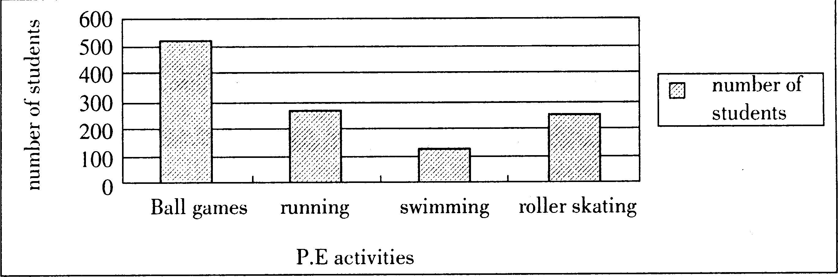
注意：开头已给出，字数不计入总数。
文中不得出现真实的人名、校名和地名。

2007年江苏省淮安市英语中考试题参考答案含听力材料

天仁英语教师资源交流网

