2007年江苏省南通市中考英语试题
共l40分。考试时间l20分钟。
第1卷(选择题共85分)
一、单项填空(本题共20小题；每小题l分，共20分)
从A、B、C、D四个选项中，选出可以填入空白处的最佳选项，并在答题卡上将该项涂黑。
1. Tom has _________ honest face, and, in fact, he never tells lies or plays tricks on others.
A, a B. an C. the D. /
2. Come on, children. Help yourselves to some _________ if you like.
A. fish and chicken B. fishes and chicken
C. fish and chickens D. fishes and chickens
3. In my class some students love music, are fond of drawing and_________ enjoy reading.
A. some ; the other B. others;the other
C. others; the others D. some ;others
4. —How about seeing the film Roman Holiday tonight?
A. Thank you B. Never mind C. Good idea D. Not at all '
5. —I'd like some... Er,... excuse me, how is the word "j-u-i-c-e"pronounced?
—It's_________.
—Thanks. I'd like some juice,please.
A. /d3u:s/ B. /'d3u:is/ C. /ju:s/ D. /'juns/
6. —How soon shall we start the bicycle trip?
A. In three day's B. After three days
C. In three days' time D. After three day's time
7. —_________day it is!
—Let's go out and have a picnic!
A. How cold B. How nice
C. What a cloudy D. What a lovely
8. —Bob, we are moving this weekend.
—Congratulations! I_________ you happiness in your new flat.
A. wish B. hope C. expect D. send
9. —Can I help you?
—Well,I'm afraid the bag is_________ heavy for you,but thanks all the same.
A. so B. too C. quite D. very
10. All my favourite story books by my mother before my last exams.
A. hid B. have hidden C. were hiding D. were hidden
11. I can_________swim_________skate. I'm going to have some training next year.
A. either; or B. neither; nor
C. both;and D. not only;but also
12. —Can you tell me_________?
—Two weeks ago.
A. when you bought the toys
B. who did you buy the toys for
C. how much the toys cost
D. how many toys did you buy
13. —Tomorrow will be Father's Day. What will you do for your father?
—I will say "I love you, Daddy"as soon as he _________ up.
A. will wake B. is waking C. wakes D. woke
14. —Will you please show me how to do the role- play exercise?
—Sure. Now let me tell you_________ first.
A. which to do B. how to do C. when to do D. what to do
15. Do you believe some special dogs can do things _________man?
A. as good as B. as well as C. as soon as D. as careful as
16. Don't_________while the bus is moving,or you may hurt yourself and even someone outside.
A. get on B. get up C. get off D. get in
17. Yesterday morning Tom hurried to class_________
his schoolbooks, so he had to share Mary's.
A. without B. for C. with D. past
18. —I came to your home yesterday afternoon, but nobody was in.
—Oh, we _________ some shopping in the supermarket.
A. have done B. did C. were doing D. are doing
19. Ann's house is ten miles away from the school and nobody else in her class lives_________.
A. far B. farther C. farthest D. the furthest
20. —May I park my car here,Sir?
—_________. You may park it over there.
A. Yes,you may B. Yes,you can
C. No,you needn't D. No,you mustn't
二、完形填空(本题共25小题；每小题l分，满分25分)请认真阅读下列短文，从短文后各题所给的A、B、C、D四个选项中，选出最佳选项，并在答题卡上将该项涂黑。
A
You must have hobbies of your own. Are you interested in our hobbies? OK,now let me tell you something about my 21 hobbies.
My hobby is collecting stamps. When I began, I tried to collect the stamps of all 22 , but there were too many, so now 1 collect only US and Chinese ones. 1 23 a lot of friends in the US, so I often get letters from them. Some of my stamps are very pretty and some are unusual. We can 24 a lot from stamps, such as the history of the countries.
My younger brother, Peter, likes 25
trains. He often goes to the station nearby and watches them carefully. 26 a train goes through the station,he writes down its name and number.
My sister's hobby is sewing. She has no sewing machine, 27 she doesn't have to worry about it—she can use my mother's. She makes most of her 28 herself, and when I tear (撕坏) my shirt or my trousers,I always ask her for 29 .
My father has a hobby, too. It is walking the 30 . Every morning and afternoon he goes walking with his handsome dog.
21. A. classmates' B. teachers' C. friends' D. family's
22. A. countries B. colours C. prices D. sizes
23. A. miss B. have C. meet t). remember
24. A. choose B. make C. learn D. take
25. A. collecting B. taking C. making D. watching
26. A. When B. Although C. Until D. Because
27. A. and B. so C. but D. or
28. A. decisions B. plans C. cakes D. clothes
29. A. money B. help C. pity D. advice
30. A. cat B. sheep C. dog D. horse
B
One day, a poor boy, who was selling newspapers from door to door in order to pay for his schooling,found he had only ten cents left,and he was 31 He decided to ask for a meal at the next house. However, he changed his mind when a young woman opened the door.
Instead of a 32 he asked for a drink of water. But as he looked so hungry, she 33 him a large glass of milk. He drank it, and then asked, "How much do I owe (欠) you?"
"My mother teaches me never to accept money for any 34 ,"she replied,"so you don't owe me anything. “
Many years later, the 35 became seriously ill. Then she was sent to a famous 36 in London.
Dr Kelly was called in to study her illness.
When he 37 the name of the town which she came 38 , a strange light filled his eyes.
As soon as he walked into her room,he recognized (认出) her at once.
He did his best to 39 her. Then he gave special attention to her. After some time she got 40 .
Dr Kelly asked for her final bill 41 she left hospital. He looked at it, then 42 something on it before it was sent to her. She was 43 to open it,for she believed it would take the rest of her life to 44 for it all. But finally she opened it, and read these words on it: Paid in full with one glass of 45 .
31. A. thirsty B. hungry C. tired D. excited
32. A_{f} tomato B. sweet C. meal D. banana
33. A. ordered B. brought C. sold D. found
34. A. business B. fitness C. illness D. kindness
35. A. woman B. boy C. man D. mother
36. A. college B. hotel C. dentist's D. hospital
37. A. called B. asked C. heard D. told
38. A. to B. from C. by D. through
39. A. save B. examine C. feed D. protect
40. A. back B. away C. well D. worse
41. A. before B. after C. when D. because
42. A. remembered B. said C. noticed D, wrote
43. A. excited B. surprised C. afraid D. ready
44. A. wait B. care C. search D. pay
45. A. water B. milk C. coffee D. juice
三、阅读理解(本题共20小题；每小题2分，满分40分)请认真阅读下列短文，从短文后各题所给的A、B、C、D四个选项中，选出最佳选项，并在答题卡上将该项涂黑。
A
The Guinness (吉尼斯)World Records Museum
Address: 329 Alamo Plaza, San Antonio, TX 78205
Open Hours：From September to May
10 am to 7 pm Sunday through Thursday
10 am to 10 pm Friday and Saturday
From June to August
10 am to 10 pm Sunday through Thursday
10 am to Midnight Friday and Saturday
Adult Single (成人单票): $ 14. 95 for 2 attractions (吸引人的展览). $18. 95 for any 4 attractions, $ 22. 95 for all attractions
Child (4—12)Single; $ 8. 95 for 2 attractions, $ 11. 95 for any 4 attractions, $ 14. 95 for all attractions
In the museum you can enter the different exhibition halls you see below. In each of these halls you can see the world records of different kinds. Sometimes you may get a chance to do something so that you can know better how a record was set
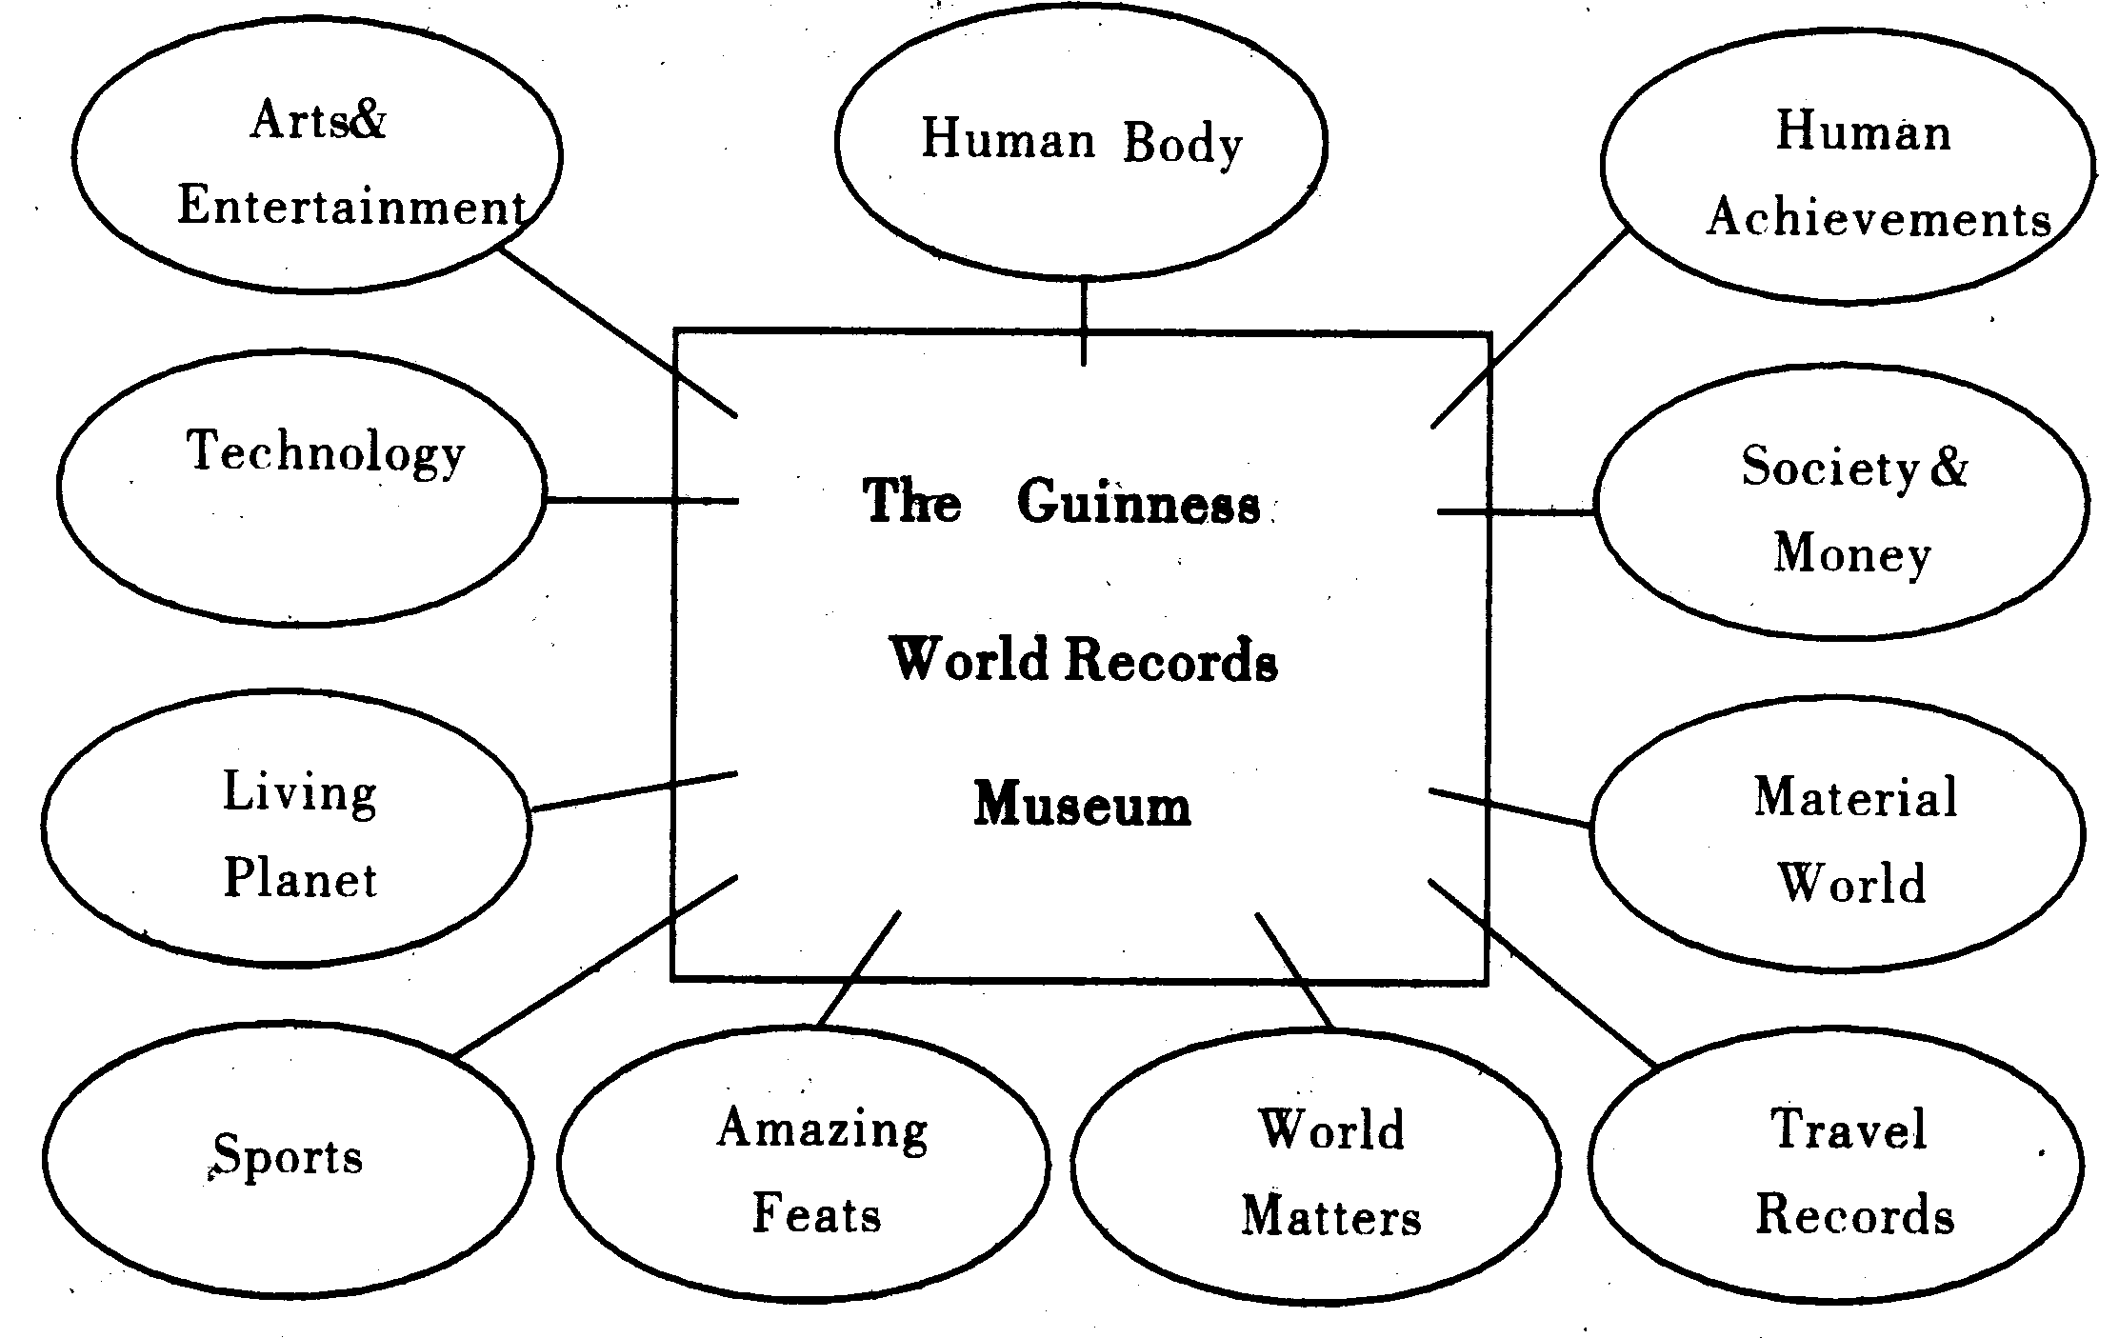

46. On a Sunday in October, you may stay in the museum until .
A. 7. 00 pm B. 8. 00 pm C. 9. 00 pm D. 10. 00 pm
47. From the advertisement we can learn that there are________visitors to the museum on Fridays
and Saturdays in summer.
A. no B. some C. fewer D. more
48. A 10-year-old girl and her mother will visit two attractions. How much will they pay?
A. $14.95. B. $17.90.
C. $ 23. 90. D. $ 29. 90.
49. If you want to see the smallest picture in the world,which exhibition hall will you visit?
A. Society & Money.
B. Arts & Entertainment.
C. World Matters.
D. Material World.
50. According to (根据) the advertisement, sometimes visitors to the museum________.
A. will surely meet one who set a record
B. may set a world record of their own
C. can experience how a record was set
D. may see someone setting a record
B
Your junior high school years are coming to an erid. After the big exam,most of you will go on to study in a senior (高级) high school. What are you expecting from senior high? Let's hear some Teens readers talk about it. Zhou Zmjie,15,from Shanghai:
I have heard that although Senior 3 is a hard year, Senior 1 and Senior 2 are less stressful. I hope there'll be time then to enjoy sports. There will be plenty to see: the Tennis Masters Cup will be held in Shanghai,and of course there is the 2008 Beijing Olympics. I am going to do something for it and I'm sure I'll really enjoy it. Jin Xin, 16, from Harbin, Heilongjiang:
I really enjoy science. I visit many science exhibitions. I am interested in UFOs too. I'm crazy about making model planes, although I'm not very good at it because I don't really have enough scientific knowledge. I'll be learning more science in senior high. In a word,sometime in the future I'm going to build an excellent model plane! Wang Yaling, 15, from Xiamen, Fujian:
I hope I can be taller in senior high school. I am only 155 cm. Many people grow faster in senior high and I hope I will too. I want to be 162 cm. But I'm not so sure about that, since most girls in my family don't grow any taller than 160 cm. I hope I'm different. Zhang Fang ,15, from Puyang, Henan:
I expect that I'll make more friends in senior high. I study in a middle school in the country. Most of my classmates live nearby. In senior high, I'll meet different people from different areas. I hope I can learn new things from them.
51. It seems that_________ has a special interest in sports.
A. Zhou Zhijie B. Jin Xin C. Wang Yaling D. Zhang Fang
52. Jin Xin believes that it needs_________ to make an excellent model plane.
A. a quite long time
B. a lot of scientific knowledge
C. knowledge of UFOs
D. help from senior high teachers
53. Wang Yaling and Zhang Fang_________.
A. are from one city B. have a similar dream
C. are the same age D. have a similar problem
54. The underlined word "stressful" in the first talk probably means "making one feel_________".
A. busy and nervous B. free and easy
C. unsuccessful and sad D. safe and happy
55. The students in the passage are talking about
A. their hobbies B. their experiences
C. their schools D. their wishes
C

BEIJING—Chinese Premier Wen Jiabao has visited the "left-behind"(留守) children whose parents are working in cities before Children's Day.
During a visit to northwest China's Shaanxi Province, Wen visited the home of Yang Saike, a primary school boy in a village of Xingping City.
Yang,whose parents were working in Fujian, thousands of kilometers away,was cared for by his grandparents. His parents fail to go home even once a year.
The premier held Yang in his arms and looked through his exercise book and praised him for his hard work.
Wen talked with many children and asked them many questions about their schooling and life.
"You are so pretty,"Wen said to Liu Mengqi, a seven-year-old girl living with her grandmother. Liu's parents were also working in the city.
"Have you been to school yet?"Wen asked two
other girls.
" We are going to the pre-school class," said one.
"Mom and dad at home?"Wen asked. The children shook their heads.
"Children cannot see their parents very often, which is a new problem in the country-side. We should give them more care and love," said the premier.
With fast economic ( 经济的) development, more people in the country chose to work in cities and left their children with grandparents or relatives back home,said Wen.
The premier asked local governments to do something to protect and care for such children at home and freeing their parents in cities from worries about their children.
56. Wen says a new problem in the country is that "left-behind"children_________.
A. seldom get care from the government
B. seldom get together with their parents
C. cannot do well in school like others
D. cannot get any love from their parents
57. Children whose parents have moved to work in cities are probably looked after by______ .
A. their teachers B. their neighbours
C. their grandparents D. their friends
58. According to (根据) Wen,more country people go to work in cities because of
A. great losses of farmland B. their hope for city life
C. economic development D. their poor country life
59. Wen Jiabao requires local governments_________.
A. to do more for " left-behind" children and their parents
B. to let the parents see their children only once a year
C. to stop the local people from going to work in cities
D. to build more schools for the " left-behind"children
60. The proper title (标题) for this passage is "Wen: Give_________more love".
A. poor children B. disabled children
C. country children D. 'left-behind'children
D
April 22 is Earth Day. Everyone on earth should care about and protect the earth!
The earth has warmed by about 1 °F (华氏度) over the past 100 years, but why and how? Well, scientists are not quite sure. Maybe the earth gets warmer and warmer on its own. But many scientists say that people are doing many things which makes the earth warmer.
First,greenhouse effect (温室效应) is a very important reason for the change of the earth. People give out too much energy into the air every year. It makes the earth warmer. Climate ("n. f^ ) change is another important reason. Sometimes it becomes too hot and sometimes too cold. Sometimes there is too much rain and sometimes too little. The change of the climate makes the earth warmer. In turn, the warmth of the earth changes the climate,too.
When the earth becomes warmer,there may be more rain and a rise in sea level. It will affect the growth of plants, animals and people. On a Pacific island, 100 people have to move to higher ground because the sea is rising. These people can no longer live on the coast. Before that,two islands without people went underwater in 1999. Scientists say that the seas can rise by nearly one metre by 2100.
People can affect the earth's air, land and water. As for us, we can do many things to protect the earth. For example, we can use fridges less. We can tell more people about protecting the earth.
61. Earth Day is probably set for people to_________.
A. learn more about the earth
B. make full use of the earth
C. take better care of the earth
D. study the warmth of the earth
62. We can infer (推断) from the passage that the reasons for the warmer earth are_________now.
A. not very clear B. completely secret
C. well known D. not given yet
63. Greenhouse effect comes from_________.
A. sea rising B. climate change-
C. nature's unbalance D. people's activity
64. According to the passage,_________ may affect each other.
A. animals and islands
B. climate and the warmth of the earth
C. fridges and animals
D. sea level and the growth of plants
65. The passage mainly tells us that________.
A. there is more rain now
B. we should protect the earth
C. we must stop pollution
D. sea level is getting higher
第Ⅱ卷(非选择题共。55分)
四、词汇(本题共20小题；每小题l分，满分20分)
A．请根据题中空格后的中文提示、英文释义或句意，写出句中所缺单词，使句子通顺。(每小题1分，共7分)
66. Andy always tells lies, so _________ (几乎) no one in his class believes him now.
67. Our Maths teacher spent about 2 hours_________
(解释) the tough problems to us.
68. Did you go to the _________ (剧院) with your
cousin last night?
69. Don't walk_________ (from one side to the other) the street when the traffic lights are red.
70. Yao Ming has a lot of _________ (people who
like a famous person) in China.
71. - What is the day after Monday,Daniel?
—It's_________.
72. He was _________ before the eye operation.
Now he can see things clearly.
B．请根据句意从方框中选用合适的词，并用其适当形式填空，使句子通顺。(每小题1分，共7分)
leaf safe sleep twelve us treat own
73. After I talked with the_________ of a local hotel, I decided to stay there for the night.
74. The talk was so boring that many of us felt_________.
75. Look at the photo. Do you know the _________
person from the left?
76. When autumn comes, you can see red maple _________ everywhere in their school.
77. Your flat is just two floors below_________,so
we are new neighbours.
78. The policeman told the young man to drive _________ in the busy street.
79. Children in poor areas can't have enough money for medical _____.
C．请根据句意从方框中选用合适的动词，并用其适当时态填空，使句子通顺。(每小题1分，共6分)
ring type repair win see fly
80. Look,the girl_________ her composition quickly on the computer.
81. Julia_________a kite with her sister every Sunday afternoon,doesn't she?
82. Mr. Wu,how many medals do you think Jiangsu _________ in the next National Games?
83. —Why didn't you come yesterday?
—I did. I_________the bell for a long time but nobody answered.
84. you _________ my glasses? I put them on my bag,but I can't find them now.
85. Peter_________his. bike when his uncle came to see him.
五、对话填空(本题共10小题；每小题l分，满分l0分)请认真阅读下面的对话，并根据各题所给首字母的提示，在右栏中标有题号的横线上，写出一个合适的英语单词完整、正确的形式，使对话通顺。
W: Wow, another lovely spring day! But I hear spring isn't very pleasant here.
M:That (86)w_________ really true in the, past. It used to be very dusty ( 灰蒙蒙的) ( 87 )w_________ there were sandstorms in spring. (88) H , it won't last long because a lot of trees have been planted. Now spring here is (89)m_________ pleasant than it was.
W:Is that so? In my country, we (90)h_________ quite a long spring. It's windy, but we don't
mind the (91)w________. There is a breath of spring in it. It seems good to us after a long (92)c_________ winter.
M: Winter here is rather long, too, but the cold is not too bad.
W:Do you get much rain (93)d_________the year?
M:Not much. We only have a (94)r_________ season in summer, that is, in (95)J_________ and August. It's rather hot then. But it's the best growing season of the year.
86. _________ 87._________88._________ 89._________90._________
91._________92._________ 93._________94._________ 95. ___
六、阅读与回答问题(共5小题；每小题l分，满分5分)请认真阅读下面的短文，根据短文内容回答短文后的各个问题，并将答案写在每个小题下的横线上。
Wang Fei, a Chinese student, and Mary, an American student studying Chinese in China, were in a supermarket. They saw a young man walking down the stairs. In his hurry,he missed the last two steps and fell onto the ground. He tried to stand up while people around him laughed. Luckily, he seemed to be OK.
Mary found Wang Fei smiling a little and was not happy about it. "Tell me,Fei,how could people laugh when someone fell like that? Why didn't they go up and ask him if he was hurt?"
Wang Fei said," Because they knew he wasn't hurt too much. "
"But I still don't understand. A fall is a.fall. In my culture,people would never laugh!^{n}
This is an example. The Chinese and the westerner will think and act differently when seeing such a thing. Chinese people are used to laughing or smiling. Very often the person who is in embarrassing ( 困窘的) situation would also laugh or smile to get out of it. However, if someone gets hurt seriously, it will not be a laughing matter arty more. People will help him or her instead.
But, in that case, a westerner will rush over
and help the person get up. If a westerner falls, he or she, like a Chinese person, may try to make a joke if he or she is not hurt. If two close friends are walking together, and one falls but clearly isn't hurt,a common joke is to say "Have a nice trip".
So different people have different habits and different countries have different cultures.
96. Will Wang Fei and Mary think and act in the same way if they see a young man falling down?
97. Why didn't people go up and ask the young man if he was hurt?
98. What do Chinese people often do when they find themselves in embarrassing situation?
99. What is a westerner likely to do when he or she sees someone fall down?
100. What might Mary say to Wang Fei if he fell but clearly was not hurt?
七、书面表达(共20分)
假如你是张通，应英国朋友Jane的要求，写一封信介绍你校开展“阳光体育活动"的情况。内容须包括下面图表中的各有关信息。
“阳光体育活动"
活动 |  | 主要参加者 |  | 选择原因
时间 | 项目 | 男生 | 女生 | 喜爱 | 放松 | 健体 | (自拟) | 我的感想
每天  一小时 | 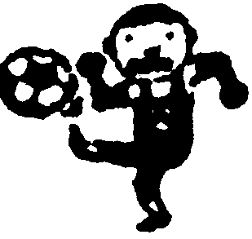 | √ |  | √
每天  一小时 | 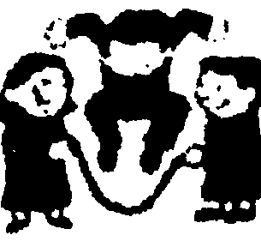 |  | √ |  | √
每天  一小时 | (自拟) | √ |  |  |  | √ |  | (自拟)
每天  一小时 | (自拟) |  | √ |  |  |  | √ | (自拟)
注意：1．词数90左右。信的开头、结尾以及提示句
已为你写好，不计入词数。
2．内容可适当发挥，注意行文连贯。
3．文中不得出现真实人名或校名。
4．参考诃汇：跳绳一skip vi．
Dear Jane,
Thank you for your last letter asking about our Sunshine Sports Programme.________________
I think the Sunshine Sports Programme is very important to us students.________________________
Best wishes, Zhang Tong

2007年江苏省南通市中考英语试题参考答案含听力材料
一、1.B 2. A 3. D 4. C 5. A 6. C 7. D 8. A 9. B 10. D 11. B 12. A 13. C 14. D 15. B 16. C 17. A 18. C 19. B 20. D
二_{s} 21. D 22. A 23. B 24. C 25. D 26. A 27. C 28. D 29. B 30. C 31. B 32. C 33. B 34. D 35. A 36. D 37. C 38. B 39. A 40. C 41. A 42. D 43. C 44. D 45. B
三.46. A 47. D 48. C 49. B 50. C 51. A 52. B 53. C 54. A 55. D 56. B 57. C 58. C 59. A 60. D 61. C 62. A 63. D 64. B 65. B
四、66. almost 67. explaining 68. theatre/theater 69. across 70. fans 71. Tuesday 72. blind 73. owner 74. sleepy 75. twelfth 76. leaves 77. ours 78. safely 79. treatment 80. is typing 81. flies 82. will win 83. rang 84. Have. .. seen 85. was repairing
五、86. was 87. when 88. However 89. more 90. have 91. wind 92. cold 93. during 94. rainy 95. July
六、 96. No(,they won't). 97. Because they knew he wasn't hurt too much. 98. (They often) laugh or smile. 99. (He or she may/will/is likely to) rush over and help the person get up. 100. (She might say) "Have a nice trip. " -fc>» One possible version: Dear Jane,
Thank you for your last letter asking about our Sunshine Sports Programme. Now we have sports for an hour every day. In my school, most boys are crazy about football as they find it exciting. Some of them play basketball to make themselves strong. On the other hand, girls often skip to relax themselves and many of them prefer exercises since they believe they will keep them fit and slim.
I think the Sunshine Sports Programme is very important to us students. We used to be tired and some of us were not strong enough because we had so much schoolwork that we hardly had enough time for sports. So the Programme will certainly do good to our health and growth.
Best wishes, Zhong Tong

天仁英语教师资源交流网

