2007年江苏省盐城市中考英语试题
试卷I(选择题，共85分)
一、听力(共20小题，每小题l．5分，计30分)
A．听下面5段对话。每段对话后有一个小题，从小题中所给的A、B、C三个选项中选出最佳选项。每段对话读一遍。
1. What time does the class begin?
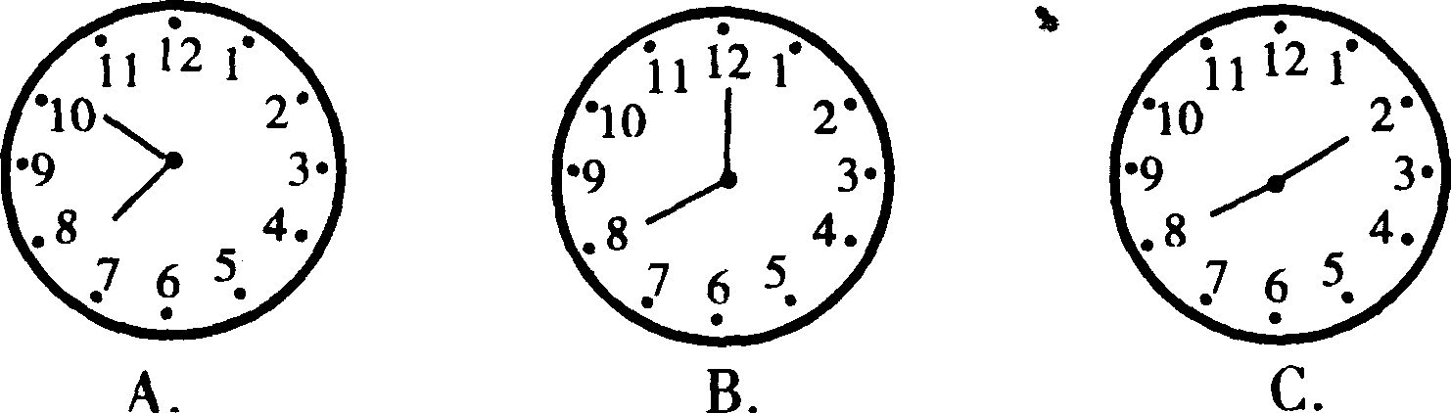
2. What's the weather like tomorrow?

3. What's Simon's favourite sport?
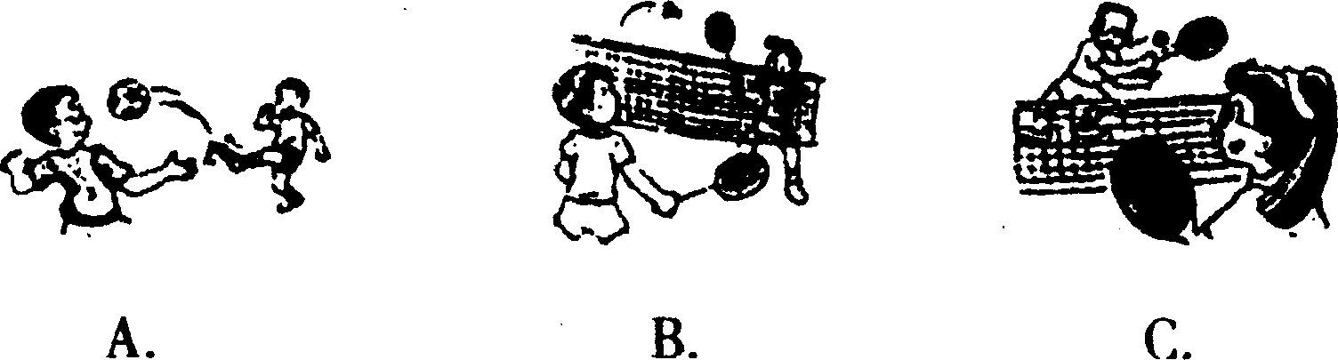
4. What are they talking about?
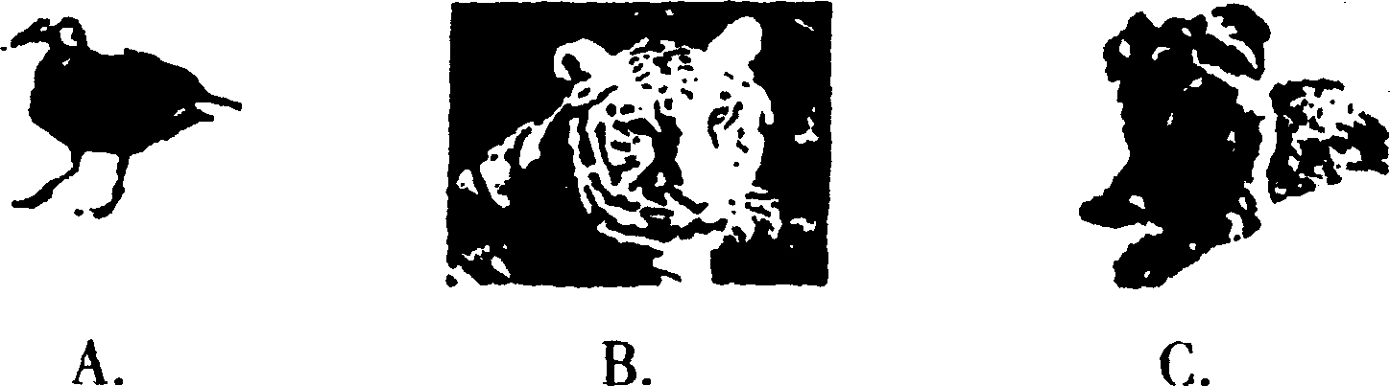
5. Where does Jane come from?
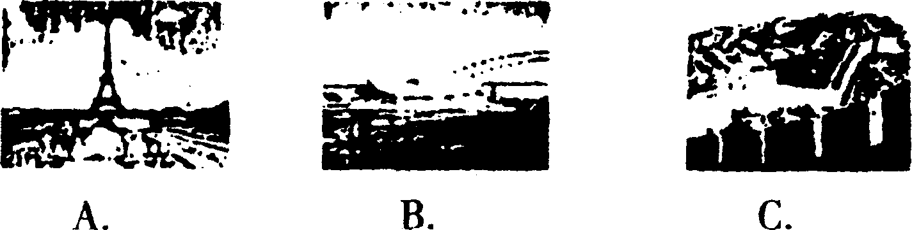
B．听下面5段对话或独自。每段对话或独自后有几个小题，从题中所给的A、B、C三个选项中选出最佳选项。每段对话或独白读两遍。
听第6段材料，回答第6～7小题a
6. Why does the girl call John?
A. She needs some help.
B. She invites John see a film.
C. She wants to chat with John.
7. Where will they meet?
A. At the cinema. B. In the library. C. At the girl's home.
听第7段材料，回答第8～10小题。
8. Where is Millie going?
A. To a party. B. To a fashion show. C. To school.
9. How are these trousers?
A. Too long. B. Too short. C. Too tight.
10. What does Millie choose to wear in the end?
A. A white T-shirt and jeans.
B. A blue shirt and trousers.
C. A red shirt and trousers. 0-13/Jx«.
听第8段材料，回答第ll～13小题。
11. Why does the man telephone the English-help Centre?
A. He wants to join the English club.
B. He has some problems with his English.
C. He wants to help others with their English.
12. What is the man weak in?
A. Speaking and writing. B. Speaking and listening. C. Only listening.
13. How many suggestions does the lady offer?
A. One. B. Two. C. Three.
听第9段材料，回答第14～16小题。
14. Why does the woman want to return the radio?
A. She doesn't like it any more.
B. She wants to buy a new one.
C. Something is wrong with it.
15. How long does the woman have to wait if the radio is repaired?
A. One week. B. More than two weeks. C. Three days.
16. Where are they probably talking?
A. In a school. B. At a shop. C. At the station.
听第l0段材料，回答第17～20小题。
17. How does the right music make us feel?
A. Good. B. Unhappy. C. Angry.
18. What is the right music for us when we study at home?
A. Loud music. B. Pop music. C. Music without singing.
19. What can help us with our English study according to the passage?
A. Watching a TV play.
B. Talking with friends.
C. Listening to English songs.
20. Why is music a special gift for us?
A. It can help us in some ways.
B. It can make us sing.
C. It can make us dance.
二、单项填空(共10小题，每小题l分，计10分)
从A、B、C、D四个选项中选出一个可以填入句中空白处的最佳答案。
21. Sandra works in a big factory. She's_________worker.
A. a B. the C. some D. /
22. Qinghai-Tibet Railway(青藏铁路) was completed last year. It is the __________ railway that connects Tibet with the other parts of China.
A. first B. second C. third D. fourth
23. Studying in a foreign country is a different _________ and you can learn a lot.
A. event B. exercise C. experience D. exhibition
24. Yi Zhongtian's simple and interesting explanation of history has _________ lots of TV viewers.
A. caused B. attacked C. tested D. attracted
25. The bus came and we_________.
A. got off B. got up C. got on D. got to
26. The number of giant pandas is getting _________ because their living areas are becoming farmlands.
A. less and less B. larger and larger
C. smaller and smaller D. fewer and fewer
27. —Two Evening Papers，please!
—Only one copy left. Would you like to have_________,sir?
A. one B. it C. this D. that
28. —Do you know_________?
— He has gone to the museum.
A. where he lives B. where he is
C. how he is getting on D. what's wrong with him
29. —Ann is in hospital.
—Yes,I know. I_________ her tomorrow.
A. visit B. used to visit
C. will visit D. am going to visit
30. Simon_________ his fingers when he was cooking the dinner.
A. burnt B. was burning C. has burnt D. had burnt
三、完形填空(共15小题，每小题l分，计15分)
阅读下面短文，掌握其大意，然后从各题所给的四个选项中选出最佳选项。
In the 13th century, Marco Polo travelled a long way to China. He was a famous Italian 31 During his stay in China, he saw many wonderful things. One of the things he 32 was that the Chinese used paper money. People in 33 countries didn't use paper money until the 17th century. However,people in China began to use paper money in the 10th century. 34 was invented by a Chinese about 2 000 years ago. His name was Cai Lun. He then 35 these pieces of paper together and made them into a 36 .
Now paper mainly comes from trees. We use it every day. 37 we waste a lot of it. If we keep on doing so, people 38 cut down many more trees. Then there will not be any trees left. If there are no 39 , there will be no paper.
So how can we 40 paper? When we making notes,we can use 41 sides of each piece of paper. We can buy drinks in bottles instead of 42 in paper packets. We can also use cotton handkerchiefs ( 棉手帕) and not the paper ones.
43 we go shopping, we can use fewer paper bags. If the salesman gives us a paper bag, we can keep it and 44 it later. We can help to protect trees if we think 45 . We should to it now,before it is too late.
31. A. traveller B. actor C. doctor D. driver
32. A. disliked B. disagreed C. invented D. discovered
33. A. Eastern B. Western C. Southern D. Northern
34. A. Iron B. Paper C. Television D. Silk
35. A. collected B. divided C. moved D. put
36. A. magazine B. newspaper C. book D. dictionary
37. A. Sometime B. Some time C. Sometimes D. Some times
38. A. have to B. mustn't C. used to D. shouldn't
39. A. books B. trees C, leaves D. factories
40. A. make B. use C.save D. buy
41. A. all B. each C. every D. both
42. A. them B. those C. these D. ones
43. A. Before B. After C. As soon as D. When
44. A. repair B. record C. reuse D. return
45. A. carefully B. badly C. quickly D. freely
四、阅读理解
A．阅读下列短文，从每题所给的A、B、C、D四个选项中选出最佳选项。(共15小题，每小题2分，计30分)
(i)
Children in England mustn't work until they are 13. They need to have a work permit (许可证) to start working.
The jobs teenagers can do:
Delivering (递送) newspapers: Many teenagers will get up early to deliver newspapers to houses in their local area before going to school. They are known as Paper-boys or Papergirls.
Babysitting: Looking after young children in their home while their parents have gone out for the evening is a popular job for teenagers, as they get money for watching children and television all at the same time!
Helping the Milkman: From the age of 14 some teenagers help the milkman deliver milk to houses.
Other popular jobs ： Working in a shop; Office work; Washing cars ; In a cafe or restaurant. The hours teenagers (13 and 14 year olds )can work:
School Days: Not more than 2 hours in one day during the following periods:
Morning 7 a. m. —start of school or Evening : close of school— 7 p. m.
Saturdays: Up to 5 hours between 7 a.m. and 7 p.m.
Sundays: Up to 2 hours between 7 a.m. and 11 a. m.
Term time: Up to 12 hours a week (Including weekends)
46. In England how old do children have to be before they can work?
A. 15. B. 14. C.10. D. 13.
47. Paper-boys and Papergirls deliver newspapers
A. early in the morning
B. at noon
C. in the afternoon
D. in the evening
48. Teenagers in England can do all of the following except_________.
A. work in an office
B. work in a night club
C. look after young children
D. deliver newspapers
49. How many hours a week may teenagers work during the term time?
A. 10. B. 14. C. 17. D. 20.
(II)
Olympic torch relay (奥运火炬接力) planned route
Beijing, April 27—The Beijing 2008 Olympic Torch Relay will cover the greatest area and include the largest number of people. The plans were announced on Thursday night. The planned route would last 130 days and travel 137 000 km.
First Nobel Prize winner to donate to Hope School
Chinanews, Beijing, May 10—Professor Dannel Chee Tsui, in the USA, signed the agreement to donate 350 000 yuan to his home town to build a Hope Primary School in China.
Bill Gates receives Tsinghua honorary doctorate
Beijing,April 20—Bill Gates, chairman of global IT giant Microsoft, received an honorary doctorate (荣誉博士学位) when he
visited China's famous Tsinghua University on Thursday.
Big Shaolin kung fu center to be built in Russia
Chinanews, Beijing, April 27—China and Russia have signed a letter of intent ( 意向书)on the building of a Shaolin kung fu center in Russia. It will be the first of its kind in Russia,and also the biggest overseas kung fu center when it is completed.
50. How long will the Beijing 2008 Olympic Torch Relay last?
A. One month.
B. Two months.
C. Three months.
D. More than four months.
51. Who signed an agreement to donate money to build a Hope Primary School on May 10?
A. Bill Gates.
B. Professor Daniel Chee Tsui.
C. Beijing government.
D. Tsinghua University.
52. What will be built in Russia according to the news?
A. A university.
B. A sports centre.
C. A Shaolin kung fu center.
D. A Hope Primary School.
(III)
Hi,my name is Erik. I live in a small town in the southeast of England. In my house there are three rooms downstairs ad three rooms upstairs. Now I'll show you some of the rooms.
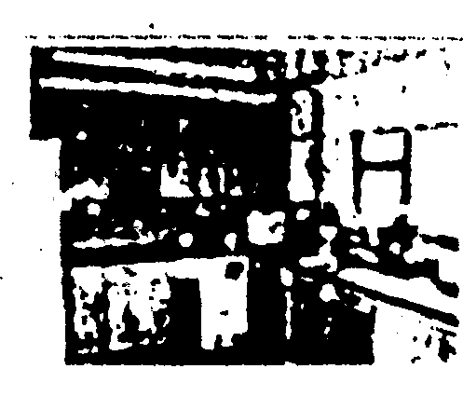  Kitchen |  | The fridge—This is the place where mum keeps things cool.  Dad's computer—Not everyone in England has a computer in his kitchen but my dad has. Washing Machine—Mum washes our clothes here and hangs them  out in our garden to dry.
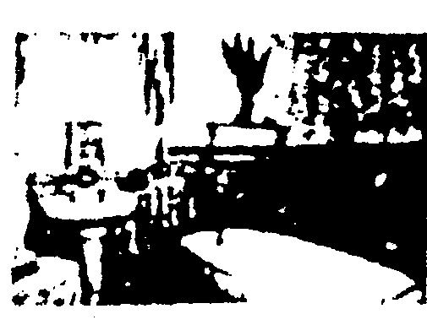  Bathroom | A toilet.  A bath—We fill the bath up with water and then climb into it to wash ourselves.  A sink with two taps (one for hot  water and one for cold). I clean my teeth at the sink and also wash my hands and face.  Laundry basket—This is where I put my dirty clothes for washing.
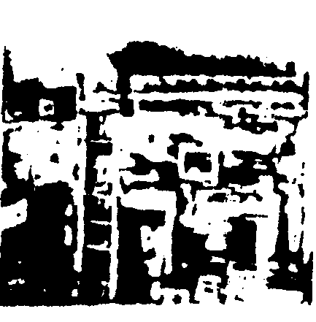  Bedroom | My own computer and my own television.  Wardrobe—to hang my clothes in.Bookcase—for my books.  My bed—My bed is high up as I have my desk and my computer under it.
- The living room is also downstairs. It is where the television is. We eat our food and watch TV there. The three rooms upstairs are all bedrooms.
53. Where will Erik's father go if he wants to surf the Internet?
A. To the kitchen.
B. To the living room.
C. To the bathroom.
D. To go upstairs.
54. Where does Erik put his dirty clothes?
A. In his bedroom.
B. In the living room.
C. In rooms upstairs.
D. In the bathroom.
55. If Erik wants to watch TV, he may go to_________.
A. his bedroom
B. the kitchen or the living room
C. the living room only
D. the bathroom or his bedroom
56. The best title for this passage is_________.
A. I love my bedroom
B. My family and my house
C. Inside an English house
D. Houses in England
(IV)
Do you want to know something about children in Africa? What to they do for fun every day? Find out here:
Education
School is expensive for many African children. Lots of families can't afford school uniforms or exercise books even though they don't have to pay for school.
For those lucky enough to go to school , they have a lot to learn. Some take two language classes: English or French, and their first language. There is also math, science, history, social studies and geography. Chores take up much of children's time after school. They have to get water and firewood for the family every day. Also there's cleaning , washing and helping Mum with the meal.
Daily fun
It's not all work and no play. Sports are very popular. Children can make goals with twigs ( 嫩树枝)and their own footballs with plastic and bits of string ( 绳子 ). They play in the country and the streets of old towns. There're many football teams for teenagers in Africa.
Internet
It's really expensive to get on the Internet. To surf the net for 20 hours costs over 600 yuan. This is more than the average (平均 的) monthly pay per person.
Egypt and South Africa are the top two users of the Internet in Africa. All of the capital cities there can get on the Internet.
Some schools offer computer lessons but few students can enjoy computer fun at home.
57. The underlined word "Chores" probably means
A．网上冲浪B．家务杂活C．体育活动D．家庭作业
58. Sports are very popular in Africa because children _________.
A. do not need money to play
B. can play all kinds of ball games
C. don't like to go to school
D. don't like to do their homework
59. The passage is mainly about_________.
A. education in Africa
B. children's school life in Africa
C. the Internet in Africa
D. children's daily life in Africa
60. From the passage, we can infer (推断) that in Africa_________.
A. basketball is popular among children
B. children in Africa have to pay for school
C. some children in Africa have to take two foreign language classes
D. people in Egypt and South Africa may get higher pay than people in the other countries
试卷lI(非选择题，共55分)
B．阅读下面短文，根据短文内容完成相关任务。(共5小题，每小题2分，计10分)
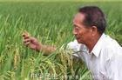
Every scientist has a childhood dream. A scientist in China once had a dream. He wished to grow a new
type of rice. This new type of rice would be as big as peanuts. This person is Yuan Longping—"Father" of Hybrid rice(杂交水稻).
Yuan Longping was born in 1930. He graduated from the Southwest Agricultural (农业) University in 1953. He came up with an idea for a Hybrid rice in the 1960s. Since then,he has devoted himself to research and to the development of new varieties.
In 1973,together with other people,he succeeded in the development of Hybrid rice. This made China a worldwide leader in rice production(生产). In 1980, the technology (技术) for hybrid, rice was introduced to the United States. Now his " super rice" has been introduced to more than 20 other countries.
Because of Professor Yuan's hard work,China now produces enough rice to feed her people every year. Last November an online survey showed that most Chinese believed that Yuan deserved (应得) a Nobel Peace Prize.
In his spare time, Yuan Longping loves playing the violin and listening to music. Every night, he reads for half an hour before he goes to sleep. He likes swimming, too. It is said that Professor Yuan is one of the richest people in China. But he cares about nothing but his research.
61. What was Yuan Longping's childhood dream?
62. What are Yuan Longping's hobbies?
63. The underlined word "her" in 4th paragraph means_________.
64. Seven years after the successful development of
Hybrid rice,it was introduced to_________. On
the map No._________ is where the country is.
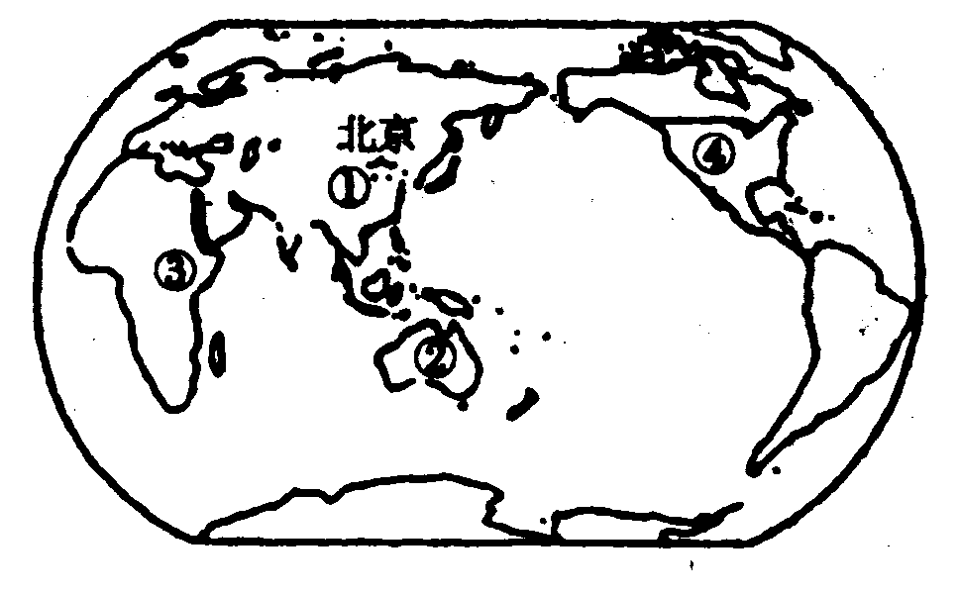
65. According to the following explanations of the word "variety" in a dictionary,the word "varieties" in 2nd paragraph probably means_________.

variety／vaIralatl／挖．1．多样化的；变化：give～toth．eprogramme使节目丰富多彩／Hiswritinglacks～．他的文体缺乏变化。2．种类：achoice～ofblacktea特级红茶／varietiesofcloth各种布匹3．种种：Ironhasavarietyofuses．铁有种种用处。4．【生】变种；品种；【语】异体：anewvarietyofapples苹果的新品种
(65)
五、词汇(共20小题，每空1分，计20分)
A．根据句意、汉语提示或首字母和英文释义写出单词的正确形式。
66. —I don't like this CD-ROM.
—Me_________(也).
67. Have you_________(回复) to his letter?
68. China Daily is a_________(窗口)for foreigners
to know about China.
69. It is said that the Opening Ceremony of the Beijing 2008 Olympic Games will be covered_____(实况转播).
70. Look! Some birds are ___________ (飞 ) in the sky.
71. National Day is on O_______(the tenth month of
the year) 1st.
72. Do you know how long Yancheng Railway Station has been in s_______(use)?
73. People use mobile phones to sent short text m_______(pieces of information)to each other.
74. Could you please give me some v_______(very useful and helpful) advice on how to keep fit?
75. I've heard of Jackie Chan for years. Since I was a child,a_______(in fact).
B．甩方框中所给词语的适当形式填空，使短文正确、通顺、连贯(每词限用一次)
learn,not understand, question, she, but also, not take, America,in surprise,do, no problem
A piece of cake
I knew little about English when I first came to America. So I went to a language school every day 76 English. One day, during the break, I asked one of my classmates a 77 that I didn't understand. When I thanked 78 for it, she said, "You are welcome. It's a piece of cake. " I thought to myself; 79 is really a society(社会) for money. Everything 80 for pay there. So I said to her,"I 81 any piece of cake with me today. What about a piece of biscuit?"
She looked at me 82 , then smiled. Then she realized that I 83 her. She said, " What I mean is ' 84 '. " Then I came to learn that " a piece of cake" is not only a piece of cake, 85 means a thing that is very easy,
76._________ 77. _________ 78. _________79. _________ 80. _________ 81._________82._________ 83. _________ 84._________85._________
六、写作
A．用所给提示词将下列各句译成英语。(共5小题，每小题2分，计10分)
86．我们的城市多美啊!(how)

87．这张照片使你想起了什么?(remind)

88．你最好马上就走，否则要迟到了。(hadbetter)

89．她花了大半辈子的时间来照顾残疾人。(spend．．．doing)

90．如果明天有空，我们就去看巩俐演的那部新片。

B．书面表达(共1题，计15分)
假如你是WuMin9，你的美国网友Ricky通过E—mail给你发来一些照片和英语阅读材料，请用英语回复他的E-mail。．
内容要点：1．收到邮件，并表示感谢；
2．对Ricky发来的照片和阅读材料(readin9’materials)作简单的评述；3．告诉Ricky你的近况。(bebusywith／doing)
要求：l．所给的内容要点都要用上，并可适当发挥；
2．不得出现真实的人名和地名；3．词数：80左右。
Dear Ricky,
How are you getting on? ____________-
I'm looking forward to hearing from you soon.
Yours, Wu Ming

2007年江苏省盐城市中考英语试题参考答案
—, S&
二,21. A 22. A 23. C 24. D 25. C 26. C 27. B 28. B 29. D 30. A
三, 31. A 32. D 33. B 34. B 35. D 36. C 37. C 38. A 39. B 40. C 41. D 42. B 43. D 44. C 45. A
四 46. D
47. A 48. B 49. A 50. D 51. B 52. C 53. A 54. D 55. A 56. C 57. B 58. A 59. D 60. D 61. To grow a new type of rice. /He wished to grow a new type of rice. /His wish was to... 62. Playing the violin, listening to music, reading books and swimming. 63. Chinese/China's 64. the USA/the US/America;4 65. 品种/变种/4 31 > 66. either 67. replied 68. window 69. live 70. flying 71. October 72. service 73. messages 74. valuable 75. actually 76. to learn 77. question 78. her 79. America 80. is done 81. haven't taken 82. in surprise 83. hadn't understood 84. no problem 85. but also 六, A. 86. How beautiful our city is! 87. What does/ did this photo/picture remind you of? 88. You'd better go at once/right away, or you'll be late. 89. She (has) spent most of her life (time) (in) caring for/looking after/taking care of the disabled (people). 90. If we are free/have time tomorrow, we will go to (the cinema to) see the new film starring Gong Li. B. One possible version: Dear Ricky,
How are you getting on? Thanks very much for sending me the pictures and the English reading materials. From the pictures I can see that your school looks very beautiful. The reading materials are very useful and helpful. I can learn a lot from them. Some stories are so interesting that I like them very much.
Now I don't have much time for my hobbies. I am busy getting ready for the coming exam( s). I'm working hard at all my lessons because I want to get a better result.
I'm looking forward to hearing from you soon. Yours, Wu Ming

天仁英语教师资源交流网

