2007年江苏省镇江市中考英语试题
1．本卷满分110分，全卷共8页。考试时间l00分钟。
一、听力(共20小题；每小题l分，满分20分)
A)听录音，从A、B、C三幅图中选出与你所听内容相符的选项，填在题前括号内。(读一遍)
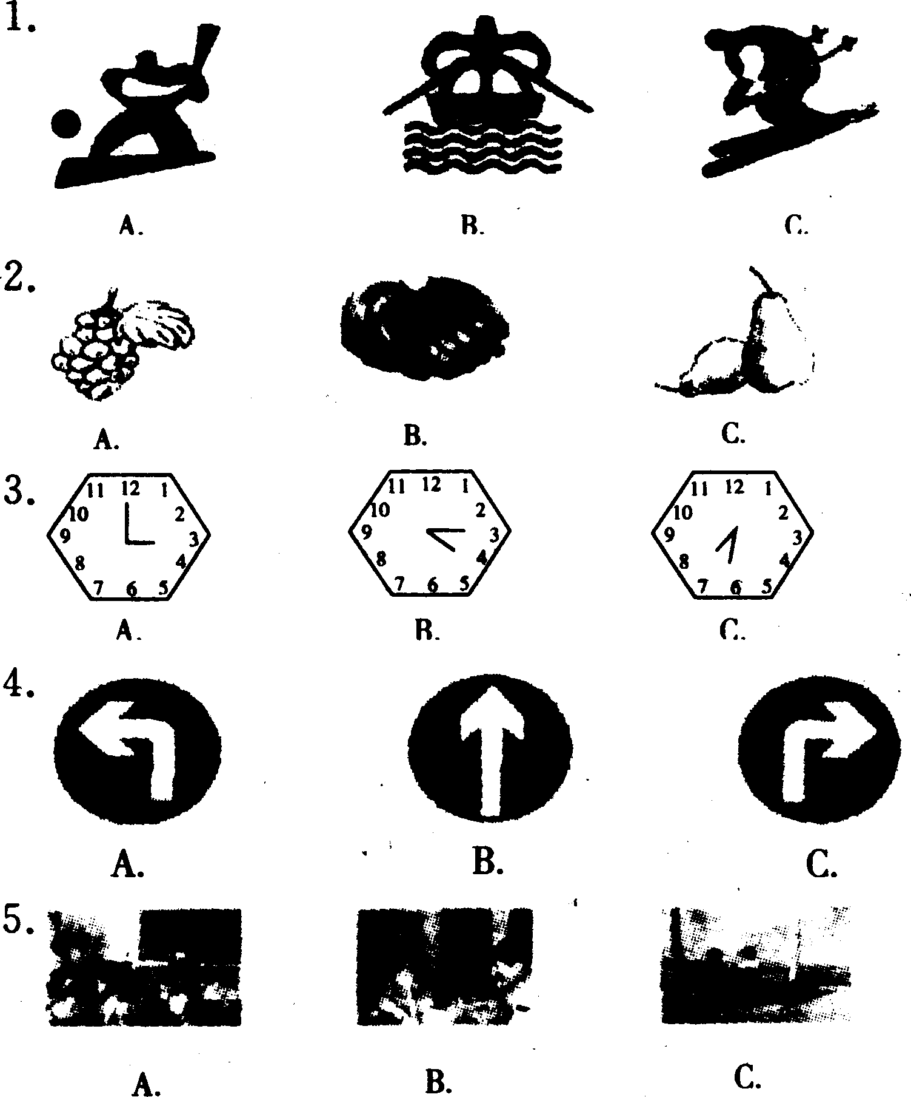
B)听下面5小段对话，每段对话后有一个问题，从A、B、C三个选项中选出能回答这个问题的最佳选项，填在题前括号内。(读两遍)
6. A. Chinese New Year. B. Mid-autumn Festival. C. Dragon Boat Festival.
7. A. A red skirt. B. A blue skirt. C. A red T-shirt.
8. A. Hamburgers and juice. B. Noodles and fish. C. Rice and meat.
9. A. Selfish. B. Friendly. C. Active.
10. A. At the railway station. B. At the doctor's. C. In the library.
C)听下面3段对话或独自，每段对话或独白后有几个小题，从A、B、C三个选项中选出最佳选项，填在题前括号内。(读两遍)
听第l段材料，回答第11～12小题。
11. What's the weather like in Beijing tomorrow?
A. Sunny. B. Rainy. C. Cloudy.
12. How long will the man stay in Beijing?
A. For five days. B. For two days. C. For four days.
听第2段材料，回答第13～15小题。
13. Where did the accident happen?
A. Near the park. B. Near the supermarket. C. Near the cinema.
14. What was the man doing when the accident happened?
A. He was riding a bike.
B. He was crossing the street.
C. He was waiting for a taxi.
15. What do you think the woman's job probably is?
A. A nurse. B. A policewoman. C. A salesgirl.
听第3段材料，回答第16～20小题。
16. Which grade is Sandy in?
A. Grade 9. B. Grade 8. C. Grade 7.
17. What is Sandy's personality?
A. Outgoing B. Shy. C. Modest.
18. When did Sandy organize the charity show?
A. Last week. B. Last month. C. Last term.
19. What does Sandy hope to be?
A. A host. B. A chairperson. C. A monitor.
20. How often does Sandy practice playing volleyball?
A. Twice a week. B. Once a week. C. Every day.
二、单项填空(共15小题；每小题l分，满分l5分)
从A、B、C、D四个选项中选出可以填入空白处的最佳选项。
21. On the shelf there is _________ fancy teddy bear.
A.the B. a C. an D. /
22. —Wow, your new bicycle looks the same as_________.
—Really?
A. me B. I C. my D. mine
23. Our school sports meeting will start _________ the morning of next Saturday.
A. on B. at C. in D. to
24. —May I try on the jeans?
—Yes, you
A. should B. can C. must D. need
25. —Where's your mother, Helen?
—She_________ the flowers in the garden.
A. waters B. watered C. is watering D. has watered
26. —So far, how long _________ you _________China?
—For one year.
A. have j come to B. have;been to
C. have; been in D. have;gone to
27. Jin Yong is one of the greatest and oldest _________ writers. He is still_________.
A. living; alive B. living; living C. alive; living D. alive; alive
28. —Could you tell me_________?
—By underground.
A. how did you come here
B. how you came here
C. when did you come here
D. when you came here
29. —Why not join us in the game,Kitty?
—_________, but I have to do my homework first.
A. Let's go B. I'd like to C. Yes,please D. It's a pleasure
30. —Remember to close the door when you leave.
A. OK,I will. B. No,I won't. C. No, I don't. D. Yes, I do.
31. —Can you work put the physics problem?
—Sorry, I can _________ understand its meaning.
A. almost B. quite C. nearly D. hardly
32. If the question_________ incorrectly,_________question will be given to you.
A. is answered;other B. answers; other
C. is answered; another D. answers; another
33. The father is creative enough_________ so many nice toys for his daughter.
A. buying B. making C. to buy D. to make
34. I'm wondering _________ Liu Xiang will have time to_________ the meeting.
A. whether;attend B. that;attend
C. whether;appear D. that;appear
35._________ the money that Mr Brown_________,poor Mary could go back to school again.
A. In; offered B. With; offered
C. In; was offered D. With; was offered
三、完形填空(共10小题；每小题l分，满分l0分)
阅读下面短文，掌握其大意，然后从36～45各题所给的四个选项中，选出一个最佳选项。
Not long ago, I made up my mind to read a lot of books to get more knowledge. So I went to the library and 36 happily with several books. But after a few days, I felt impatient. The 37 of finishing all of them seemed impossible, because I always found it 38 to calm down to read a whole book. I didn't know what to do with it. Then 39 one day I thought of "Why not make reading fun?" It gave me 40 again. Reading is a journey of spirit. Every time we read a book, we are actually talking 41 the writer. I tried to put all
my effort into his or her books, 42 I could feel all of his or her happiness and suffering. Now books have become a part of my life.
See? Attitude (态度) can make a great 43 . Someone once said,"Even though the situation is bad, people still have one freedom ( 自由) to 44 their attitude. "So,don't complain about study or work. It helps 45 . Try to see things from a different way. Believe me; this will change the situation and help you a lot.
36. A. sang B. jumped C. returned D. danced
37. A. way B. habit C. suggestion D. idea
38. A. hard B. interesting C. happy D.easy
39. A. sadly B quickly C. suddenly D. hardly
40. A. advice B. hope C. time D. knowledge
41. A. with B. about C. of D. at
42. A. because B. though C. but D. so
43. A. decision B. difference C. discussion D. promise
44. A. announce B. choose C. show D. hide
45. A. nothing B. anything C. everything D. something
四、阅读理解(共10小题；每小题2分，满分20分)
阅读下面图表或短文，然后从46～55各题所给的四个选项中，选出一个最佳选项。
(A)
Here are reports of three attacks. The three swimmers were attacked by sharks because they didn't obey (遵守) the safety rules for swimmers.
Rules for swimmers:
A. Don't swim at night.
B. You are more likely to be attacked in warm water.
C. Sharks are attacking by blood. Don't swim with an open cut.
D. It's best to wear a swimming suit to match your skin colour. Sharks can see colours.
E. If you see a shark,don't be nervous. Try to! swim quietly, with even (平稳的) strokes(划水动作).
Which rule didn't each of the following swimmers obey?
46. Report 1: Colin was swimming with two friends
very late at night. He was attacked by a shark and died.
47. Report 2: Ann was a very good swimmer. She
bought a new bright red swimming suit. She was swimming with some friends when a shark attacked her.
48. Report 3: Jack was on holiday in Australia. He
cut his foot on the beach. He went swimming the same day and got attacked.
(B)
Who are the top students in the world, do you know? Last week the Organization for Economic Co-operation Development (经济合作与发展组织) picked the best students in the world. They are Finnish (芬兰的). The OECD gave a test to 280 000 15-year-old students from more than 40 countries and regions (地区) last year. The OECD wanted to know how well students were doing at school.
Finnish students were No. 1 in the reading test and second in maths after Hong Kong students. Those from Japan and Finland were top in science. In the problem solving, Finnish students came second to those from South Korea. The test also showed Finland had more top students than the other countries.
Finns (芬兰人) of your age have done a really good job but don't have a sense of envy. You can learn from them. Most Finnish students make good use of the Internet. Of course not for computer games, but for doing more exercises and finding out more information.
Libraries are also important. Finland spends a lot of money on them. Many students have a free card. They read for at least one or two hours a day.
What do you usually do on the Internet? How often do you go to libraries?
49. Students from which country or region did best in the reading test?
A. South Korea. B. Hong Kong. C. Finland. D. Japan.
50. Which of the following is NOT true?
A. Hong Kong students were No. 1 in maths.
B. Finnish students were the first of all the tests.
C. Finnish students did well in the problem solving.
D. Japanese students were top in science. 51. From this passage we know that_________.
A. the test can make the students lose their interest in learning
B. the test is designed to find out good ways to use the Internet
C. it's hard to tell who the best students in the world are
D. Finnish students make better use of the Internet and libraries
(C)
Penguins are lovely animals. Most people like them. But now as many as 10 of the 17 kinds of penguins are in danger of disappearing. The number of penguins has decreased by ( 减少了) 30% since 1987.
Penguins are black and white birds that live in the southern part of the world. They are common in the Antarctic Continent (南极大陆) ,New Zealand, Australia and South America. Many live near cold waters (水域). But some live near warm waters in Galapagos Islands. Penguins cannot fly, but they are fine swimmers. The shape of their body helps them to survive. Penguins eat fish and krill (磷虾). They have short wings that help them to dive up to 900 feet to catch larger fish. They can swim 10-15 kilometers an hour which lets them protect themselves. They also have lots of body oil that helps in keeping them dry in the water.
The warming of the earth is the reason for the decrease in the number of penguins. The hotter and hotter air has caused ocean waters to become warmer. Higher water temperature has decreased the fish and krill. Some years later these birds are completely unable to reproduce. And many adult penguins die of hunger.
Too much fishing, exploration for oil and oil leaks (泄漏) also make penguins be in danger. Poisonous things in ocean waters are another danger. Penguins also have their enemies, including sharks, seals and sea lions.
52. Penguins can do the following except________.
A. diving B. flying C. swimming D. catching fish
53. Which of the following is NOT the reason for the decrease in the number penguins?
A. The warming of the earth. B. Too much fishing.
C. Natural disasters. D. Poisonous things in ocean waters.
54. What does the underlined word "reproduce" mean?
A．繁殖B．灭绝C．迁徙D．觅食
55. What's the passage mainly about?
A. Fish and krill have decreased.
B. Ocean waters are polluted.
C. Sharks and seals are the enemies of penguins.
D. The decrease in the number of penguins.
五、词汇运用(共10小题；每小题l分，满分l0分)
A)根据句意，用括号中所给词的正确形式填空，每空填一词。
56. It is October the _________ (nine). It's my mother's birthday.
57. Congratulations! Both of you are the_________ (win) of the match.
58. Computers and printers are now (wide) used in many companies.
59. My aunt . (teach) me to play the violin when I was a child.
60. She was so_________ (care) that she wore different socks on her feet.
B)根据句意及汉语提示，写出各单词的正确形式，每空填一词。
61. All of the travelers live together like a big______(家庭).
62. The girl is too young to look after ________(她自己).
63. It's generous of Julia to_________ (提供) books and stationery for the schools in the west of China.
64. Mr "Smith is such an _________ (诚实的) man that we all trust him.
65. The old lady was _________ (期待) a letter from her son while he was abroad.
六、补全对话(共10小题；每小题l分，满分l0分)
根据对话内容及所给首字母提示写出所缺单词，并将答案写在右边对应题号后的横线上。
Daniel: Hello, Ed ward! You look tired today. Edward: Yes, we're b (66) reviewing lessons these days. This term will be o (67) soon. Daniel: Yeah, how time f (68) ! Summer holiday is coming. Edward:What are you going to do d (69) the holiday? Daniel:I want to have a good rest first. Then I'm going to Tibet to e (70) the beautiful scenery. By the way,what's your p (71) for the holiday? Edward:I would r (72) stay at home than go out. I will buy some DVDs and watch my favourite films. Daniel: Only watch films at home? It's a bit b (73) ,1 think. Ed ward: Oh, no. I'm also going to learn h (74)
to make computer programmes. Daniel:I'm i (75) in it as well. Could I learn it with you? Edward: All right! We can discuss it together then.
66. b_________ 67. o_________68. f_________ 69. d_________ 70. e_________
71. p_________72. r_________ 73. b 74. h_________ 75. i_________
七、任务型阅读(共10小题；每小题l分，满分l0分)
Olympic torch relay around the world
The Beijing 2008 Olympic Torch Relay (火炬接力) will travel the longest distance, cover the greatest area and include the largest number of people. On March 25,Olympic Flame (火种)will be lit (点燃) in Greece.
Route Distance: 137 000 km Time: 130 days
Route:March 31,Torch Relay starts in Beijing→.London→Paris→San Francisco.. →Hong Kong..→Beijing
Torch Length:72 cm Torch Weight:985 grams Design: It is based in the shape of a paper scroll (卷) with lucky clouds on it.
It can stay lighted (燃烧的) in bad weather conditions.
根据以上信息填空，每空填一词。
The Beijing 2008 Olympic Torch Relay will travel a (76) distance than before. It will take more than (77) months to travel around the world. The Torch Relay will start in the city of (78) . The torch is (79) cm long and 985 grams heavy. It looks like a paper scroll. Bad weather can't (80) the torch from burning.
76._________ 77._________ 78._________ 79._________80._________
(B)
Dear all,
Time passes without knowing. I have finally found my partner in Paris. She gives me the true meaning of love, happiness and also as a true friend.
Here,I want to announce that we,Paul Brown and Lisa Yang have decided to marry on 26 th September, 2007. The wedding will consist of a wedding promise in a church and a dinner party that will be held in Blue Sky Hotel.
As you are our friends and our relatives, all of you and also your loved ones are invited to this special day of ours, you, looking, we, all, to, forward, of,are. Thank you for your time here.
Love,
Paul & Lisa
根据上面的邀请信，完成81—85小题。
81. Paul is going to marry______________________.
82. The young couple got to know each other in
83. Date of their marriage:_______________________
84. Place of their dinner party,;_______________
85. Put the underlined words in right order.
八、书面表达(共1题；满分l5分)
据报道，中学生的身体素质有所下降。这一情况已经引起全社会的关注和教育部门的高度重视。右图是某中学关于青少年体育锻炼的宣传标语。
请你根据下面的要点和要求，用英语写一篇短文，80词左右。
要点：1．锻炼身体的好处：strong，healthy，energetic，
2．锻炼身体的方式：ballgames，running，
swimming，．．．
3．请你谈谈对学校开展体育锻炼的看法或建议。(至少写两点)
要求：1．内容必须包括以上要点，可适当发挥。
2．开头已给出，不计入总词数。
3．语句通顺，意思连贯，条理清楚，字迹工整。
4．文中不得出现真实校名及姓名。
HealthisveryimportanttoUSteenagers．

EXERCISE ONE HOLR A DAY， KEEP ILLNESS AWAY!

2007年江苏省镇江市中考英语试题参考答案
一、二、21.21. B 22. D 23. A 24. B 25. C 26. C 27. A 28. B 29. B 30. A 31. D 32. C 33. D
34. A 35. B
三.36. C 37. D 38. A 39. C 40. B 41. A 42. D 43. B 44. B 45. A 四,46. A 47. D 48. C 49. C 50. B 51. D 52. B 53. C 54. A 55. D 五, 56. ninth 57. winners 58. widely 59. taught 60. careless 61. family 62. herself 63. provide 64. honest 65. expecting 六、 66. busy 67. over
68. flies 69. during 70. enjoy 71. plan 72. rather 73. boring 74. how 75. interested 七、 76. longer 77. 4/four 78. Beijing 79. 72/seventy-two 80. stop/prevent/keep 81. Lisa(Yang) 82. Paris 83. (On) 26 September, 2007 84. (In) Blue Sky Hotel 85. We are looking forward to all of you. 八、 One possible version:
Health is very important to us teenagers. Either study or work is based on strong body. Doing sports every day helps us keep healthy and energetic. If we don't take any exercise, we may feel tired and get sick easily. Just as the slogan says, "Exercise one hour a day, keep illness away. "
There are many kinds of sports we can do, such as running, swimming and ball games.
Now we students have to do too much homework after school. I hope teachers will leave us less homework so that we can have more time to take part in sports. I also hope our school can organize more sports activities for us.

天仁英语教师资源交流网

