2007年浙江省台州市中考英语试题
第一部分 听力部分(25分)
一、听力(共15小题，第一节每小题1分，第二、三节每小题2分，满分25分)
第一节：听小对话，选择图片回答问题。
1. Which is Kate' s favorite sport?
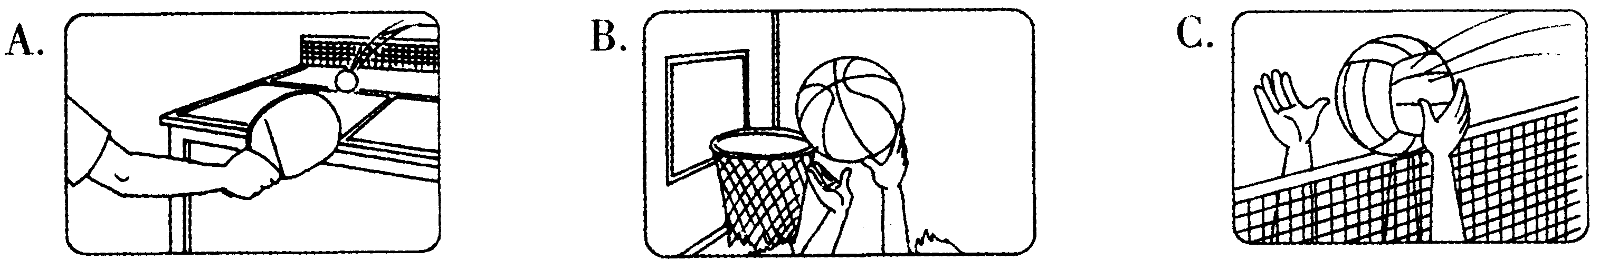
2. How's the weather now?
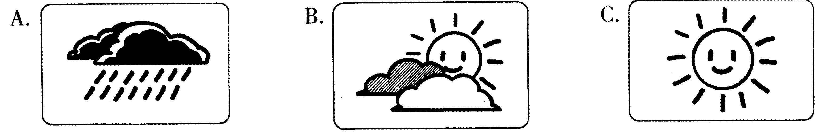
3. What does Emma want to be?
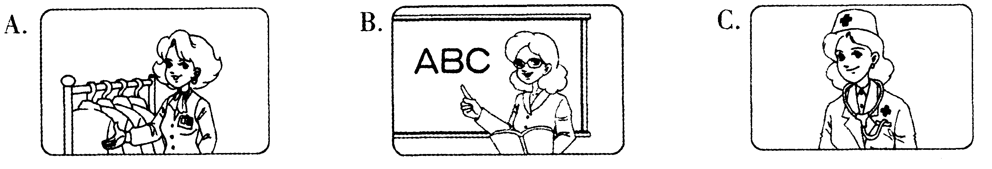
4. Which city is Ann going to for holiday?
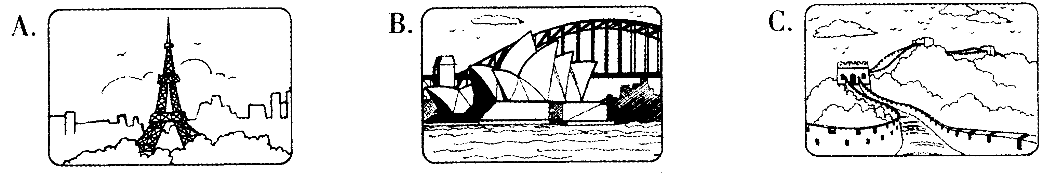
5. What' s wrong with the woman?
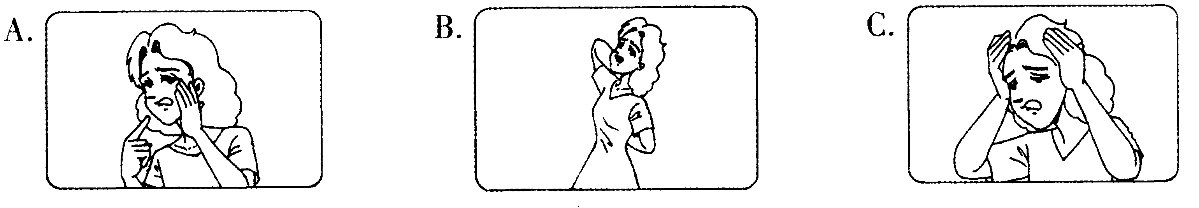
第二节：听小对话，请从A、B、C三个选项中选择正确的选项。
6. When does Jim' s birthday party begin?
A. At 5:00. B. At 5:30. C. At 6:30.
7. How is Mrs Green going to school today?
A. By bike. B. By bus. C. On foot.
8. Whose is the red pen?
A. Betty's. B. Lily's. C. Sandy's.
9. Where are the two speakers probably talking?
A. In the street. B. In the classroom. C. In the shop.
10. What does Lucy think of playing the piano?
A. Interesting. B. Difficult. C. Boring.
第三节：听独白．请根据提问从A、B、C三个选项中选择正确的选项，完成信息记录表c
Homework: A composition
The title ( 题目) of the composition: 11
What to write about; 12
How many words:at least 13
When to e-mail; 14
E-mail address; 15
11. A. My Teacher B. My Mother C. My Father
12. A. wishes, love B. hobbies, love C. hobbies, wishes
13. A. 60 B. 80 C. 100
14. A. before Wednesday B. before Thursday C. before Friday
15. A. woody@hotmail.com B. wilson@hotmail.com C. jackson@yahoo.com
第二部分 读写做部分(95分)
二、语言知识运用(共15小题，每小题l分，满分l5分)
从A、B、C、D四个选项中，选出一个可以填入空白处的最佳选项。
16. — What' s in your bag?
— There' s English book in it.
A. a B. an C. the D. /
17. — Where's my watch?
— Sorry, I don't know. Maybe you put on the table.
A. it B. her C. him D. them
18. — It' s time to go. Is here?
— No. Sam is still on the way.
A. no one B. everyone C. someone D. anyone
19. — Mum! The box' s too heavy.
— Don't worry. Let me it for you.
A. carry B. carries C. carrying D. to carry
20. — What do you think of the music, Fred?
— It wonderful.
A. smells B. looks C. tastes D. sounds
21. — Can I eat the cake, Mum?
— Yes, you can. you must wash your hands first.
A. But B. So C. Or D. Till
22. — Hello. Could I speak to Mr Brown?
— Sorry. He to the library.
A. goes B. will go C. has gone D. was going
23. — How often were you late for school last term,Tom?
— . I got to school early every day.
A. Always B. Usually C. Sometimes D. Never
24. — Make sure all the lights when you leave the room.
— OK, I will.
A. turn off B. are turned off C. turn on D. are turned on
25. — There will be a railway in Taizhou soon.
— Great ! We' 11 have ways of traveling than before.
A. many B. much C. more D. fewer
26. — Could you tell me , dear?
— She called to borrow my VCDs.
A. why Mary called you B. why did Mary call you
C. when Mary called you D. when did Mary call you
27. Though their parents work in faraway cities to make money, those "stay-home children" can themselves.
A. look out of B. come up with C. take care of D. catch up with
28. — Would you please pass me the sugar?
— . Here you are.
A. Sorry B. Sure C. Thanks a lot D. Nothing much
29. — Thank you for your help, Sarah.
— .
A. Good idea B. Please don t say so
C. It doesn' t matter D. You are welcome
30. Look at the picture on the right. What are the people saying to the runners?
A. Help! B. Ready? Go!
C. Come on! D. Congratulations!
三、完形填空(共15小题，每小题l分，满分l5分)
阅读下面短文，从各题所给的A、B、C、D四个选项中选出最佳选项。
A shopkeeper found a dog in his shop. It had a 31 in its mouth that read, "Can I have two kilos of meat, please?" In the dog's mouth there was also a ten-dollar bill. The shopkeeper felt very 32 , so he took the money, put the meat in a bag, put the bag in the dog's mouth, and then 33 it.The dog walked down the street. 34 it came to a crossing, it waited for the lights to turn 35 , and then walked across the road.
Soon the dog got to a 36 , It looked at the timetable, and then it sat on a seat to 37 the bus.
When a bus came, the dog walked to the front of the bus, looked at the 38 of the bus, and went back to its seat. Another bus came. The dog went and looked at the number again, and then 39 .
The bus traveled out of the town. 40 the dog stood up to push the button to stop the bus.
The shopkeeper walked after the dog to a house. It 41 the bag and hit itself against the door again and again! A man opened the door and shouted at the dog 42 "What are you
doing?" the shopkeeper 43 the man, "This dog is a genius!"
The man answered, "Clever? 44 | This is the second time this week it's forgotten its 45 !"
31. A. book B. photo C. map D. note
32. A. surprised B. worried C. sad D. shy
33. A. beat B. saved C. followed D. killed
34. A. When B. Before C. If D. Though
35. A. red B. green C. yellow D. black
36. A. park B. bus stop C. cinema D. book shop
37. A. wait for B. look after C. clean up D. try on
38. A. size B. color C. driver D. number
39. A. got back B. got down C. got on D. got off
40. A. In the future B. After a while C. Just now D. So far
41. A. sold B. washed C. dropped D. mended
42. A. happily B. angrily C. quietly D. politely
43. A. stopped B. thanked C. telephoned D. helped
44. A. Yes B. Sure C. No D. OK
45. A. money B. bag C. home D. key
四、阅读理解(共15小题，每小题2分，满分30分)
阅读下面短文及图片，从每题所给的A、B、C、D四个选项中选出最佳选项。
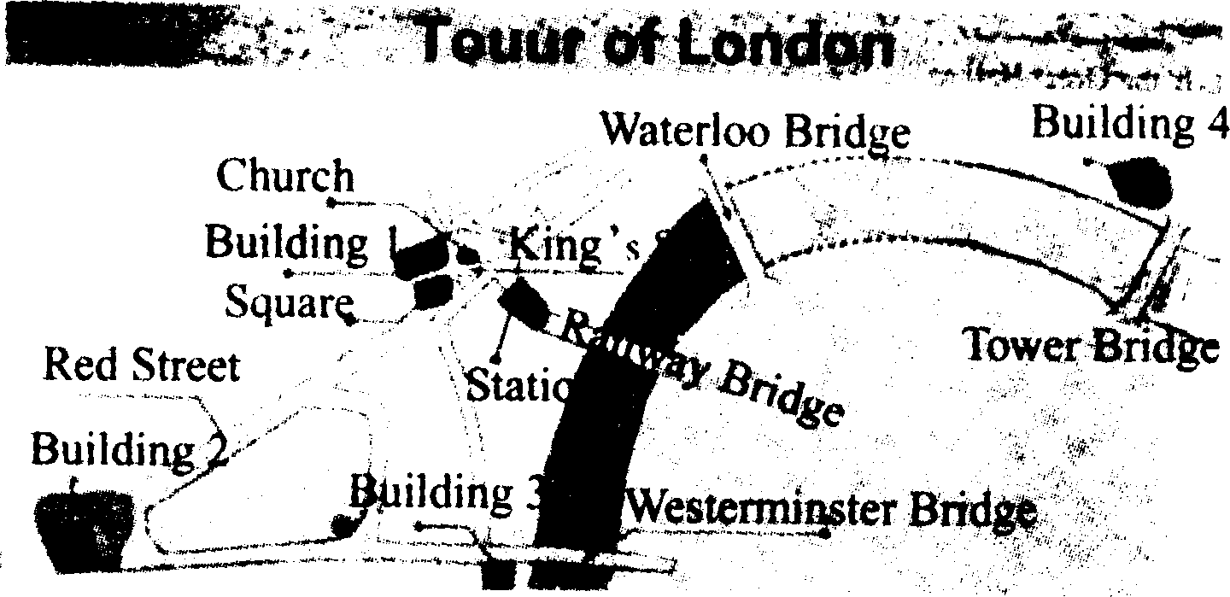
A
Welcome to London! Would you please have a look at your map? We are standing in this square, which is in the middle of London. You'11 see many places of great interest. First you can go along the Red Street to Buckingham Palace. Then turn left and go to Big Ben, the famous big clock in the world.
When you are tired, the best way to see London is by boat. You can get the boat near Big Ben. The beautiful sceneries along the river will make you relaxed. Get off the boat at Tower Bridge. There you can see the Tower of London next to the bridge. The Tower of London is the city's oldest palace. It is 900 years old ...
We'll meet again in this square at 5:00 pm. I don' t want any of you to get lost. Enjoy your trip !
46. How many bridges can you find on this map?
A. One. B. Two. C. Three. D. Four.
47. Building 3 on the map stands for (代表) .
A. Big Ben B. Tower of London C. London Eye D. Buckingham Palace
48. Who is most probably the speaker of this passage?
A. A tour guide. B. A policeman. C. A visitor. D. A waiter.
b
In Miss Lee' s class, the students are asked to discuss the topic " Do you do housework at home?" in groups. Here' s what the students of Group One say.
Tommy: No, / have no time. Schoolwork almost takes all of my time ! How can I spend such precious time doing housework?
Helen: / help my mother with our housework, but she must pay me. I don' t enjoy doing that. It doesn' t do any good to me in any way.
Linda: Doing some housework not only helps my parents but also helps myself. It is a chance for me to take a break from my schoolwork and to learn some skills for my future. Also, it' s a chance to show my love and care for my parents.
Emily: To tell you the truth, I hardly ever do housework at home. My parents say a nice girl should learn to do housework if she wants to be a good wife in the future, but I don' t think so. Why can' t I hire a housekeeper then?
49. Who likes doing housework at home?
A. Tommy. B. Helen. C. Linda. D. Emily.
50. What does Helen do housework for?
A. To learn some skills. B. To learn to be a good wife in the future.
C. To get some money. D. To show her love and care for her parents.
51. Which of the following is RIGHT?
A. Tommy spends almost all of his time on schoolwork.
B. Linda doesn't do her schoolwork at all.
C. Emily says she will learn to do housework in the future.
D. Emily' s parents think a good wife needn' t do housework.
C
In fifteen years, China plans to put its astronauts on the Moon. But before that, a small machine rover will be there. Not long ago, scientists in Shanghai showed a Moon rover to the public. Scientists said they spent four years making it. And they hoped the rover would be chosen to go to the Moon.
What is the rover like? It has six wheels. It is 1.5 meters high and 200 kilograms in weight. It can take videos and pictures of the Moon. It can also get Moon soil and study it. The rover can go as fast as 100 meters an hour. Experts said it can climb a 30° slope.
The Moon is a harsh place. According to the scientists, the rover may need to be improved. The Moon' s gravity is only one-sixth that of the earth's. There are strong rays from the Sun. The temperature also changes greatly there. It can be - 180℃ at night and 150℃! in the day.
China will take three steps to explore the Moon. First, a spaceship will be sent to go around the Moon this year. There will be no person in the spaceship. Then in 2012, a Moon rover will be sent to the Moon. Finally, an astronaut will land on the Moon sometime after 2017.
52. How long did it take the scientists to make the rover?
A. 15 years. B. 6 years. C. 5 years. D. 4 years.
53. According to the passage, the rover can do the following things EXCEPT .
A. going as fast as 100 meters a minute B. studying Moon soil
C. going from a low place to a high place D. taking videos and pictures of the Moon
54. Which paragraph (段落) tells us something about the Moon?
A. Paragraph 1. B. Paragraph 2. C. Paragraph 3. D. Paragraph 4.
55. Which picture shows the third step China will take to explore the Moon?
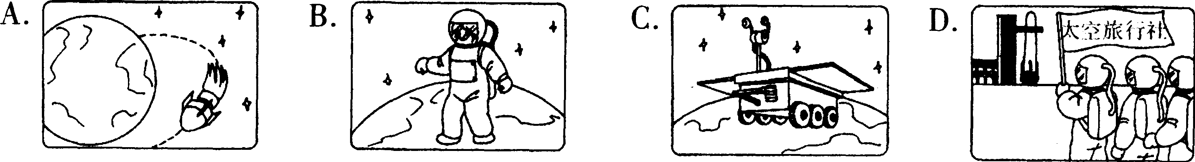

D
The Xin' an Street Community began three programs not long ago.
The Neighborhood Clean-up Program
Every Sunday at 5:00 pm, the neighbors begin cleaning Xin' an Street from one end to the other. The head of the community, Zhao Fuqin, said, " The first Sunday, only eleven people came, but we picked up over seven big bags of rubbish from the sidewalk and street. The next weekend, twenty people came, and filled eight big rubbish bags. Now the neighborhood really looks great!"
The Neighborhood Watch Program
The neighbors on Xin' an Street began this program to look for problems in the neighborhood and to call the police if necessary. The neighbors all say the watch has already helped.
Sun Yan, aged 60, a retired teacher, said, "In the past, I felt afraid at night. Now I know my neighbors are watching for trouble. " According to the police, there are fewer problems on Xin'an Street. "Calls to 110 went down last month. Criminals knew that the people on Xin'an Street were watching, so they stayed away," said a policeman.
The Neighborhood Fitness Program
A Health Club was built last month, where the neighbors can do different kinds of sports like basketball, ping-pong ball, tennis, etc. "Every morning you can see groups of neighbors running, dancing and playing taijiquan. We have come to realize the importance of taking exercise," said Chen Jinliang, a businessman of 45.
The community has more plans. "We plan to start the Kids Care Program for children. We are going to build an after-school club. And we want to have a picnic for everyone in the neighborhood! " said Zhao Fuqin.
56. The neighbors of the Clean-up Program on the first Sunday.
A. swept the park B. picked up rubbish
C. collected school bags D. cleaned the clubs
57. How is Sun Yan, a retired teacher, feeling now?
A. Afraid. B. Safe. C. Worried. D. Lonely.
58. Why did calls to 110 go down last month?
A. The neighbors were on watch. B. More policemen stayed there.
C. The police had caught all the criminals. D. The neighbors didn't like to call 110.
59. Which of the four programs can help neighbors keep healthy?
A. The Neighborhood Clean-up Program. B. The Kids Care Program.
C. The Neighborhood Fitness Program. D. The Neighborhood Watch Program.
60. From the passage we know on Xin' an Street.
A. there are more problems now
B. the neighbors have a picnic every weekend
C. the after-school club was built last month
D. the neighborhood looks nicer and cleaner now
五、词汇运用(本大题有l5小题，每小题l分，只要做对l0题即得满分10分)
李军即将升人高中，在高中的第一节英语课上他将要用英文作自我介绍。以下是他准
备的发言稿，请你完成文中的单词拼写。每空限填一词。
Hello, everyone! Now let me 61 (说) something about myself. I'm Li Jun. I was born on 62 (五月) 20th, 1991. I come 63 (来自 ) Red Star Village, which is in the 64 (西部) of the city. It' s beautiful with lots of green 65 (树) and colorful flowers.
Many boys like playing ball games, but I 66 (更喜欢) running. I have ever 67 {得到，赢得) first prize in the 1,500-meter race in the city' s sports meeting. My parents are very 68 ( 自豪) of me. But I'm not 69 (擅长，好) at spoken English. I will practice it 70 (大声地). I'm sure 71 (没有什么) is difficult if I put my heart into it.
I' m really 72 (幸运的) to have the chance to study in this school. I hear the lessons won' t be as 73 (容易的) as before. I will 74 my best (尽力). I like75 (交) friends and helping others. I'm sure we'll get on well with each other. That's all. Thank you for listening!
六、任务型阅读(本题有5小题，每小题l分，满分5分)
以下左边四个方框中的内容是四位中学生向某报编辑诉说的烦恼，右边方框中的内容
是编辑提供给他们的建议。请将它们一一配对。
76. My parents never allow me to play computer games at all. They want me to study all day and do well in my exams. I feel unhappy. |  | A. When you feel angry, you should stop talking and count to ten or walk away until you keep calm.
77.I found that my mother read my diary when I was out. I don’t think anyone, even my parents, has the right to read my diary. Now I feel hurt and sad. |  | B. He doe'snt mean to hurt you. Each time he calls you that, tell him politely you don‘t like it. I'm sure he will not call you in that way any more.
78.Sometimes I get angry easily and shout at my friends. That makes them think I' m not being friendly to them. |  | C. I don't think it s wrong for your mother to do so. Our parents look after us, and they have the right to know what we do. They do so only because they care for us.
79. One of my classmates gave me a nickname. I really don' t like it because I think he laughs at me. I feel sad. |  | D. Tell your parents that many kids play computer games and do well at school, too. Ask them to allow you to play for a short time on weekends.
你也经常帮助别人解决烦恼吗?现请你就以下这位同学的烦恼提出一条建议。
I can't learn English well. What should I do?
80.

七、书面表达(本题有2小题，81小题5分，82小题l5分，满分20分)
81．假设你是Kate，收到Ann寄来的一件生日礼物(如钢笔、书……)，现请你以电子邮件的形式给她写一封感谢信：感谢她送给你X X X，告诉她你很喜欢它，并用一句话说明喜欢的理由。 ．
收件人 Ann 1228@163.com
主题Thanks

Dear

Your
82．下面四幅图片描述了三位学生上星期天所做的事情，请仔细阅读图片，然后写一篇短文。要求如下：
1)描述四幅图片的内容；
2)从安全角度就图中某一行为简单谈谈你的看法；
3)语句通顺，行文连贾，书穹整洁。词数：80词左右(开头已给出，不计入总词数)。
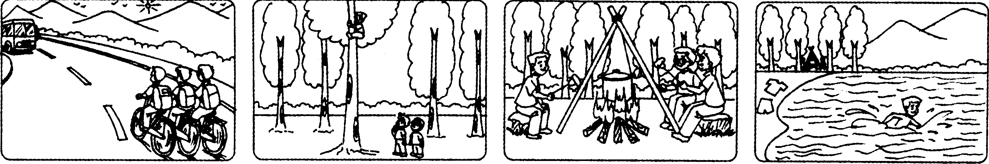It was sunny last Sunday. Three students

2007年浙江省台州市中考英语试题参考答案
一、听力(共1 5小题，第一节每小题1分，第二、三节每小题2分，满分25分)
1． B 2． A 3． B 4． C 5． C 6． B 7． C 8． B 9． A l0． A l l． B l 2． A l 3． C 14． C l 5． B
二、语言知识运用(共l 5小题，每小题l分，满分l5分)
1 6．B l 7．A l 8．B l9．A 20．D 21．A 22．C 23．D 24．B 25．C 26．A 27．C
28． B 29． D 30． C
三、完形填空(共15小题，每小题l分，满分l 5分)
3 1．D 32．A 33．C 34．A 35．B 36．B 37．A 38．D 39．C 40．B 41．C 42．B 43．A 44．C 45．D
四、阅读理解(共15小题，每小题2分，满分30分)
46．D 47．A 48．A 49．C 50．C 5 1．A 52．D 53．A 54．C 55．B 56．B 57．B 58．A 59．C 60．D
五、词汇运用(本大题共l 5小题，每小题l分，做对l 0题即得满分10分)
61. say 62. May 63. from 64. west 65. trees 66. prefer 67 got/won 68. proud 69. good 70. loudly/loud/aloud 71. nothing 72. lucky 73. easy 74. try/do 75. making
六、任务型阅读(共5小题，每小题l分，满分5分)
76．D 77．C 78．A 79．B
80．You(He)should remember more words．／You(He)’d better do more reading．／You(He)should study hard
七、书面表达(共2小题，第8 1小题5分，第82小题l5分，满分20分)
80. You (He) should remember more words./You ( He) 'd better do more reading./You ( He) should study harder. ...
m*x | Ann 1228@163.com
± g | Thanks
Dear Ann,
Thank you for your present (pen, book ...).
I like it very much. It's very nice.
Yours
Kate
82. 书面表达 One possible version;
It was sunny last Sunday. Three students were going for a picnic by bike. When they reached a hill, they saw many tall trees. One boy began to climb up a tree while, the others were watching him. Later they had great fun cooking some food. After the food was cooked, one of them ate it quickly and went to swim in the lake alone. They enjoyed themselves that day.
But I think they shouldn' t ride their bikes side by side on the road. It is dangerous. A bus may hit them.
(or:But I think the boy mustn' t climb such a tall tree. It is dangerous. He may fall down and hurt himself. )
(or;But I think they mustn' t have a picnic among trees. It is dangerous. It can cause a fire. )
(or;But I think the boy shouldn't swim in the lake alone. It is dangerous. He may lose his life. )
英语听力测试材料
第一节：听下面5段小对话。每段对话后有一个小题。从题中所给的A、B、C三个选项中选出最佳选项，并标在试卷的相应位置。每段对话仅读一遍。 (停顿2秒)
(以下每两小题之间停顿6秒、)
1. M:Shall we do sports this afternoon, Kate?
W: Good idea! Let' s play basketball. It' s my favorite.
2. M:What bad weather! Will the rain last long?
W:No, I don't think so.
3. M;What are you going to be when you grow up, Emma?
W: A teacher of English. It' s a good job.
4. M;Are you going to Sydney for the coming holiday, Ann?
W: Oh, no. It costs too much. I' m going to Beijing.
5. M: What' s your trouble, madam?
W:I' m not feeling well. My head hurts. (停顿6秒)
第二节：听下面5段小对话。每段对话后有一个小题。从题中所给的A、B、C三个选项中选出最佳选项，并标在试卷的相应位置。每段对话读两遍。
(停顿2秒)
(以下两遍之间停顿2秒，每两小题之间停顿6秒)
6. M:What time does Jim' s birthday party begin?
W: Don' t you know? It begins at half past five.
7. M：.Morning, Mrs Green. Why are you walking to school?
W:I have to, because my bike is broken.
8. M:Hi, Betty. Is this red pen yours?
W:Let me see. Oh, no. It's Lily's.
9. M;Excuse me,Miss. You can' t drive too fast.
W: Sorry, sir. I won' t do that again.
10. M;Can you play the piano, Lucy?
W:Yes, I play it every day and I enjoy it. (停顿6秒)
第三节：听独白，请根据提问从A、B、C三个选项中选择正确的选项，完成信息记录表、。独白读两遍。
Boys and girls, now here' s the homework. I' d like you to write a composition. The title of the composition is My Mother. You know, Mother' s Day is coming. Usually you buy presents to show your love. Why not have a change?
In the composition you can write about her wishes and her love for you. The composition shouldn' t be too short, at least 100 words. Remember to e-mail it to me before Friday. My e-mail address is Wilson @ hotmail. com.
Question 11 :What' s the title of the composition?
Question 12: What does the teacher ask the students to write about?
Question 13: How many words should the students write?
Question 14: When should the students e-mail the composition?
Question 15 : What' s the teacher' s e-mail address?
(停顿6秒)

天仁英语教师资源交流网

