2007年浙江省绍兴市中考英语试题
试卷I(选择题共80分)
(一)听力部分(共25分)
一、听力(本题有15小题，共计25分，第一节每小题l分，第二、三节每小题2分)第一节听对话，选择图片。
1. What is the man going to buy tomorrow?
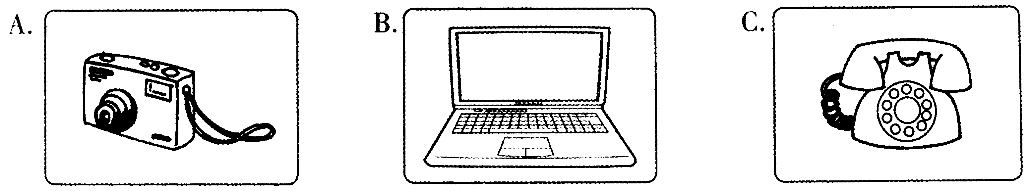
2. Who is Tony's brother?
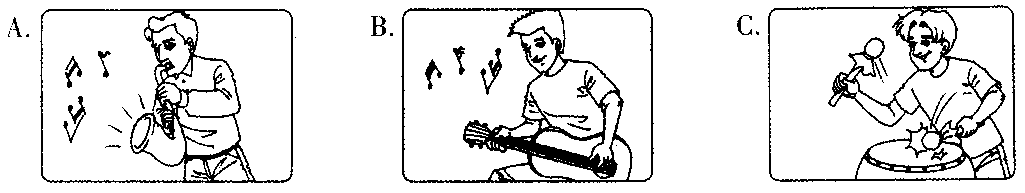
3. Which is the right picture?
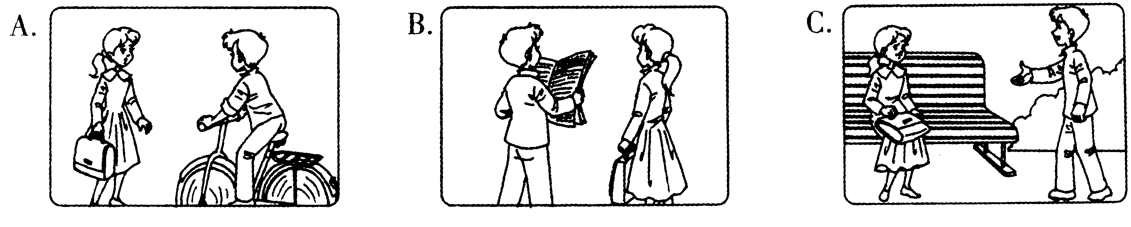
4. Where is the boy's schoolbag?
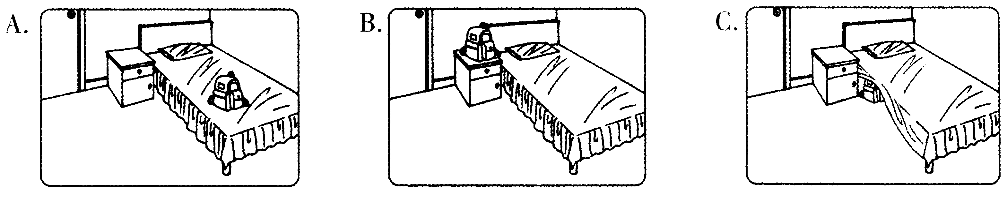
5. What's the man's favourite sport?
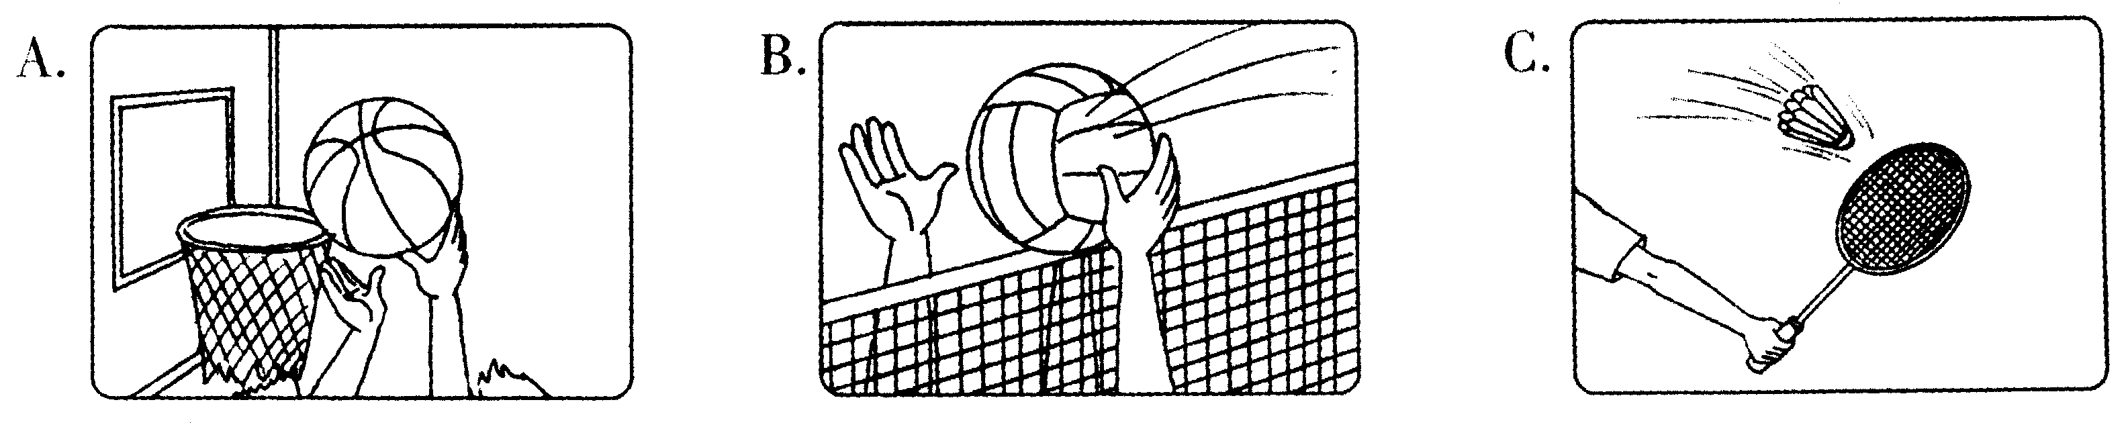
第二节听对话，回答问题。
6. Where does the dialogue probably take place?
A. In a school.
B. In a restaurant.
C. In a hospital.
7. How long did the man stay in Beijing last month?
A. One day. B. One week. C. Half a month.
8. What will the weather be like in the afternoon?
A. Rainy. B. Sunny. C. Cloudy.
9. Why won't George go to the party?
A. Because he has to see a doctor.
B. Because he isn't interested in the party.
C. Because he has to look after his younger sister.
10. How much are the three books?
A. 50 yuan. B. 55 yuan. C. 35 yuan.
第三节听独自，请根据提问从A、B、C三个选项中选择正确的选项，完成信息记录表。

Personal Information Form
Name: Mike Age:11
Country: 12 Job:13
Telephone Number: 14 Hobby:15
11. A. Nineteen. B. Twenty-nine. C. Thirty-nine.
12. A. America. B. England. C. France.
13. A. A doctor. B. A teacher. C. A manager.
14. A. 7876034. B. 7786043. C.7876043
15. A. Playing cards. B. Collecting stamps. C. Traveling.
(二)笔试部分(共55分)
二、单项填空(本题有15小题，每小题l分，共计l5分)从A、B、C、D四个选项中，选出可以填入空白处的最佳答案。
16. What interesting story! 1 want to read it a second time.
A. a B. an C. the D. /
17. —Let me help you to carry the box. —No,thanks. I can do it by .
A. me B. my C. mine D. myself
18.—Keep quiet, kids. Dad in the next room.
—OK, Mum.
A. slept B. sleeps C. is sleeping D. had slept
19. A lot of tourists will come to Lu Xun Museum tomorrow, you had better get up early if you want to visit it.
A. or B. but C. so D. though
20. You can not imagine how much I on this dress. Is it beautiful?
A. paid B. took C. cost D. spent
21. —Do you know what the wordªcool^{w}means?
—Of course. It by young people so often these years.
A. uses B. is used C. was used D. is using
22. —Alice,you dance very well! — .
A. Not so well B. That's all right
C. Thank you D. I agree with you
23. —Please remember to say goodbye to Mr. Smith when you tomorrow.
—Sure. I will.
A. leave B. will leave C. left D. have left
24. —Excuse me, what is your ?
—No. 7,King Street.
A. e-mail B. address C. name D. way
25. — you come to my birthday party tomorrow , Robert?
—I'm afraid not. I have to study for my exam.
A. Must B. Should C. Can D. Need
26. —What did your sister say to you last night?
—She asked me my father her secret.
A. to tell not B. not to tell C. don't tell D. not tell
27. — do you go for a trip with your fam-
ily? —About once a year. A. How long B. How soon
C. How far D. How often
28. —It is said that no one bought that kind of fruit.
—That's true. It tasted .
A. good B. terrible C. well D. terribly
29. The girl won the match not so long ago is called Guo Yue, a famous Chinese table tennis player.
A. who B. which C. what D. whom
30. —My sister has lost the chance to work in Guangzhou.
— !
A. Well done B. Good luck
C. What a pity D. Congratulations
三、完形填空(本题有15小题，每小题l分，共计l5分)阅读下面短文，然后在各题所给的四个选项中选出一个最佳答案。
Vanilla is my best friend. She is a lovely girl with two big, beautiful eyes. But she always hides them 31 a pair of black glasses.
One day, however, I 32 ended our friendship. I remember that day clearly. We were 33 in the classroom. The teacher was giving us our results of a Chinese exam. I had done badly. I felt so 34 that I wouldn't talk to anyone. At lunch-time,! even stayed in the classroom alone. Suddenly,! heard a 35 . It was Vanilla. "You look very unhappy,"she said. "What's wrong?" I looked at her for a while,but said 36 .1 knew Vanilla had got a good mark (分数) in the exam. I thought she was 37 me. I sat silently, but Vanilla didn't go away,she 38 asking me questions: “Is it because of the exam? Do you want me to tell you the right 39 ?" I looked away from her. When I looked up again, Vanilla had gone. And so had my exam paper! I didn't know 40 to do. I looked for my paper every where, but couldn't find it.
In the afternoon, Vanilla came up to my desk and 41 me my exam paper back. I looked at it and got a big 42 . Vanilla had written the right answers next to every one of my mistakes. How 43 she was! My face turned red. I wanted to hug her,but I only held her hands and said,"Thank you. "That afternoon, 44 Vanilla and I were on the way home, I felt quite happy and thanked her again. We are 45 best friends.
31. A. behind B. below C. among D. near
32. A. slowly B. quickly C. nearly D. happily
33. A. singing B. sitting C. dancing D. playing
34. A. happy B. sad C. funny D. excited
35. A. voice B. sound C. noise D. cry
36. A. everything B. something C. anything D. nothing
37. A. knocking at B. shouting at C. laughing at D. pointing at
38. A. forgot B. kept C. practiced D. remembered
39. A. answers B. exams C. results D. notes
40. A. that B. who C. which D. what
41. A. gave B. turned C. carried D. moved
42. A. pain B. interest C. surprise D. fun
43. A. kind B. brave C. healthy D. careless
44. A. whether B. when C. after D. unless
45. A. still B. yet C. also D. ever
四、阅读理解(本题有15小题，46～55小题每小题2分，56～60小题每小题1分，共计25分)
阅读下面三篇材料，从四个选项中选出一个最佳答案。
Huang Fang  15 years old  iangxi  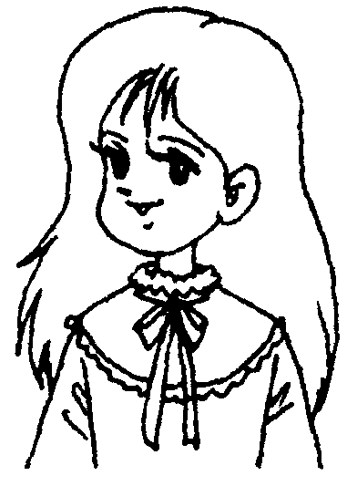 | I always dream big. I had planned to get the highest marks during the final exam. But I didn't make it. And my dream of winning the English Olympic competition also didn't come true. But I have a new dream now. I want to study abroad when I grow up.So my next year's plan is to improve my English.
Li Qiang  15 years old  Hunan  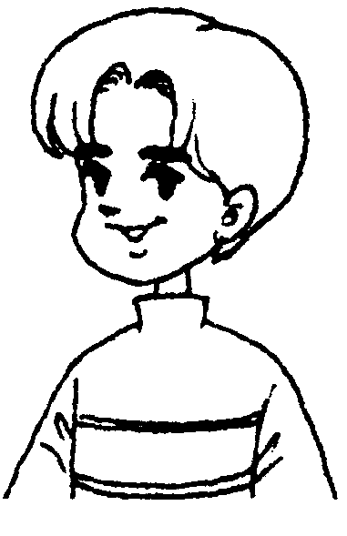 | My biggest wish is to watch to the end of the Spring Festival Eve Variety Show (春节联欢晚会) without falling asleep this year. Last year, I got bored with program after 11 o'clock and went to bed early. This year I will stay awake until the last minute, why? My favourite star Jay Chou, together with other stars, will be on the program this year. How can I not watch to the end?
Wang Rong  13 years old  Shanghai   | I want to be closer to my friend this year. We used to be in the same middle school. Now her school is about half an hour's ride from mine. We don't see each other often now but we do miss each other. I will buy her some of her favourite things as presents when her birthday comes. I want to tell her that I hope our friendship lasts the whole life.
Elizabeth  14 years old  US   | I have too many ideas. First of all,I want to be a better sister. I always enjoy being with my sister. She is four years younger than me. We make cakes and watch films together. She once told me that my chocolate cookie was her favourite food. But this year I was too busy with my school work. I didn't make enough time for her.
46. Huang Fang wants to when she grows up.
A. travel all over the world
B. get good marks in exams
C. win the English Olympic competition
D. study abroad
47. Li Qiang didn't watch to the end of the Spring Festival Eve Variety Show last year because
A. he felt the program was boring
B. he was not allowed to do so
C. he had some homework to do
D. something was wrong with the TV set
48. Which of the following is NOT TRUE?
A. Wang Rong and her friend are not in the same school.
B. Wang Rong can see her friend very often now.
C. Wang Rong misses her friend very much.
D. Wang Rong's school is half an hour's ride from her friend's.
49. How old is Elizabeth's sister?
A. 14 years old. B. 18 years old.
C. 10 years old. D. 4 years old.
50. The four persons in the passage are talking a-bout their .
A. hobbies B. wishes C. subjects D. friends
B
Millions of people have seen Disney films and TV programs. They have made friends with all the Disney heroes ( 英雄): Mickey Mouse, Donald Duck, Snow White, and Peter Pan. Millions more have visited Disney Parks. Probably no other company has pleased so many children. It is not surprising that it has been called a dream factory.
Walt Disney was born in Chicago, Illinois. Then his family moved to Missouri. He grew up on a farm there. At the age of 16, Disney began to study art in Chicago. Four years later,he joined the Kansas City Film Ad Company. He helped make cartoon (卡通) advertisements to be shown in cinemas.
In 1923, Walt Disney moved to Hollywood, California to join his brother Roy. He wanted to be a film producer or director (导演) »but he failed to find a job. So he decided to make animated films (动画片) . In these films, drawings are made to move in a lifelike way. We call them cartoons. Disney wanted to bring his pictures to life.
Disney opened his first film company in the back of an office. For the first several years,he had to work hard for a living. But he believed that cartoon films could be popular.
Mickey Mouse was drawn with a group of circles. The public first saw Mickey Mouse in a film called Steamboat Willie. Walt Disney himself provided the voice for Mickey Mouse. The film was produced in 1928. It was a huge success. Mickey Mouse appeared in hundreds of cartoons during the years that followed. He became known all over the world.
51. The first paragraph tells us that millions of people enjoy Disney Company's .
A. parks B. TV programs C. films D. all of the above
52. Where did Walt Disney grow up?
A. In Illinois. B. In Missouri. C. In Kansas. D. In California.
53. Which of the following is the right order of the events about Walt Disney?
a. He moved to Hollywood to join his brother.
b. He was born in Chicago, Illinois.
c. He opened his first film company.
d. He helped to make cartoon advertisements in a company.
e. He moved to Missouri with his family.
A. a—c—d—e—b B. b—d—a—c—e C. b—e—d—a—c D. b—d—e—c—a
54. When did people see Mickey Mouse for the first time?
A. In 1923. B. In 1927.
C. In 1928. D. We don't know.
55. The best title of this passage is .
A. Walt Disney B. Dream Factory
C. Mickey Mouse D. Disney Company
C
After a serious earthquake happened, a father left his wife safely at home and rushed to his son's
school,only to find that the building where his son studied had collapsed and looked like a pancake(煎饼).
He was shocked (震惊). He didn't know what he should do for a while, then he remembered the words he had said to his son:"No matter what, I'll always be there for you!"And tears began to fill his eyes. He started digging through the ruins (废墟).
As he was digging, other helpless parents and the firemen arrived and tried to pull him off the ruins, saying: " It's too late! They're all dead! There's nothing you can do!"To them he replied with one line: "Are you going to help me now?" And then he kept on digging.
No one helped,however. He went on alone because he needed to know for himself:"Is my boy a-live or is he dead?" He dug for eight hours... 12 hours. . . 24 hours.. . 36 hours. . . then, in the 39th hour, he pulled back a rock and heard his son's words. He shouted his son's name, "ARMAND!" He heard back, "Dad!?! It's me, Dad! I told the other kids not to worry. I told them that if you were alive,you'd save me and when you saved me, they'd be saved. You promised (承诺), 'No matter what happens, I'll always be there for you!? You did it,Dad!"
"What's going on in there? How is it?"the father asked.
"There are 14 of us left out of 33,Dad. We're frightened, hungry, thirsty and thankful you're here. When the building fell down,it made a triangle (三角) ,and it saved us. "
"Come out,boy!"
"No, Dad! Let the other kids out first, because I know you'll get me! No matter what happens,! know you'll always be there for me!"
56. The underlined word "collapsed" probably means “ “.
A．倒塌 B．摇晃 C．耸立 D．颠簸
57. Who came to help the father when he was digging?
A. His wife. B. Other parents. C. The firemen. D. No one.
58. Other parents and the firemen wanted to pull him off the ruins because they thought .
A. he was mad
B. all the children had died in the earthquake
C. he was too dangerous to others
D. it was not his job to dig
59. How many students were still alive when the father found them in the ruins?
A. Fourteen. B. Thirty-three. C. Forty-seven. D. Nineteen.
60. We can learn from the passage that
A. it took the father one day to find his son and other students
B. his wife died in the earthquake
C. his son was the last one to come out of the ruins
D. the son didn't believe his father would come to save him
试卷Ⅱ(非选择题共40分)
五、单词拼写(本题有l0小题，每小题l分，共计l0分)根据下列句子所给的汉语或英语注释，写出句子空缺处各单词的正确形式(每空限填一词)。
61. No one knows whether Mr. Li lives on the (八) floor of this building.
62. Go (横穿) the bridge. You'll find the library on the left.
63. David (穿着) an old coat every day, looking very strange.
64. She is such a kind person that everyone will miss her (永远).
65. Yesterday we went to a (音乐会)and had a good time.
66. When I came into his home, he had finished (read) the news report.
67.I have two (knife). Which one do you want?
68. I think the mooncakes with nuts are the (nice) of all.
69. We were talking on the playground when the bell (ring).
70. The woman looked at the young man (angry) and didn't say a word.
六、词语填空(本题有10小题，每小题l分，共计l0分)用方框中所给词语的适当形式填空，使短文正确、通顺、连贯(每词限用一次，其中有两个词是多余的)。
under at letter be hurry cry
it polite she if sorry laugh
Allen studied in a city far from her hometown. One day, she went to buy a blue umbrella for her mother as a birthday present, because 71 was old and broken.
On her way back to school, Allen felt thirsty and went into a tea house for a drink. There 72 so many people in it. She found a seat and sat 73 a table. She put the umbrella behind the chair. After she finished her cup of tea, she looked at her watch, 74 was nearly the time for classes in the afternoon. She 75 out and back to school. Suddenly, she found that she had left her umbrella in the tea house. She ran back to the tea house. But the umbrella was no longer here.
She couldn't stop herself from 76 ,and she told the people around about the blue umbrella, which was a birthday present for her mother. The people all felt 77 for her. Then the owner of the tea house came and asked for her mother's address. He said 78 someone took it away by mistake and came to return the umbrella,he would send it to her mother. The girl told him her mother's address, thanked him 79 and then left.
A few days after her mother's birthday, Allen got a 80 from her mother, which said, "Dear Allen, thank you for your good presents. But could you tell me why you sent me so many blue umbrellas from different places?"
七、任务型阅读(本题有5小题，每小题l分，共计5分)下面是五个摘自英语词典中的例句，其中的斜体词可能会影响你对句子的理解。但每个斜体词我们均给出了它在词典中的三种不同解释，请你结合句子意义，为每个斜体词找出最合适的解释，并将答案(A、B或C)写在对应题号的横线上。
81. Lucy! That shelf isn't stable. Be careful!
82. During summer holidays I'm going to have my fling first,then I'll work on my study.
83. When the children handle the baby cats, it makes the mother cat worried.
84. As soon as I walked into his garden,I saw many beautiful blooms on the trees.
85. We're meeting at 6: 00 prompt. Don't be late, please.
• bloom /blu:m/
A. (n. ) a flower or flowers
B. (n. ) the best or happiest time
C. (v. ) to become happy and healthy
• fling /flirj/
A. (v. ) to throw something quickly
B. (v. ) to suddenly open a door,window
C. (n. ) a short time that you enjoy yourself without worrying about anything
•handle /'haendl/
A. (v. ) to do with a problem
B. (u. ) to pick up or feel something(e. g. animals) with hands
C. (w. ) the part of a door, window that you use for opening it
• prompt /prompt/
A. (adj. ) done quickly
B. (adv. ) on time
C. (v. ) to make someone decide to do something
• stable /'steibl/
A. (adj. ) not possible to move or change
B. (n. ) a building where horses are kept
C. (n. ) a group of people working for the same company Sunday Sunny
八、书面表达(本小题共l小题，计l5分)
假如你是绍兴晚报的小记者，星期天和同学一起参加了“环保小卫士"活动。请你根据下表所提供的信息，把当天的活动写成日记发表在校园网上，倡导更多的同学来关心环保。
出发时间 | 上午8：00
活动地点 | 人民公园
交通方式 | 公交车
你们的发现 | 1．儿童攀爬树木  2．墙上乱涂乱画  3．地上垃圾很多
你们的行动 | 捡垃圾、擦墙、植树
你们的感受
要求：(1)日记应包括表格中的所有内容，可适当增加细节；
(2)感受要符合活动主题，至少在两个句子以上；
(3)日记格式和开头已给出(不计入总词数)，你只需接着写；
(4)词数在80左右。
Sunday sunny
I took part in the "Environment Protector" activity with my classmates today. In the morning,

2007年浙江省绍兴市中考英语试题参考答案
一、听力
1． A 2． B 3． A 4． C 5． A 6． B 7． A 8． B 9． A l0． A l l． C l 2． B l 3． B 14． A l 5． C
二、单项填空
16． B l 7． D l 8． C l 9． C 20． D 21． B 22． C 23． A 24． B 25． C 26． B 27． D 28． B 29． A 30． C
三、完形填空
31．A 32．C 33．B 34．B 35．A 36．D 37．C 38．B 39．A 40．D 41．A 42．C 43．A 44．B 45．A
四、阅读理解
46．D 47．A 48．B 49．C 50．B 51．D 52．B 53．C 54．C 55．A 56．A 57．D 58． B 59． A 60． C
五、单词拼写
61．eighth 62．across 63．wears 64．forever 65．concert 66．readin967．knives 68．nicest
69．．ran970．angrily
六、词语填空
71．hers 72．were 73．at 74．it 75．hurried 76．Crying 77．sorry 78．if 79．politely 80．1etter
七、任务型阅读
81．A 82．C 83．B 84．A 85．B
八、书面表达
One possible version:
Sunday Sunny
I took part in the "Environment Protector" activity with my classmates today. In the morning, we set off for People's Park at 8:00 by bus. When we got there, we found that some children were climbing the trees, the ground and the public walls were very dirty. So we began to pick up the rubbish and clean the public walls. We also planted some trees. All of us worked very hard! We think it's our duty to take good care of our environment. If everyone makes a contribution to protecting the environment, the world will become more and more beautiful.

天仁英语教师资源交流网

