2007年浙江省宁波市中考英语试题
全卷有l 0个大题。满分为110分，考试时间为100分钟。
一、听力部分(计20分)
1．听小对话，选择图片(共5小题，计5分)
1. Which animal can bring us good luck?
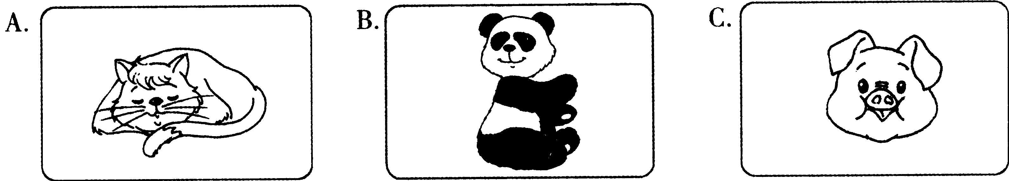

2. Which Olympic Games are they talking about?
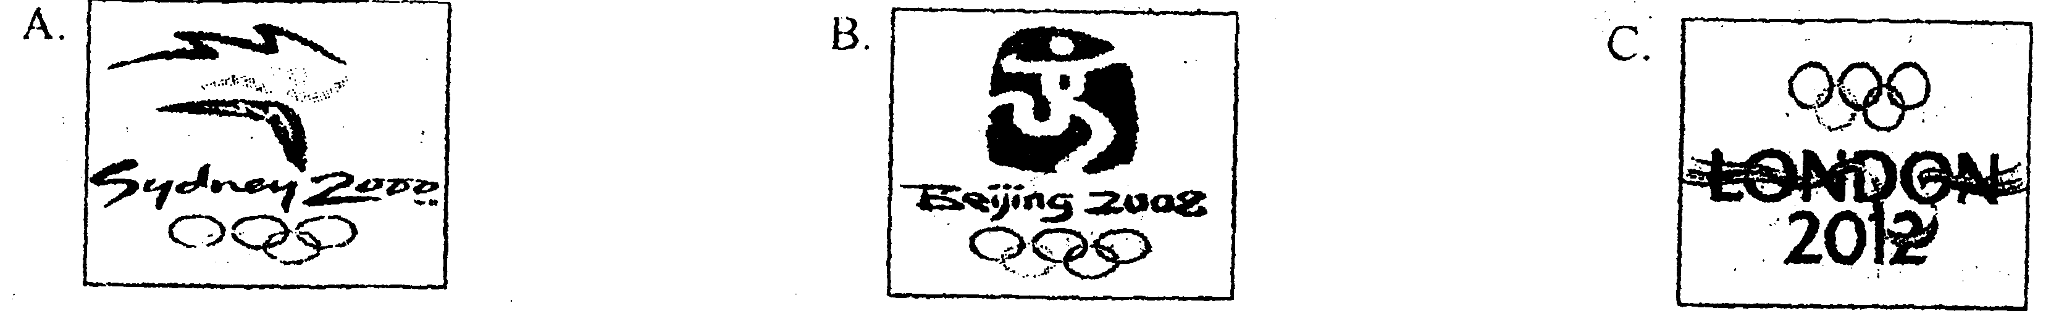
3. Where is the police station?
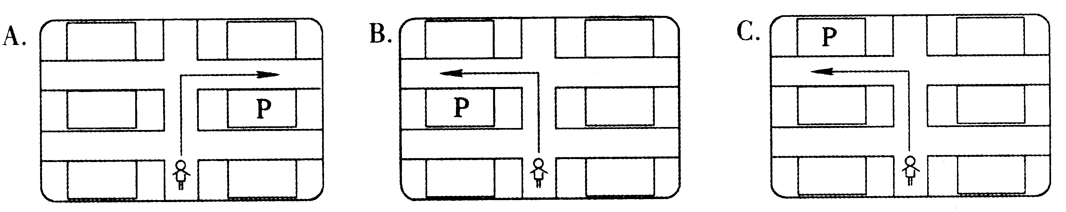
4. What's David 's favorite sport?
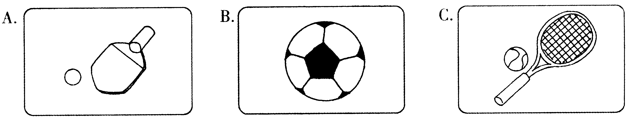
5. What did Linda lose?
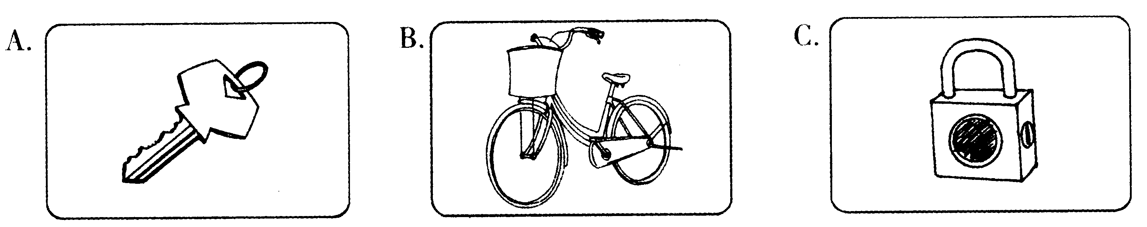
Ⅱ．听小对话，回答问题(共5小题，计5分)
6. A. A picture. B. A kite. C. A watch.
7. A. At home. B. In a shop. C. At school..
8. A. At 7:10. B. At 7:20. C. At 7:30
9. A. Exciting. B. Interesting. C. Boring.
10. A. Sunny.. B. Windy. C. Cloudy.
III．听长对话，回答问题(共5小题，计5分)
听下面一段较长的对话，回答第ll至第l2两小题。
11. Where are they going to spend their holidays?
A. the USA. B. Canada. C. Australia.
12. Who are the two speakers?
A. A father and a daughter. B. A mother and a son. C. A brother and a sister.
听下面一段较长的对话，回答第l3至第l5三小题。
13. What does Steven do?
A. A journalist. B. A driver. C. A student.
14. What foreign languages can Steven speak?
A. French and English. B. English and Russian. C. French and Russian.
15. Which country is NOT mentioned in the dialogue?
A. America. B. Australia. C. France.
Ⅳ．听短文，回答问题(共5小题，计5分)
16. Tom was told to paint at first.
A. a hand B. a foot C. a head
17. His grandpa wanted Tom to before painting.
A. watch the model carefully B. walk on the paper C. listen to him carefully
18. Tom made his feet with paint.
A. yellow B. green C. black
19. His grandpa felt when he came back.
A. excited B. angry C. interested
20. At last Tom .
A. copied the model B. asked someone for help
C.left his own footprints(脚印) on the paper
二、笔试部分(计90分)
V．选择填空(共l 5小题，计l 5分)
从A、B、C、D四个选项中，选出可以填入空白处的最佳答案。
21. —What about dictionary on the bookshelf?
—It's very useful, I think.
A. a B. an C. the D. one
22. —Would you like some ?
—Yes, please. I'm a little thirsty.
A. bread B. meat C. beef D. orange
23. —Have you ever heard the song" TAKE ME TO YOUR HEART" ?
—Yes, it terrific. All of us like it very much.
A. smells B. sounds C. looks D. tastes
24. —I don' t know which T-shirt was , so I took them both.
—Yes, it's really difficult to choose.
A. better B. well C. best D. good
25.—What did the teacher say just now?
— He us not to play computer games all day.
A. tells B. told C. has told D. is told
26. —How long have you your watch? It looks new.
—Only about three weeks.
A. had B. bought C. received D. borrowed
27. —Miss Sun, what are we going to do next?
—Let' s go out for doing sports. sunny day!
A. What B. What a C. How D. How a
28. —It was quite a heavy snow last night. Is everyone here now?
—Yes, and of us was late for school this morning.
A. neither B. either C. all D. none
29. —Excuse me, is the supermarket far from here?
—No, it' s about .
A. 7 minutes walk B.7 minute walk
C. 7 minutes' walk D. 7 minute's walk
30. —I'm not sure Mr. Wang goes to see his parents.
—Twice a week.
A. how long B. how often C. how soon D. how many
31. —Jill looks so painful, there be something wrong with her.
—Oh dear! We'd better take her to the nearest hospital at once.
A. can B. should C. would D. must
32. —What sign is often found in museums?
A. MENU B. THIS SIDE UP C. PAUSE D. NO PHOTOS
33. —Chen Jie, the workers our new library already.
— Really? I'll go there and borrow some books.
A. decorated B. are decorating
C. have decorated D. were decorated
34. —May I use your computer this afternoon?
A. It' s a pity B. Not at all C. No problem D. Not too bad
35. —Thank you for offering us such a good meal!
— .
A. I'm glad you all enjoy it B. Don't mention it
C. Come here next time D. I didn't cook so well
Ⅵ．完形填空(共l 5小题，计l5分)
阅读下面短文，掌握其大意，然后从A、B、C、D四个选项中，选出可以填入空白处的最佳答案。
John Thomas was an 18 - year - old student, but he had been a famous champion (冠军) Everybody at Boston University liked this tail, quiet boy. Once he was hurt, everybody at Boston University was 36 . People all over the country 37 about John Thomas and often asked, "Will he ever jump again ?"
John' s mother went to the hospital to see her son. She looked at his 38 leg. Then she looked into his 39 . She knew what her son would 40 . "You're going to jump again, John, I know it,"she said. " 41 will be all right. "
If John hoped to jump again, he would have a 42 to do. He began at once. Even in his hospital bed John started to exercise. He used a wheel(轮子) and other metal things. Soon his 43 looked like a machine shop!
It was May when John 44 the hospital. "Is it all right if I go camping( 宿营) this summer?" he asked the doctors.
" Yes," the doctors said. " But take it easy on that fool. "
John took only 45 walks at first. He was taking it easy on his foot. But not on anything else. He went swimming and did other kinds of exercises. He exercised 46 his body cried for a rest. Some days later, he exercised a little 47 . In late summer John went back to 48 . He asked if he could practise with the football team. Football wasn't his favorite, but he had to get that leg 49 again! He worked hard. "No one pushed him as hard as he pushed himself," said one of his friends. "To 50 a champion fighting back is a wonderful thing to watch. ":
36. A. sorry B. afraid C. alone D. tired
37. A. thought B. talked C. heard D. moved
38. A. broken B. lost C. missing D. dead
39. A. face B. foot C. eyes D. leg
40. A. make B. use C. agree D. do
41. A. Nothing B. Anything C. Something D. Everything
42. A. little B. lot C. few D. bit
43. A. chair B. classroom C. home D. bed
44. A. reached B. called C. left D. found
45. A. short B. long C. quick D. fast
46. A. after B. if C. until D. when
47. A. later B. better C. more D. less
48. A. school B. hospital C. shop D. church
49. A. thick B. strong C. straight D. hard
50. A. look B. hear C. know D. see
Ⅶ．阅读理解(共15小题，计25分，其中第51—55每小题1分，第56--65每小题2分)
阅读下面短文，并做短文后的题目，从A、B、C、D四个选项中，选出能回答所提问题或完成所给句子的最佳答案。
(A)
Do you want to do well in exams? Sometimes your knowledge is not enough, you also need good Strategies. Here are some for you:
●Before you answer the questions, if you feel a little nervous, take a few deep breaths to help you relax.
●Always read the question carefully and make sure that you understand it. Read it a few times if possible.
●Find out how much each question is worth or how many points you need.
●If it asks to give one answer, only write one.
●If there is a difficult question, don' t worry. Go on to the next question and come back to it if you have time later.
● Try not to leave questions unanswered when you finish the test. Sometimes a guess may get you points.
●When you finish, go back and check your answers. You will need to check your writing for spelling mistakes.
51. From the passage, we know we can to help ourselves relax if we feel a little nervous.
A. tell ourselves not to be nervous B. ask the teacher for help
C. go out for a walk D. take a few deep breaths
52. To make sure we understand the question, we had better .
A. read it fast B. read it till we finish it
C. read it a few times if possible D. read it slowly
53. When we finish answering all the questions, we need to .
A. hand in at once B. check spelling mistakes
C. worry about our points D. check with classmates
54. The underlined word "strategies" in the passage means .
A．策略 B．思维 C．途径 D．智慧
55. Which of the following is NOT RIGHT according to the passage?
A. Find out how many points we need or how much each question is worth.
B. Try not to leave questions unanswered when we finish the test.
C. If it asks to give one answer, we'd better write more .
D. Sometimes we should guess the answers to get points,
(B)
A city without cars would be very strange, right? But Venice is such a city.
Venice is in the northeast of Italy. It wasn't built on land, like Beijing or Shanghai, but on more than 110 islands. Seawater is everywhere around the city.
Even so, travel isn't difficult. The waterways have always been the best way to get around. There are 117 waterways and more than 400 bridges that can guide you where you want to go_{r} People in Venice move from place to place by boat. They like to enjoy the scenery and cool summer nights while taking boat trips. They can talk to other people as they go along.
Venice grew out of small islands in saltwater lakes when some Italians escaped from a war more than 1,500 years ago, and built homes there.
Water makes the city special, but it is also a big problem.
Once, people used too much underground water. This made the city get lower little by little. Now the city has gone down by 23 centimeters. Another problem is the rising seawater. The temperature has risen over the years. This has made the ice of the Arctic Ocean (北冰洋) rnelt( 融化).
Every year, high waters hit the city in autumn and winter. When a lot of water comes, more than half of the city is underwater.
Scientists are trying different ways to stop the city from getting even lower.
56. According to the passage, which picture shows the right place of Venice?
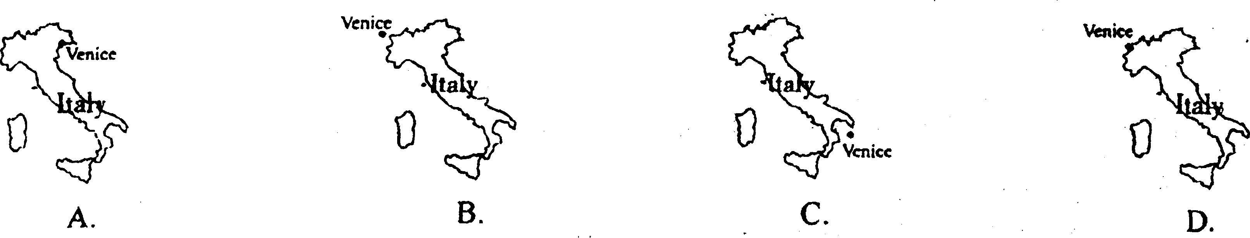
57. Which is the most impossible way for people in Venice to get around in the passage?
A. On foot. B. By boat. C. By car. D. By bike.
58. Why is Venice still getting lower and lower?
A. Because too many people live there.
B. Because the rising temperature has made the ice melt.
C. Because lots of bridges have been built.
D. Because the underground water is rising.
59. What seasons are dangerous for Venice because of high waters?
A. Summer and autumn. B. Autumn and winter.
C. Summer and winter. D. Spring and winter.
60. The passage is mainly about .
A. the waterways of Venice B. the history of Venice
C. the scenery of Venice D. the problem of Venice
(C)
Hangzhou Bay (海湾) Bridge
The world' s longest trans-oceanic bridge (跨海大桥) started to be built four years ago in Cixi in Zhejiang Province. Thanks to the workers' hard work, the first main step of the bridge will be finished - the southern part and the northern one will be connected in June this year. In 2008, people can drive their cars on it.
Hangzhou Bay Bridge will be 36 kilometers long. It will cost about RMB 11.4 billion, 35% of which is offered by many personal companies in Ningbo, 59% is loaned (贷款) from different China's banks.
It usually takes people over four hours to travel from Shanghai to Ningbo by car. Now the bridge will make the journey short by 120 kilometers, making it a 179 -kilometer journey. So the bridge will make the trip faster and easier. The drive between Shanghai and Ningbo will be less than 2 hours.
On the other hand, the development is so fast that more and more foreign companies in Shanghai like to make money in Ningbo. In the future, Ningbo and northern Zhejiang will be parts of the Greater Shanghai economic zone(经济圈).
根据短文内容，回答下列问题。
61. Will Hangzhou Bay Bridge be the world' s longest trans - oceanic bridge?
62. Will the first main step of the bridge be finished in 2007 or 2008?
63. How long will Hangzhou Bay Bridge be?
64. Where was the most part of money for the bridge from?
65. Why will Ningbo be one part of the Greater Shanghai economic zone?
Ⅷ．词汇(共l0小题，计l0分)
(A)根据下列句子及所给汉语注释，写出空缺处各单词的正确形式，每空只写一词。
66. One of the ▲ (获胜) is my cousin. He is the pride of our school,
67. The girl ▲ (花费) time collecting toys last year.
68. My younger sister does the ▲ (最少) work in my family.
69. About a ▲ (千 ) people left their hometown because of the terrible sandstorm.
70. To our ▲ (惊讶) ,the factory is still pouring waste water into the river near it:.
(B)根据下列句子及所给单词的首字母，写出各单词的完全形式。
71. Li Hua fell off his bike this morning. Luckily, he didn't hurt b ▲ .
72. Many people are k ▲ in traffic accidents every year.
73. Nobody taught him how to swim, he taught h ▲ .
74. Animals are our friends, so p ▲ them is our duty.
75. A ▲ is another way of saying 15 minutes.
Ⅸ．补全对话(共5小题，计l0分)
补全下列对话，要求语句通顺，意思连贯，符合情景，所写的句子必须与所给的标点符号一致。
(A girl wants to buy a camera. Now she is in a shop. )
MAN: Good morning. 76 ?
GIRL: Yes, please. I'd like to buy a camera.
MAN: We have many cameras here. Some are made in China, and some are made in other countries.
GIRL: This one looks very nice. 77 ?
MAN: In Japan.
GIRL: 78 ?
MAN: 5 ,000 yuan. This is a digital camera.
GIRL: Wow, that's too expensive! 79 . Do you have an ordinary one?
MAN: Sure. What about those ones?
GIRL: Well, this one looks very good. And the price is OK. Is it made in China?
MAN: Yes, it's made in Shanghai.
GIRL: OK, 80
X.书面表达(计l 5分)
某市教育局将每年的9月1日定为爱心慈善日(Charity Day)，今年活动的主题是“人人为贫困孩子献爱心”。现在请你以学生会的名义写一份倡议书，内容要点如下(括号中的词汇可供参考)：
1．许多孩子因贫困而上不起学；(too……to……)
2．他们没有足够的学习用品和衣物；(school things and clothes)
3．每个孩子都应该有上学的权力；(have the right to do something)
4．我们应该做一些力所能及的事去帮助他们，比如……；(as possible as one can)
5．希望他们和我们一样享有在学校获得知识的机会。(the same…as…，get knowledge)
注意：1．文章开头、结尾已给出，但不计人总词数；
2．词数：80左右。
Dear students,
In some parts of our country, there are many children out of school.

Thanks for your joining!
Students' Union

2007年浙江省宁波市中考英语试题参考答案及评分标准
宁波市
听力材料
1．听小对话，选择图片。
本题共有五个小题，在每一小题内你将听到一个小对话，我们把对话念一遍。请你从试卷上的A、B、C
三个选项中，选择一幅恰当的图片。(现在你有l5秒钟的时间阅读第l至第5五小题)
1. M: How time flies! It's the year of pig now.
W: Yes, I think pig can bring, us good luck this year. (停顿10秒)
2. W: Good news, Ted! I've booked two tickets for the Olympic Games online.
M: You mean the tickets for the Olympic Games in Beijing? Great! (停顿10秒)
3. M: Excuse me, could you tell me the way to the police station?
W: Yes, go straight and turn left. It' s on your right. (停顿10秒)
4. W: What are you going to do, David?
M: I'm going to play soccer, it's my favorite. (停顿10秒)
5. M: Linda, why do you look so worried?
W: I can't find the key to the bike. (停顿10秒)
Ⅱ．听小对话，回答问题。
本题共有五个小题，在每一小题内你将听到一个小对话，然后你会听到一个问题，我们把对话和问题都念一遍。请你从试卷上的A、B、C三个选项中，找出能回答这个问题的最佳答案。(现在你有：15秒钟的时间阅读第6至第l 0五小题)
6. W: Is this your birthday present, Bruce?
M: Yes. It's a nice kite from Tina.
Q: What present was from Tina? (停顿10秒)
7. M.. Where were you yesterday afternoon?
W: I was at home making a cake.
Q: Where was the girl yesterday afternoon? (停顿10秒)
8. W: What time does your father go to work every morning, George?
M : He usually goes to work at 7:30. What about your father, Ann?
W: Oh,10 minutes earlier.
Q: When does Ann's father go to work in the morning? (停顿10秒)
9. W: Mary told me she didn' t like watching football matches.
M: Why?
W: She said it was boring.
Q: What did Mary think of watching football matches? (停顿10秒)
10. M : Mom, it' s a nice day.
W: Yes. But the radio says it will rain later on.
Q: How is the weather now? (停顿10秒)

Ⅲ．听长对话，回答问题。
本题共有两段较长的对话，我们把对话念两遍。请你根据对话内容，从A、B、C三个选项中，选择一个最佳答案。
听下面一段较长的对话，回答第l l至第l2两小题。
(现在你有8秒钟的时间阅读第l l至第l 2两小题)
W: Tom, your dad is waiting for you. We' re going to have a family meeting.
M: OK, I'm coming. What are we going to talk about?
W: About where to spend our holidays. Do you have any ideas?
M: I'd like to go to New York. Is that OK?
W: Good idea. I'm sure your father will agree with you. ((停顿10秒))
听下面一段较长的对话，回答第l3至第l5三小题。
(现在你有l 2秒钟的时间阅读第l 3至第l5三小题)
W: Excuse me, could you tell me your name?
M : I' m Steven.
W: What do you do?
M: I'm a student, but I also have a part-time job in a restaurant.
W: You' re very busy then. Well, what foreign languages can you speak?
M: I can speak French and Russian a little.
W: Do you like traveling around?
M: Yes. I' ve got friends in France, America and Russia. (停顿15秒)
IV．听短文，选择正确答案。
本题是一篇短文，短文后有五个小题，我们把短文念两遍。请你根据短文内容从A、B、C三个选项中选择一个最佳答案。
(现在你有l 5秒钟的时间读第l6至第20五小题)
Tom wanted to learn painting. His grandpa told him to paint a foot at first. He wanted Tom to watch the model carefully and then paint it on the paper. When his grandpa left the room, Tom looked at the model for a while. Then he took off his shoes and looked at his own feet. Suddenly he found an easy way to paint. Tom made his feet black with paint and walked on the paper. At once, his footprints were left on the paper. Soon his grandpa came back and was angry with him, but Tom proudly said that painting the feet was the easiest thing in the world.
(停顿l5秒)(听力考试到此结束，请考生们继续做笔试部分。)

2007年浙江省宁波市中考英语试题参考答案
一、听力部分(计20分)
I．听小对话，选择图片(共5小题，计5分)
1．C 2．B 3．C 4．B 5．A
Ⅱ．听小对话，回答问题(共5小题，计5分)
6． B 7．A 8． B 9． C l 0．A
Ⅲ．听长对话，回答问题(共5小题，计5分)
11．A l 2．B l 3．C l 4．C l 5．B
Ⅳ．听短文，回答问题(共5小题，计5分)
16．B l 7．A l 8．C l 9．B 20．C
二、笔试部分(计90分)
V．单项填空(共l 5小题，计l 5分)
21．C 22． D 23． B 24．A 25．B
26．A 27．B 28．D 29．C 30．B
31．D 32．D 33．C 34．C 35．A
Ⅵ．完形填空(共l 5小题，计l 5分)
36．A 37．B 38．A 39．C 40．D 41．D 42．B 43．D 44．C 45． A 46．C 47．C 48．A 49．B 50．D
Ⅶ．阅读理解(共l 5小题，计25分，其中第51—55每小题1分，第56—65每小题2分)
51. D 52. C 53. B 54. A 55. C 56. A 57. C 58. B 59. B 60. D
61. Yes. / Yes, it will (be).
62. In 2007. /The first main step of the bridge (It) will be finished in 2007.
63. 36 kilometers (long)./ Hangzhou Bay Bridge (It) will be 36 kilometers (long).
64. From the different China' s banks. / The most part of money (for the bridge ) / It is from the different China's banks.
65. Because of Hangzhou Bay Bridge and the development of Ningbo. / Because Hangzhou Bay Bridge will be finished in 2008 and the development of Ningbo is so fast / Because Hangzhou Bay Bridge (it) will make the trip faster and easier, Ningbo is developing very fast.
Ⅷ．词汇(共10小题，计l 0分)
66. winners 67. spent 68. least 69. thousand 70. surprise 71. badly 72. killed 73. himself 74. protecting 75. quarter
Ⅸ．补全对话(共5小题，计l 0分)
76. Can I help you?
77. Where is it made?
78. How much is it?
79. I can’t afford it.
80. I’ll take/have/get/buy this one/it.

天仁英语教师资源交流网

