2007年浙江省丽水市中考英语试题
(一)听力部分(25分)
一、听力(共15小题，第一节每小题1分，第二、三节每小题2分，计25分)
第一节：听小对话，选择图片。
1. What animal does Mary like best?
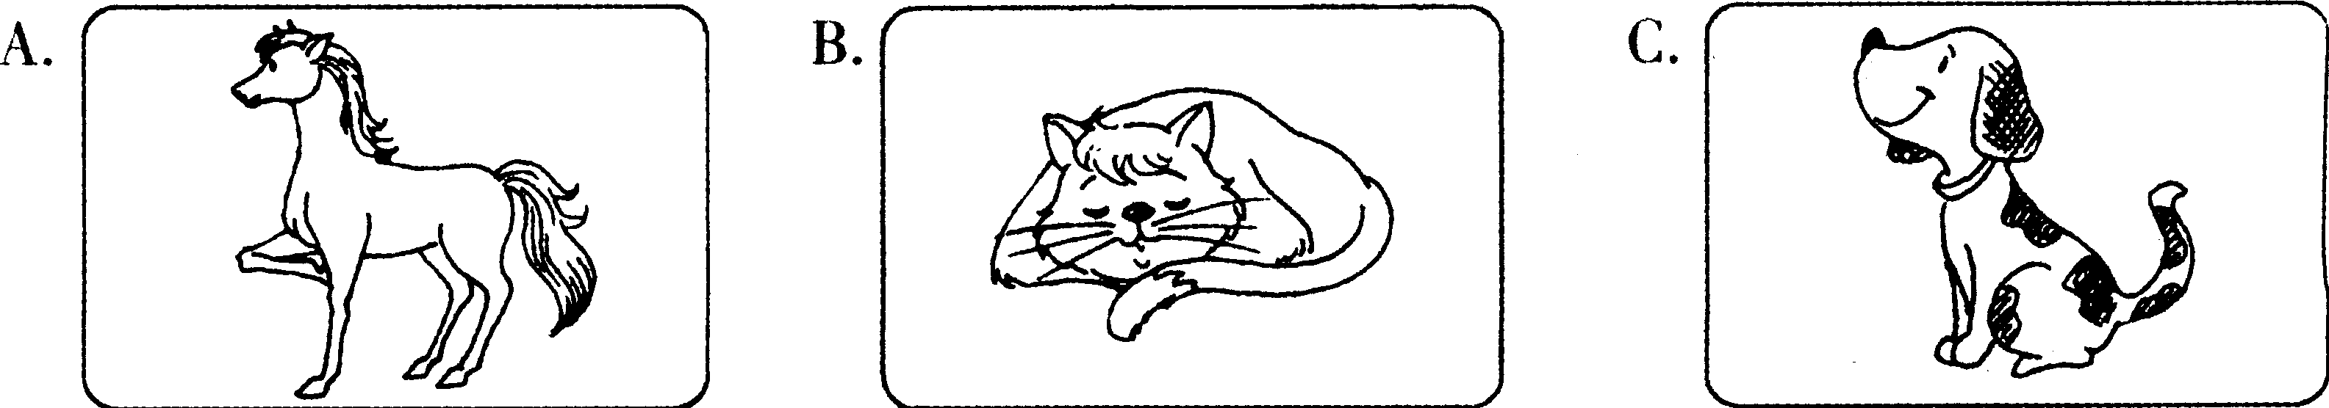2. Where' s the girl' s pencil?
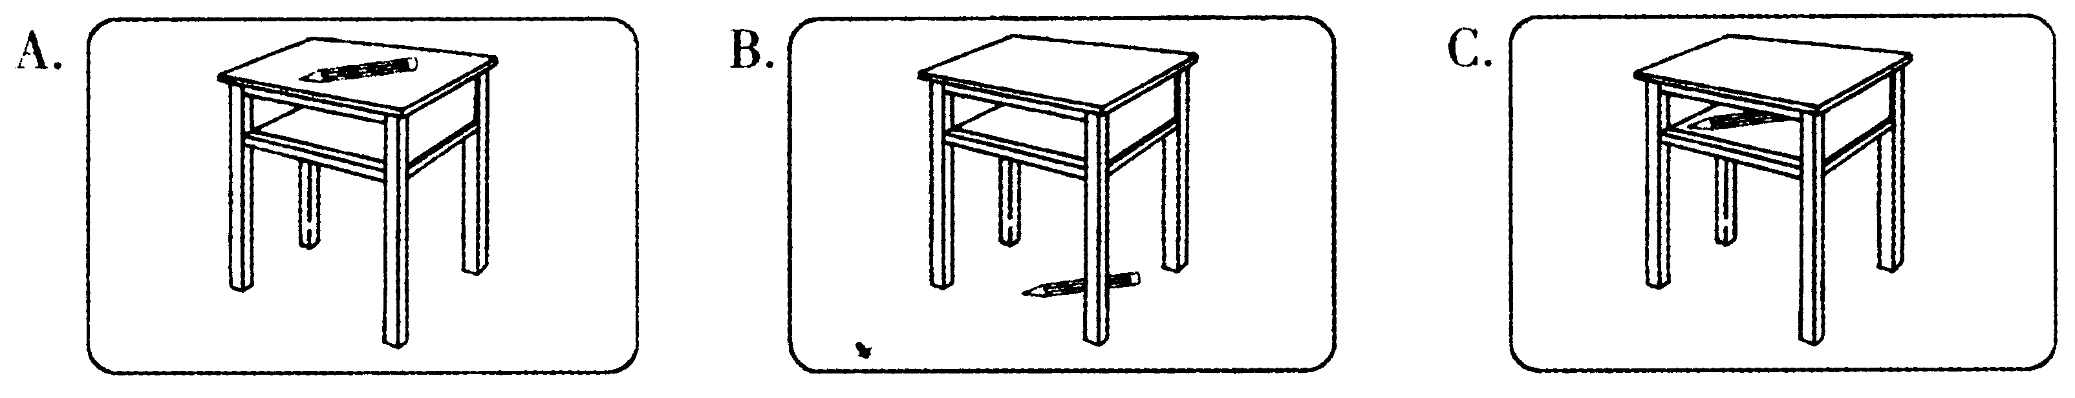3. What' s the weather like now?
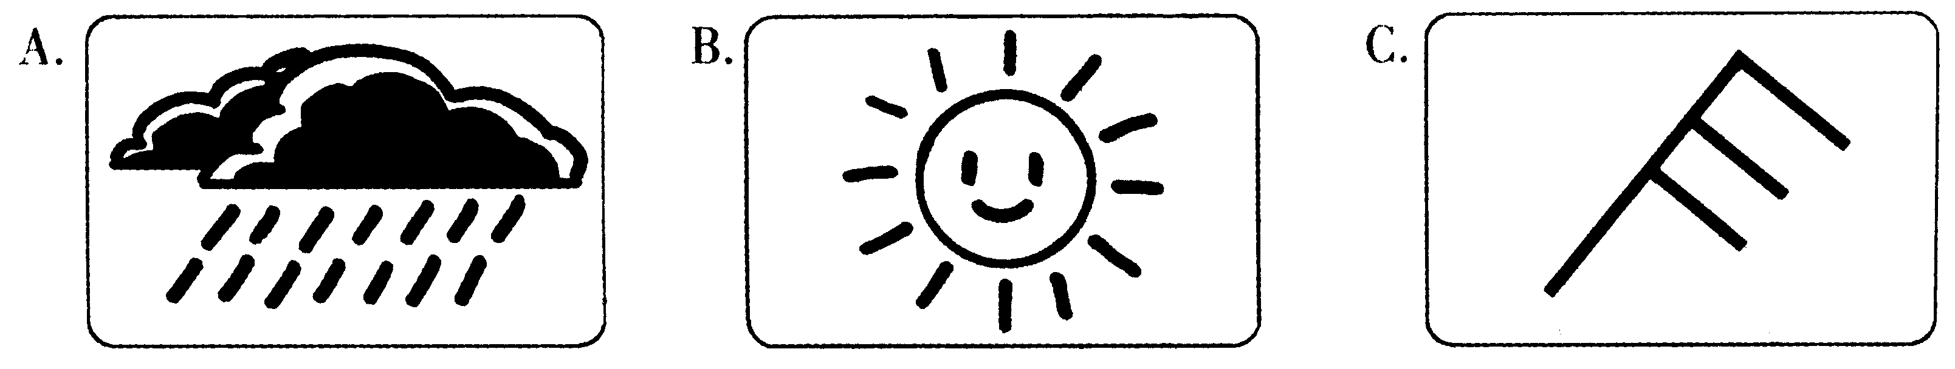
4. What does Kelly like for breakfast?
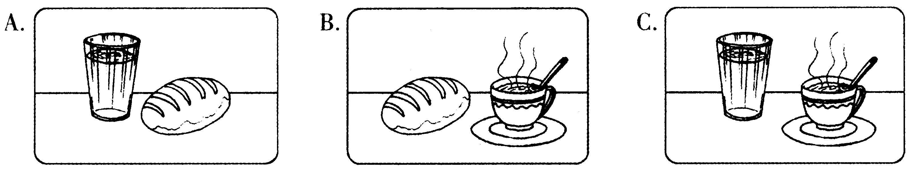
5. When is Nancy's birthday?
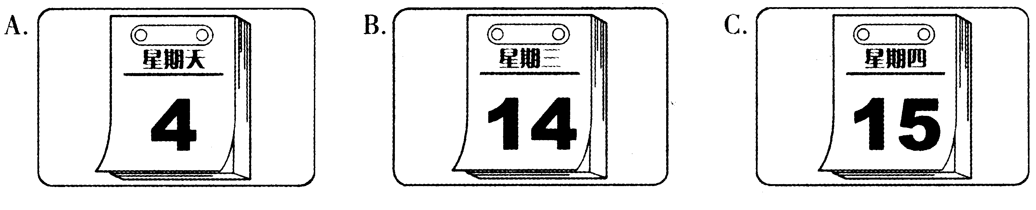
第二节：听小对话，回答问题。
6. Where did Jane go yesterday?
A. To the park. B. To the zoo. C. To the cinema.
7. What are they going to do tomorrow?
A. Play volleyball. B. Play football. C. Play basketball.
8. Where was Mrs Black two years ago?
A. In Guangzhou. B. In Shanghai. C. I don't know.
9. How many times has the woman been to the museum?
A. Once. B. Twice. C. Three times.
10. Who is listening to the radio?
A. Ann. B. Ann's father. C. Ann'smother.
第三节：听长对话，回答问题。
听下面一段较长的对话，回答第ll、12两小题。
11. What day does Ming like best?
A. Tuesday. B. Wednesday. C. Friday.
12. What is Joe's favorite subject?
A. Science. B. History. C. Music.
听下面一段较长的对话，回答第l3～15三小题。
13. How old is Miss Smith?
A. 12. B. 21. C. 37.
14. What does Jean want to be?
A. A teacher. B. A policewoman. C. A journalist.
15. What does Jean think of the job?
A. Interesting. B. Busy. C. Hard.
(二)读写做部分(125分)
二、单项填空(共25小题，计25分)
从A、B、C、D四个选项中，选出可以填入空白处的最佳选项。
16. This is nice picture. We can see something beautiful in it.
A. a B. an C. the D. /
17. Look at the boy! name is Tom, Li Lei' s American friend.
A. My B. Your C. His D. Her
18. — What does Zhang Hong do, do you know?
— She is a . Look! Here' s a photo of her.
A. teacher B. nurse
C. worker D. farmer
19. — Wow, a nice T-shirt! is it?
— Only 25 yuan. It' s on sale.
A. What color B. How many C. What size D. How much
20. — Happy birthday, Bill!
A. Thank you B. The same to you C. Not at all D. That's OK
21. I often go to school . I like walking.
A. by bus B. by car C. on foot D. by taxi
22. — Math is too hard for me, Mum. I failed again.
— Come on, dear. is difficult in the world, you see, if you put your heart into it.
A. Everything B. Something C. Anything D. Nothing
23. Tina runs in our class. No one can catch up with her.
A. slowly B. faster C. more slowly D. fastest
24. It' s not polite to ask a lady' s in western countries.
A. name B. age C. address D. hobby
25. Listen! It' s Han Mei. She English in the classroom again.
A. reads B. read C. is reading D. has read
26. — May I watch TV, Mum?
— Certainly. But you finish your homework first.
A. may B. must C. can't D. needn't
27. — Is there a post office near here?
— Yes. Over there, behind the supermarket.
A. Sorry. B. Hello. C. Excuse me. D. Pardon?
28. Bill Gates a talk at Peking University on April 18, 2007 during his visit to China.
A. gave B. let C. got D. did
29. Sally doesn' t like milk at all, her mother wants her to drink every day.
A. and B. so C. or D. but
30. — Which notebook will you buy, the big one or the small one?
— . The big one is for myself and the small one is for my son.
A. Either B. Neither C. Both D. None
31. Everyone will make a mistake, but we must correct it before it worse.
A. gets B. got C. will get D. is getting
32. Guo Yue won the match again. She always does in the table tennis competitions.
A. good B. well C. fine D. nice
33. — Nice to see you, Henry. ?
— I'm quite well.
A. What are you doing B. What's up
C. Where are you going D. How are you
34. It' s very hot in the classroom. Please the window.
A. close B. open C. mend D. break
35. Oh, TV again! It' s so boring. go out to do some sports for a change?
A. What about B. Why not C. How about D. Why don't
36. — Where is Lin Tao, do you know?
— Eeeer ... I saw him basketball on the playground just now.
A. play B. plays C. played D. to play
37. — How many English words should I remember, Mr Black?
— , the better, of course.
A. The harder B. The sooner C. The faster D. The more
38. Sorry, Betty. I haven't finished your book , but I' m going to.
A. already B. just C. yet D. ever
39. — What a beautiful garden! And clean, too!
— Yes, it every day.
A. cleans B. cleaned C. is cleaned D. was cleaned
40. — What are you searching the Internet for?
— I'm trying to find out
A. how many persons have died in Iraq
B. how do we protect our environment
C. what' s the difference between SARS and Bird Flu
D. why isn' t our Chinese team able to beat Korean one
三、完形填空(共15小题，计l5分)
阅读下面短文，掌握其大意，然后从41～55每题所给的A、B、C、D四个选项中选出最佳选项。
David was a middle school student. His father, Mr Hill, was a rich farmer and he had a very big 41 They lived in a small village 42 fifteen years. Later on Mr Hill opened a shop in our town and 43 a house here last month. Then his family moved in and David began to 44 in our class. But at first he had 45 friends at school. He was always alone.
His neighbour Cathy was a 46 girl. She had many friends. When she found the boy 47 talked with others, she decided to 48 him. She talked a lot with him and sometimes played with him. So very soon 49 became good friends.
One afternoon, Cathy said to David, " It' 11 be my 50 birthday tomorrow. I' 11 have a birthday 51 Will you please come?"
"Certainly. I'm glad to," the boy said 52
David got home and thought about 53 he could give to Cathy. He was sorry that he
54 to ask the girl what she liked. At that moment Mrs Hill came and asked, "What' s the
matter, dear?"
"What would you like 55 it was your sixteenth birthday, Mummy?"
"Nothing," the woman said. "I just wish I were 16. "
41. A. school B. factory C. farm D. restaurant
42. A. in B. for C. on D. until
43. A. closed B. opened C. sold D. bought
44. A. live B. study C. teach D. read
45. A. few B. many C. some D. little
46. A. bad B. kind C. shy D. poor
47. A. never B. sometimes C. usually D. always
48. A. ask B. save C. tell D. help
49. A. she B. they C. he D. we
50. A. 14th B. 15th C. 16th D. 17th
51. A. card B. present C. cake D. party
52. A. slowly B. happily C. lonely D. carefully
53. A. what B. which C. when D. where
54. A. tried B. forgot C. wanted D. liked
55. A. because B. why C. if D. how
四、阅读理解(共20小题，计40分)
阅读下面的e-mail和短文，从每题所给的三个或四个选项中选出最佳选项。
A
From: Ukkyi@tom.com
To; Jennysmith@ yahoo, com
Subject; Party
Hi, Jenny,
My sister Ann and I are going to have a party at home this Friday. Lisa, Tom and some other friends of mine will be there. Most of them are from the office. My best friend, Mike, will come, too. I want you to meet him.
Would you like to come? We' 11 play games and have a chat. Then we'll have dinner. Everyone will bring something to eat. It will begin at 3:00 pm and end at 8:00 or 9:00 pm.
We'll have a great time! Can you come? I hope so! Let me know your idea. Call me or send me an e-mail soon.
Katie
56. This e-mail is to .
A. Jenny B. Mike C. Katie
57. The party will begin at .
A. 3:00 pm B. 8:00 pm C. 9:00 pm
58. Mike is best friend.
A. Jenny's B. Katie's C. Ann's
59. The party will last about .
A. 3 hours B. 5 hours C. 8 hours
60. Jenny needs to first.
A. give Mike a ring
B. buy something for the party
C. send an e-mail to Katie
B
On Sunday, May 13th, 2007, we celebrated Mother's Day.
Mother' s Day is a special day for our mothers. It is celebrated in the United States, England, India and some other countries. Children often give their mothers cards, presents and flowers on this day. Some people send messages on telephone or Internet if they live far away. Everyone wants to show their love to their mothers on this great day.
Mother' s Day falls on the second Sunday in May. The idea of a day for mothers was first given by Miss Anna Jarvis in 1872. After her hard work for many years, the first American Mother' s Day was held on May 10th, 1908. Soon the holiday became popular all over the country and around the world.
Celebrating Mother' s Day and learning more about it are important, but probably they are not as important as understanding what your mother always does for you. It is a time to let mum know how important she is to you.
61. Mother' s Day was first celebrated in .
A. the USA B. England C. India D. China
62. Mother' s Day falls on every year.
A. May 13th B. May 10th
C. the 2nd Sunday in May D. the 2nd Saturday in May
63. From the passage, we know that it was NOT for Anna Jarvis to start the holiday.
A. important B. great C. easy D. popular
64. Now people celebrate Mother' s Day because they want .
A. to have lots of fun B. to show their love to mums
C. to get some presents D. to buy more flowers
65. Which of the following does the writer think is the most important to show love to mothers?
A. Learning more about Mother' s Day. B. Sending presents to mothers.
C. Celebrating Mother' s Day every year. D. Understanding what mothers do for us.
C
A greeting is a way of saying "Hello" to someone. People in different countries greet each other in different ways. Here are some.
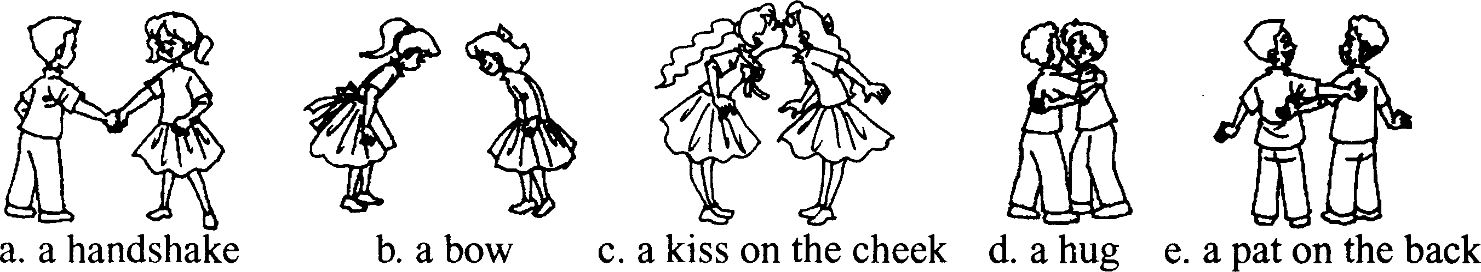

World Greetings
Philippine | The everyday greeting for friends is a handshake for both men and women. Men sometimes pat each other on the back.
Japan | When people meet for the first time, they usually bow. In business, people also snake hands.  In formal situations, people often exchange business cards. When you give a business card, give it with two hands This is polite.  Special note: In Japan, a smile can have different mean -ings. It usually means that the person is happy, or that the person thinks something is funny. But it can also mean that the person is embarrassed.
New Zealand | Usually, both men and women shake hands when they meet someone for the first time.  Fun fact: If you see two people pressing their noses together, they are probably Maori. The Maori are the native people of New Zealand. This is their traditional greeting.
Brazil | Men often shake hands when thev meet for the first time.  When women meet, they kiss each other on the cheek. Women also kiss male friends to say hello.  When you shake hands, look at the person in the eyes. This shows interest and friendliness.
66. In which country do men sometimes pat each other on the back?
A. Philippine. B. Brazil.
C. Japan. D. New Zealand.
67. In this passage, which of the following is NOT mentioned?
A. Kisses. B. Hugs.
C. Bows. D. Handshakes.
68. Of the five pictures above (a, b, c, d and e) , which is the same way to greet each other in the four countries?
A. a B. b C. c D. d
69. Which of the following is true, according to the passage?
A. Both men and women shake hands in Brazil when they meet.
B. Japanese won't smile until they feel very happy.
C. The Maori often press their noses together to greet each other.
D. In Philippine, people shake hands only when they meet for the first time.
70. What does the writer mainly want to tell us in the passage?
A. Different ways of greetings. B. Four countries.
C. Some fun facts. D. Some special notes.
D
The English Fashion recently asked people about their wonderful ideas and plans about things they could do. The magazine asked people the following question: "If you had all the money you wanted, what would you like to do?" About 500 people answered the survey question.
Almost half (49% ) of the people in the survey said they would buy material things such as a bigger house or a better car. One fifth (20% ) of the people said they would travel to interesting or famous places. 17% answered that they would give money to someone else. They would donate money to a charity or to their families to help poor people. More than half of the rest of the people (about 10%) said they would give money to help medical research. They want doctors and scientists to find cures for terrible diseases, which will help sick people get better. All the other people in the English Fashion survey said they would save money in the bank. They said they didn' t know what they would like to do right now, but perhaps in a few years they would find a good use for the money.
" Lots of people think that if they buy bigger and better things, they will feel happier," said Dr. Mary Wilson, a sociologist at City University. "However," she said, "this feeling will not last long. After a while, they won't be satisfied with them any longer. " Dr. Wilson thinks the happiest people are those who want to make a change in people's lives that will last into the future. She thinks those people who give money to someone else or to medical research are thinking beyond themselves and their own needs at the moment. If they had all the money they wanted, they would make a difference in the world.
71. What is the English Fashion?
A. A sociology book. B. A magazine.
C. A newspaper. D. A TV program.
72. Which of the following is a material thing?
A. A big car. B. A holiday to Europe.
C. Medical research. D. Terrible diseases.
73. What does the word donate mean in the passage?
A. To give money to. B. To make money.
C. To spend money. D. To waste money.
74. How many people would save the money in the bank if they had all the money?
A. 8%. B. 15%. C. 4%. D. 10%.
75. According to Dr. Wilson, who are the unhappiest people?
A. The people who would save the money for the future.
B. The people who would give the money to a charity.
C. The people who would give the money to medical research.
D. The people who would spend the money on material things.
五、词汇运用(共10小题，计l 0分)
阅读下面短文，掌握其大意，根据所给汉语提示，写出空缺处各单词的正确形式，使短文完整、达意，每空限填一词。
Bob is English. He is a bit heavy. He has a round face with two big 76 (蓝色) eyes. He loves to cook and to make delicious 77 ( 食物) . Now he is the owner of a 78 (新的) restaurant in the town. So, every day he is busy. He gets up at a quarter to 79 (六) in the morning. Then he makes a special coffee just for 80 ( 他自己) . While he drinks his coffee, he 81 ( 写) a shopping list. Then he goes to the market to 82 ( 买) all the meat, fresh vegetables and fruit that he needs.
When he gets home, he feeds his two 83 (猫). Then he wakes up his wife. They eat breakfast at half 84 ( 超过) seven. She doesn' t like to get up so 85 (早) in the morning, but she' s happy to meet different people and make lots of money.
六、任务型阅读(共5小题，计l0分)
以下是Daily Times，Section 3 C Lifestyle中健康咨询栏目的一些读者来信。请你认真阅读后，完成以下两项任务。
Daily Times Section 3C Lifestyle, June 10, 2007
★Dear Dr. Feelwell,  My stomach makes noise all day and all  night. But it doesn't hurt. It is just very noisy.  What should I do?  Sara | ★Dear Dr. Feelwell,  I find it difficult to make friends. I'm always unhappy and worried about it. What do you think I should do?  Molly
★Dear Dr. Feelwell,  I' m a student. I like a girl in the class but she never notices me. I' m very sad. I can't eat or sleep. What can I do?  Ben | ★Dear Dr. Feelwell,  I' m a school boy. I' m often late for school. I try not to be, but I can ' t help it. Please give me some advice. I really want to be a good student.  Tommy
A．根据以上内容，确定下面四条建议分别是给谁的，将他们的姓名填入86—89小题的横 线上。

Dear 86 ,  Eat some yogurt with your meals. That should help with your stomach.  Dr. Feelwell | Dear 87 ,  You should wear bright red or orange  clothes. That should do it! Good luck!  Dr. Feelwell
Dear 88 ,  I can' t help you until I know more about you. Maybe you are shy, or maybe you are too bold. Write and tell me more about yourself.  Dr. Feelwell | Dear 89 ,  You are late probably because you don' t really like school. My advice to you is trying to enjoy school more, and then you won' t be late so often.  Dr. Feelwell

B．请你阅读Stella的来信后，以Dr．Feelwell的名义给她提建议，写在90小题的横线上。

Daily Times Section 3C Lifestyle, June 10, 2007
*Dear Dr. Feelwell,
I can't sleep very well. I can' t fall asleep quickly or I dream a lot every night. But during the daytime I want to sleep very much. I' m worried about my job. What should I do? Please help me.
Stella
Dear Stella,
90
Dr. Feelwell

七、书面表达(共1小题，计25分)
91．被称为“浙江绿谷"的丽水，因其环境优美、空气清新而吸引了越来越多的中外游客。作为丽水人，我们深感自豪。为了进一步激发同学们热爱家乡的情怀，我市准备举办一次以My Hometown为题的中学生英语演讲比赛。现在请你根据下面的要求和所给的提示
词，以Li Hua的身份写一篇英语演讲稿。文章头尾已给出，不计入单词总数。
要求：1)演讲稿内容必须包含丽水的地理位置、人口、环境及名胜或特产等要点；
2)演讲稿中不能出现真实的姓名和学校名称；
3)书写规范，字迹清楚，单词数在60—9O之间。
提示词：population, over 2. 5 million, in the southwest of Zhejiang, places of interest, beautiful
enviroment, Zhejiang Green Valley (浙江绿谷) , green mountains, clean air, friendly people, delicious food, be famous for [ Huiming Tea ( 惠明茶) , mushroom (香菇) , wooden toys (木制玩具) , Zhejiang Nice (纳爱斯) , • • • ] , make . . . more beautiful,

My Hometown
Good morning, ladies and gentlemen! I am very happy to be here to speak highly of our beautiful hometown—Lishui.

Thank you for your listening!
Li Hua

2007年浙江省丽水市中考英语试题参考答案
一、听力
1． C 2． B 3． B 4． A 5． B 6． A 7． C 8． A 9． B l0． A l l． C l 2． A l 3． B 14． C l 5． A
二、单项填空
1 6． A l 7． C l 8． B l 9． D 20． A 2 1． C 22． D 23． D 24． B 25． C 26． B 27． C
28． A 29． D 30． C 3 1． A 32． B 33． D 34． B 35． B 36． A 37． D’ 38． C 39． C 40． A
三、完形填空
41． C 42． B 43． D 44． B 45． A 46． B 47． A 48． D 49． B 50． C 5 1． D 52． B
53．A 54．B 55．C
四、阅读理解
56． A 57． A 58． B 59． B 60． C 61． A 62． C 63． C 64． B 65． D 66． A 67． B
68．A 69．C 70．A 7 1．B 72．A 73．A 74．C 75．D
五、词汇运用
76. blue 77. food 78. new 79. six 80. himself 81. writes 82. buy 83. cats 84. past 85. early
A. 86. Sara 87. Ben 88. Molly 89. Tommy
B. 90. You can drink some milk/listen to some music/take some sleeping pills/take some exercise/see a doctor/count numbers/. . .
七、书面表达 One possible version-.
91. My Hometown
Good morning, ladies and gentlemen! I am very happy to be here to speak highly of our beautiful hometown—Lishui. Lishui lies in the southwest of Zhejiang Province, with more than 2.5 million people in it. It is known as Zhejiang Green Valley because of its beautiful environment. All the year round, you can enjoy green mountains and clean air here. You can also meet friendly people and delicious food as well in Lishui. Nowadays, more and more people, in and out of China, become interested in Lishui. And lots of things, such as Zhejiang Nice, Huiming Tea, Qingyuan Mushroom and so on, are well known all over the country or even around the world. As a student from Lishui, I' m so proud of it. And I' m sure we can make it more and more beautiful.
I love you, my beautiful hometown—Lishui! Thank you for your listening!
Li Hua

天仁英语教师资源交流网

