2007年浙江省金华市中考英语试题
全卷共七大题，97小题，满分为150分。考试时间为100分钟。
卷 Ⅰ
说明：本卷共有四大题，80小题（第1～80小题），共110分。请用2B铅笔在“答题纸”上将你认为正确的选项对应的小方框涂黑、涂满。
第一部分 听力部分
一、听力（共15小题，满分25分）
第一节：听小对话, 选图画，回答问题。（共5小题，每小题1分，计5分）
1. Which book does the boy want to buy?
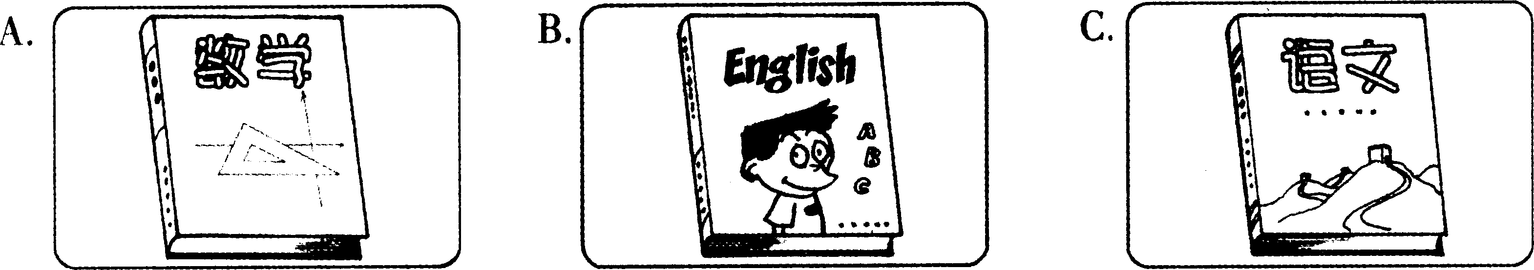
2. How will the weather be tomorrow?
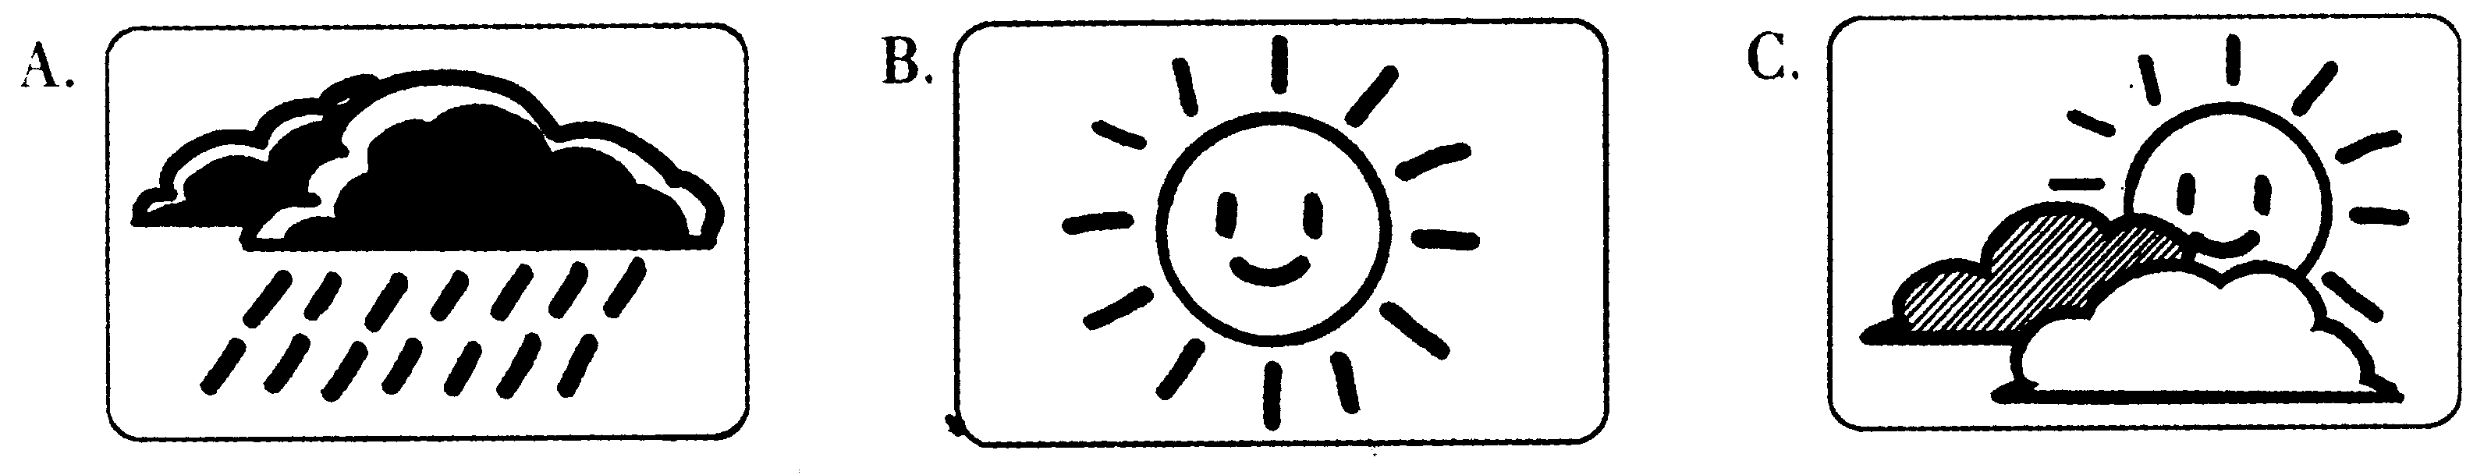
3. When will they meet at the school gate?
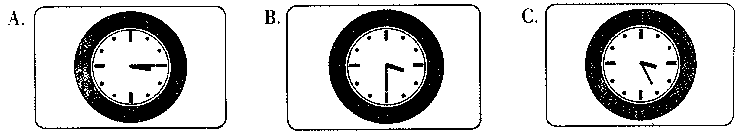
4. What is Bill doing?
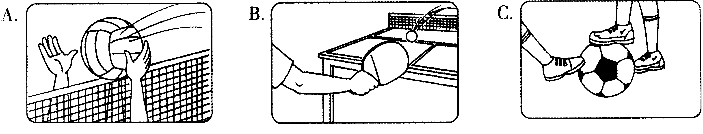
5. Where was the boy yesterday afternoon?
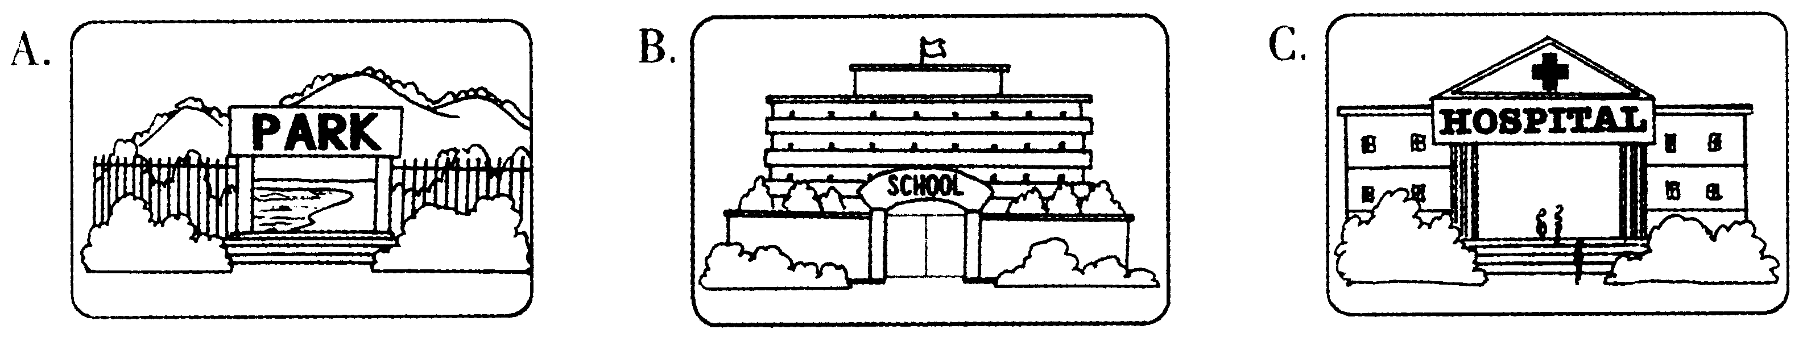
第二节：听小对话，回答问题。（共5小题，每小题2分，计10分）
6. How does the girl feel now?
A. Sad. B. Worried. C. Happy.
7. Which place did the girl visit on May Day holiday?
A. Hainan. B. Shanghai. C. Hangzhou.
8. What’s the man most probably going to do next?
A. Have some sports. B. Go to a movie. C. Have a rest.
9. How much does it cost to buy two CDs？
A. $5. B. $10. C. $15.
10. What does the boy mean?
A. He likes to go alone.
B. Kate is too busy to go with him.
C. He didn’t ask Kate to go with him.
第三节：听长对话，请根据对话内容从A、B、C三个选项中选择正确的选项，完成信息记录表。（共5小题，每小题2分，计10分）
Notice
Name of the activity: 11 Place: 12
Time: 13 Speaker: 14
Topic(主题): 15
11. A. An English talk B. An English party C. An English show
12. A. On the playground B. In the classroom C. In the library
13. A. At 2:00 p.m. B. At 5:00 p.m. C. At 7:00 p.m.
14. A. A student from No. 20 Middle School
B. An English teacher from a foreign language school
C. Mr Zhang, an English teacher from No. 20 Middle School
15. A. How to use the computer
B. How to learn English well
C. How to be an English teacher
第二部分 笔试部分
二、单项填空（共20小题，每小题1分，满分20分）
从每题所给的A、B、C、D四个选项中，选出可以填入空白处的最佳选项。
16. —What’s in your bag, Cathy?
—There’s interesting book about animals.
A. a B. an C. the D. /
17. —Whose bike is this? Is it David’s?
—No, it isn’t. is black.
A. Mine B. Hers C. His D. Yours
18. —Do you like listening to “The Moonlight Sonata”?
—Yes. Listening to is my favourite.
A. news B. stories C. reports D. music
19. —Look at my new digital camera. I bought it June 1, Children’s Day.
—Wow, how nice!
A. on B. in C. at D. for
20. —Would you like some bread or cookies?
— , thanks. I don’t have any food before going to bed.
A. Any B. None C. Either D. Neither
21. — is the price of the MP4?
— 60 dollars.
A. Who B. How C. What D. How much
22. —Why do Chinese people like red?
—Because they think it can them good luck.
A. carry B. bring C. make D. take
23. —Don’t , my children. Keep working on and you will be successful.
—Thank you, Mr Wang. We’ll try our best.
A. put up B. turn off C. work out D. give up
24. —Must I hand in my composition today?
—No, you . You may give it to me tomorrow.
A. needn’t B. can’t C. mustn’t D. shouldn’t
25. —This sweater is too expensive. I can’t afford it.
—How about this one? It’s much .
A. cheap B. cheaper C. cheapest D. the cheapest
26. —Excuse me. Is Joan in?
—Sorry, she isn’t here at the moment. She to the railway station half an hour ago.
A. goes B. went C. has gone D. has been
27. — city!
—Yes. Tourists from all over the world come to visit it every year.
A. How lively B. What busy C. How a big D. What a beautiful
28. Attention, please! All the mobile phones during the meeting.
A. must keep off B. have kept off C. are keeping off D. must be kept off
29. — I hear Jay Chou will come to our city.
— Really? he comes, Helen will be very happy because she is a big fan of Jay.
A. If B. Until C. Unless D. Before

- In which of the following places can you often see this sign?
A. In a park. B. In a school.
C. In a science museum. D. In a street.
31. —Could you tell me , please?
—Yes. Walk along Zhongshan Road for about 300 metres. It’s on your left.
A. how can I get to Hualian Supermarket B. how I can get to Hualian Supermarket
C. how did I get to Hualian Supermarket D. how I got to Hualian Supermarket
32. — Mum, I won the 400-metre race in the school sports meeting.
—
A. Congratulations! B. You’re welcome.. C. It’s a pleasure D. That’s all right.
33. —I’m not hungry but thirsty.
—
A. I’m hungry, too. B. What about some cakes?
C. I’m happy to hear that. D. How about a glass of water?
34. —
—It’s about Bill Gates, one of the richest men in the world.
A. Who is Bill Gates? B. How do you like the book?
C. What’s the book about? D. What do you think of Bill Gates?
35. Mr Smith had a trip to China last summer. Which of the following is the picture he took there?
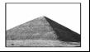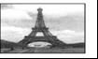
A B C D
三、完形填空（共25小题，每小题1分，满分25分）
阅读下面短文，掌握其大意，然后从每题所给的A、B、C、D四个选项中选出最佳选项。
A
Several years ago, a farmer owned some land along the sea. He advertised(征聘) for workers, but no one wanted to work for him. Most people didn’t want to work there 36 they didn’t like the bad storms. Finally, a 37 man, who looked weak and more than fifty years old, came to see the farmer. “Are you a good farmhand?” the farmer asked him.
“Well, I 38 sleep well when the wind blows.” answered the little man.
Although the answer was strange, the farmer let the man stay to work. The little man worked 39 around the farm, busy from morning till evening. The farmer felt very pleased with his work.
Then one night the wind began to blow strongly. Jumping out of the bed, the farmer 40 into the little man’s room. He shook the little man and cried, “Get up! A 41 is coming!”
The little man said slowly, “No sir, I told you—I can 42 well when the wind blows.”
The farmer was very angry, but he had to hurry outside to get ready for the storm. To his 43 , everything was ready outside. 44 could be blown away.
The farmer 45 what the man meant, so he returned to his bed to sleep while the wind was still blowing.
36. A. so B. but C. because D. although
37. A. big B. little C. young D. strong
38. A. can B. must C. need D. should
39. A. well B. badly C. loudly D. clearly
40. A. walked B. rushed C. moved D. drove
41. A. man B. dog C. ship D. storm
42. A. work B. play C. sleep D. listen
43. A. anger B. pride C. surprise D. confidence
44. A. Everything B. Something C. Anything D. Nothing
45. A. understood B. preferred C. heard D. did
B
One day, a boy had a fight(打架) with one of his classmates. Then he went to his 46 and told him his story angrily. “He is really bad,” the boy said, “and I 47 him.”
The grandfather said, “48 me tell you a story. When I was a boy, I too, sometimes hated others for what they did. But hate will make you feel 49 . It doesn’t hurt your enemy but only hurt 50 .”
As the boy 51 carefully, the grandfather went on, “There are always two tigers inside my heart. One is 52 and kind. He gets on well 53 everything around him. But 54 is bad and unfriendly. He is full of anger. 55 the smallest thing will make him angry. He fights with everyone all the time, and for no 56 . He can’t think carefully because he always hates others. It is difficult to live with these two tigers inside my heart. They 57 try to control(控制) me. ”
The boy looked into his grandfather’s 58 and asked, “ 59 tiger always controls you, Grandfather?”
The old man said slowly in a 60 voice, “The one that I feed. I always feed the good and kind tiger, so I never hate others and seldom(很少) get angry now. ”
46. A. mother B. father C. teacher D. grandfather
47. A. love B. hate C. know D. enjoy
48. A. Make B. Help C. Let D. Ask
49. A. tired B. happy C. comfortable D. interested
50. A. myself B. herself C. himself D. yourself
51. A. saw B. felt C. talked D. listened
52. A. bad B. good C. lazy D. dirty
53. A. at B. on C. with D. about
54. A. other B. others C. another D. the other
55. A. Even B. Ever C. Once D. Already
56. A. time B. money C. reason D. place
57. A. all B. both C. none D. neither
58. A. eyes B. ears C. nose D. mouth
59. A. Who B. When C. Where D. Which
60. A. shy B. sad C. serious D. nervous

四、阅读理解（共20小题，每小题2分，满分40分）
阅读下面短文，从每题所给的A、B、C、D四个选项中选出最佳选项。
A
In Japan, children who are three, five or seven years old are thought to be especially lucky. So, on November 15, families who have children of these ages take part in a very old festival. This special children’s festival is called Shichi-Go-San, or “Seven-Five-Three”.

On this day, the children put on their finest clothes. And every child has a long paper bag. On each bag there are pictures with the meanings of youth(年轻) and long life.
When everyone is ready, the families go to a shrine(神殿). There they give thanks for the good health of the children. Outside the shrine, the parents will buy candy and toys to fill the children’s paper bags. After the families return home, the children give some of their candy to friends and relatives. In return, the children are often given presents.
Finally, the day usually ends with a party.
61. In Japan, which of the following age is NOT thought to be especially lucky?
A. 3. B. 5. C. 7. D. 15.
62. The passage is about a(an) festival.
A. new B. old C. Chinese D. American
63. The festival is on .
A. December 25 B. December 15 C. November 15 D. November 5
64. Why do the families go to a shrine?
A. Because they can buy candy and toys there.
B. Because the children can get presents there.
C. Because they want to have a party with friends.
D. Because they want to give thanks for the good health of the children.
65. The festival usually ends with .
A. a party B. a big meal
C. a visit to a shrine D. shopping for some candy and toys

B
We surveyed(调查) 300 young people on what they like to do at weekends. One hundred people are from the ages of 11-18, one hundred 19-26 and one hundred 27-35. The following shows their answers:
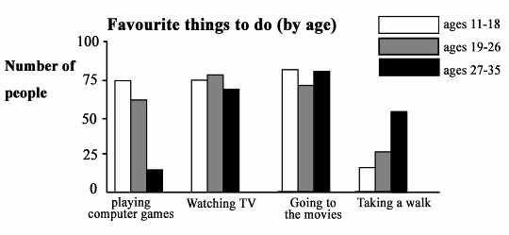
66. How many people enjoy playing computer games in the 11-18 group?
A. 20. B. 50. C. 60. D. 75.
67. The people of 19-26 enjoy most.
A. watching TV B. going to the movies C. playing computer games D. taking a walk
68. According to the survey, which two activities do most people enjoy doing?
A. Playing computer games and watching TV.
B. Playing computer games and taking a walk.
C. Watching TV and going to the movies.
D. Going to the movies and taking a walk.
69. From the chart above, we can see the older people are, the more they like .
A. watching TV B. taking a walk
C. going to the movies D. playing computer games
70. Which of the following is TRUE according to the chart?
A. Fewest people like taking a walk.
B. The people of 11-18 like taking a walk most.
C. 90 people like going to the movies in the 19-26 group.
D. The people of 27-35 like playing computer games most.
C

When I was looking for a Christmas present for my daughter in a toy store, a nicely dressed little girl, with some money in her little hand, was looking at some beautiful dolls. When she saw a doll she liked, she would ask her father if she had enough money. He usually said yes.
At the same time, a boy, with old and small clothes, was looking at some video games. He, too, had money in his hand, but it looked no more than five dollars. Each time he picked up one of the video games and looked at his father, he shook his head.
The little girl had chosen her doll, a very beautiful one. However, she noticed the boy and his father. She saw the boy give up a video game with disappointment(失望) and walk to another corner of the store.
The little girl put her doll back to the shelf and ran over to the video game. After she talked to her father, she paid for the video game and whispered(耳语) to the shop assistant.
So the boy got the video game that he wanted for free—he was told it was a prize from the store. He smiled happily, although he felt it was so incredible.
The girl saw all this happen. She smiled, too.
When I walked out of the store to my car, I heard the father ask his daughter why she had done that. I would never forget their short talk. “Daddy, didn’t Grandma want me to buy something that would make me happy?”
He said, “Of course, she did.”
“Well, I just did!” With that, the little girl started skipping(蹦跳) towards their car happily.
71. The story happened in a .
A. school B. toy store C. cinema D. computer room
72. The boy .
A. wore new and nice clothes B. had much money in his hand
C. was from a poor family D. wanted to get a doll very much
73. The underlined word “incredible” most probably means “ ” in Chinese.
A. 难以置信的 B. 令人兴奋的 C. 感到绝望的 D. 荒谬可笑的
74. Which of the following is TRUE according to the story?
A. The little girl was kind and helpful.
B. The video game was a prize from the store.
C. The writer paid for the video game for the boy.
D. The boy bought the video game himself from the store.
75. What does the sentence “Well, I just did!” mean?
A. I just did something for the boy and he would be happy.
B. I just bought a nice doll for myself and I would be happy.
C. I just bought a present for Grandma and she would be happy.
D. I just did something for the boy and it would make me happy.
D
I began to send e-mail when I was 17. I discovered Google 5 years later. Now, I use the Internet all the time. Internet has become so popular that 90 percent of 12-to-17-year-olds in the United States use the Internet, and about half of these kids use it every day. They visit chat(聊天) rooms and send e-mails. They go to websites to get information for their homework.
“Kids are now living in a virtual(虚拟的) world,” says Greenfield, an expert at the University of California, “As the Internet is becoming more and more important for our life, we should worry about one question: Is the Internet good or bad for kids? ”
“It’s X to answer the question because the Internet involves(涉及) so many things,” says Justine, who is from Northwestern University. “They include online computer games, news, messages and even e-mails to your grandmother.” So, more and more people believe that the online world can be helpful in some ways but dangerous in others.
“Although it’s not easy to tell whether it’s good or bad,” says Justine, “the Internet, at least, is very useful and can be used widely by everyone in the world.”
76. The writer discovered Google at the age of .
A. 5 B. 12 C. 17 D. 22
77. What percentage of American 12-to17-year-olds use the Internet every day?
A. About 45%. B. About 50%. C. About 80%. D. About 90%.
78. Greenfield .
A. is an expert from Northwestern University
B. wants to stop all the kids from using the Internet
C. thinks that the Internet is good for all the kids in the world
D. is worrying about whether the Internet is good or bad for kids
79. “X” in the passage should be the word “ ”.
A. possible B. difficult C. easy D. good
80. Which is the best title of the passage?
A. Don’t Use the Internet B. Kids and Emails
C. Is the Internet Good or Bad D. Two Experts from Universities
卷 Ⅱ
五、词汇运用（共10小题，每小题1分，满分10分）
The 2008 Olympic Games are 81 (来) soon. Chinese people are doing something for it. The people in Beijing are especially 82 (忙碌的). Taxi 83 (驾驶员) are learning English so that they can 84 (交谈) with foreign friends during the Olympics. Workers are working 85 (努力地) so that the buildings can be finished before the games start.
The environment is getting better and better. The streets will be cleaner and the roads will be 86 (更宽的). More trees and flowers will be 87 (种植) in the city.
It is the 88 (第一) time that China has got the chance to host the Olympic Games. All of 89 (我们) believe that it will be a great success and Beijing will become a better city 90 (在……后) the games are over.
注: host vt. (主办)
六、任务型阅读（共5小题，每小题1分，满分5分）
下面是四位同学写给《21世纪中学生英文报》编辑Lee的求助信。在信中，四位同学分别谈了自己在学习或生活中的问题。
(A)请将四封信与问题进行配对，并把序号A、B、C、D填入91～94题题后相应的横线上。
A | B
Dear Editor Lee,  I am a middle school student. I am good at all the subjects except English. 1 can' t remember words well. I am especially weak in speaking and listening. What shall I do?  John | Dear Editor Lee,  I have a problem! I really don't know what to say when I meet strangers. I find it difficult to talk with others because I'm afraid they might laugh at me. I am not as interesting, clever or funny as my friends. If people start talking to me, they will realize that I am just boring. Please help me.  Ann
C | D
Dear Editor Lee,  I was getting on well with my best friend, Cindy. But a few days ago, another friend of mine told me that Cindy often said bad words about me. When I heard this, I was very angry. What should I do? Should I stop being her friend or stay with her as usual?  Betty | Dear Editor Lee,  Recently I have much difficulty in falling asleep. When I go to bed, though I feel very tired, I always think a lot and can't fall asleep. So I always feel very sleepy in class and sometimes my head hurts badly. Could you give me some advice?  Steven

The student finds it difficult to fall asleep. 91.
The student doesn’t know what to say to strangers. 92.
The student doesn’t know how to learn English well. 93.
The student doesn’t know if she should still stay with her best friend. 94.

(B) 假如你是编辑Lee，请针对第一位同学John的问题，提出一条建议。
95.
七、书面表达 （共2小题，满分25 分）
最近，我国政府面向青少年提出了“阳光体育活动”。其口号是“每天锻炼一小时，健康工作50年，幸福生活一辈子”。
96. 为了配合“阳光体育活动”，学校决定对同学们的体育锻炼情况作一次调查。假如你叫Jack, 请根据自己的实际情况,完成下面调查内容（括号中的内容供选择）。（计5分）
My name is Jack. I’m in Class Two, Grade Nine. I (always, often, sometimes, hardly) do sports after school. I usually do sports with my . My favourite sport is , because .
97. 为了配合该活动，你班将举行一次主题班会。请你以“Sports and Health”为题写一篇发言稿，介绍你自己的体育锻炼情况、感受等。文中不能出现真实的姓名、地名、校名。词数80左右。发言稿的开头与结尾已给出，不计入总词数。（计20分）
以下要点供参考：
(1)自己的锻炼情况；
(2)最喜欢的体育活动及原因；
(3)锻炼的效果及感受；
(4)倡议大家积极参与体育锻炼。
Dear friends,
I am very glad to be here to say something about sports and health.

That’s all. Thank you!

2007年浙江省金华市中考英语试题参考答案
一、听力
1． B 2． A 3． B 4． C 5． C 6． B 7． A 8． C 9． B l0． A l l． A l 2． B l 3． C 14． C l 5． B
二、单项填空
16．B l7．C l 8．D l 9．A 20．D 21．C 22．B 23．D 24．A 25．B 26．B 27．D 28． D 29． A 30． C 31． B 32． A 33． D 34． C 35． B
三、完形填空
36．C 37．B 38．A 39．A 40．B 41．D 42．C 43．C 44．D 45．A 46．D 47．B
48． C 49． A 50． D 51． D 52． B 53． C 54． D 55． A 56． C 57． B 58． A 59． D 60． C
四、阅读理解
61． D 62． B 63． C 64． D 65． A 66． D 67． A 68． C 69． B 70． A 71． B 72．C 73． A 74． A 75． D 76． D 77． A 78． D 79． B 80． C
五、词汇运用
81. coming 82. busy 83. drivers 84. talk/speak 85. hard 86. wider 87. planted/grown 88. first 89. us 90. after
六、任务型阅读
91．D 92．B 93．A 94．C 95．(略)
七、书面表达
96. always/often/sometimes/hardly friend ( s) /classmate( s ) /parent( s) /. . . (playing)basketball/football/table tennis/. . .
it' s good for my health/it' s interesting/exciting. . .
97. One possible version: Dear friends,
I' m very glad to be here to say something about sports and health. I love sports. My favorite sport is playing basketball. I like it because it' s exciting and good for my health. I usually play basketball with my best friends on the playground after school. I also enjoy playing ping-pong and swimming.
I am stronger than before because I keep on taking exercise almost every day. " Keeping doing sports an hour a day, you can work healthily for fifty years and live a happy life all the time. " So I hope all of us can take an active part in sports, and also I wish everybody good health.
That' s all. Thank you!

天仁英语教师资源交流网

