2007年浙江省湖州市中考英语试题
友情提示：
全卷满分为100分，考试时间为90分钟。
卷 I
一、听力(本题有l5小题，共20分。其中1—10小题每题l分，ll一l5小题每题2分)
第一节
(A)听句子，根据所提问题，选择正确图画。句子读一遍。
1. What is John looking for?
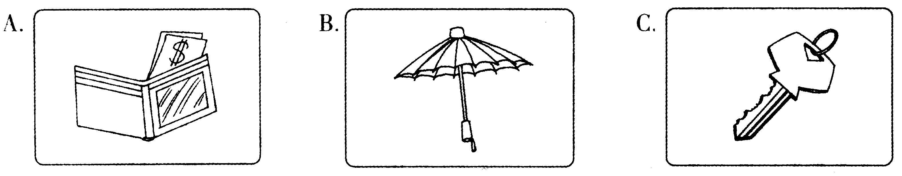
2. How does Tom learn Chinese?
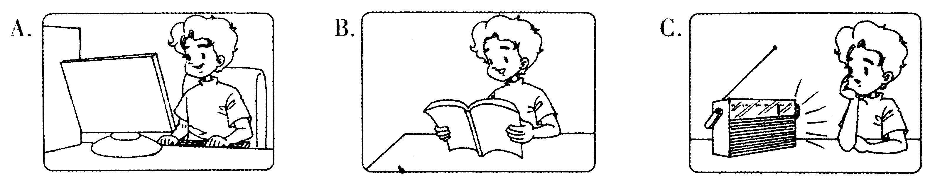
3. What time does Miss Yuan drive to the office?
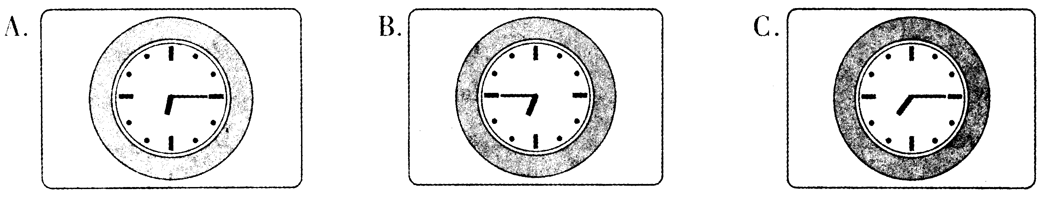
4. How does Mr Huang go to work?
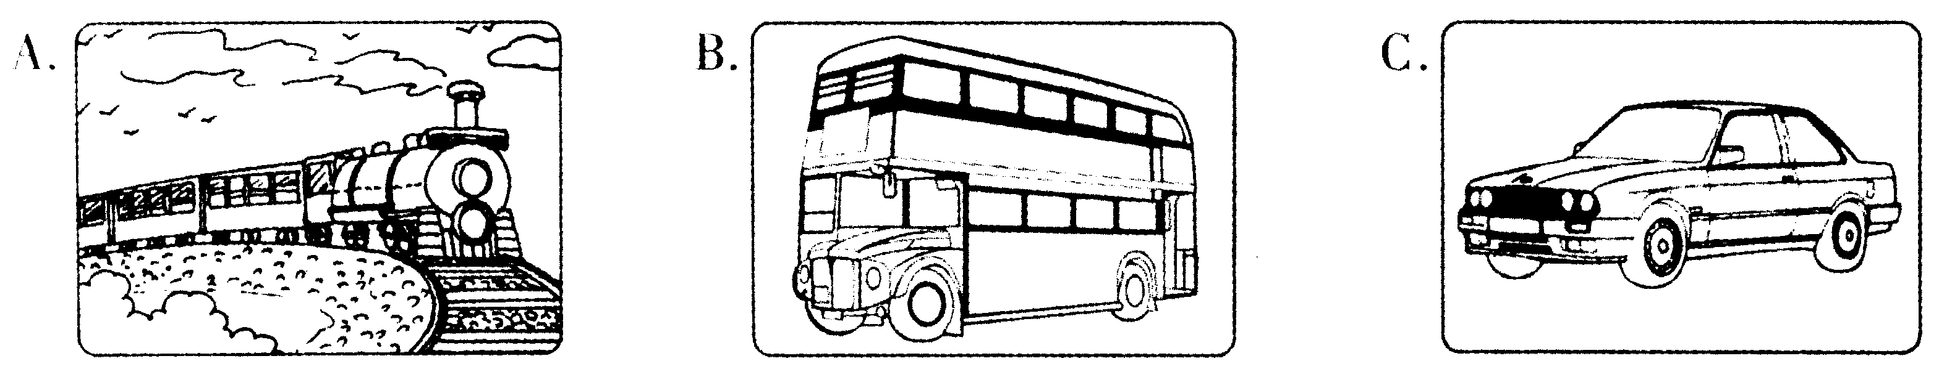
5. What's Linda's favourite subject?
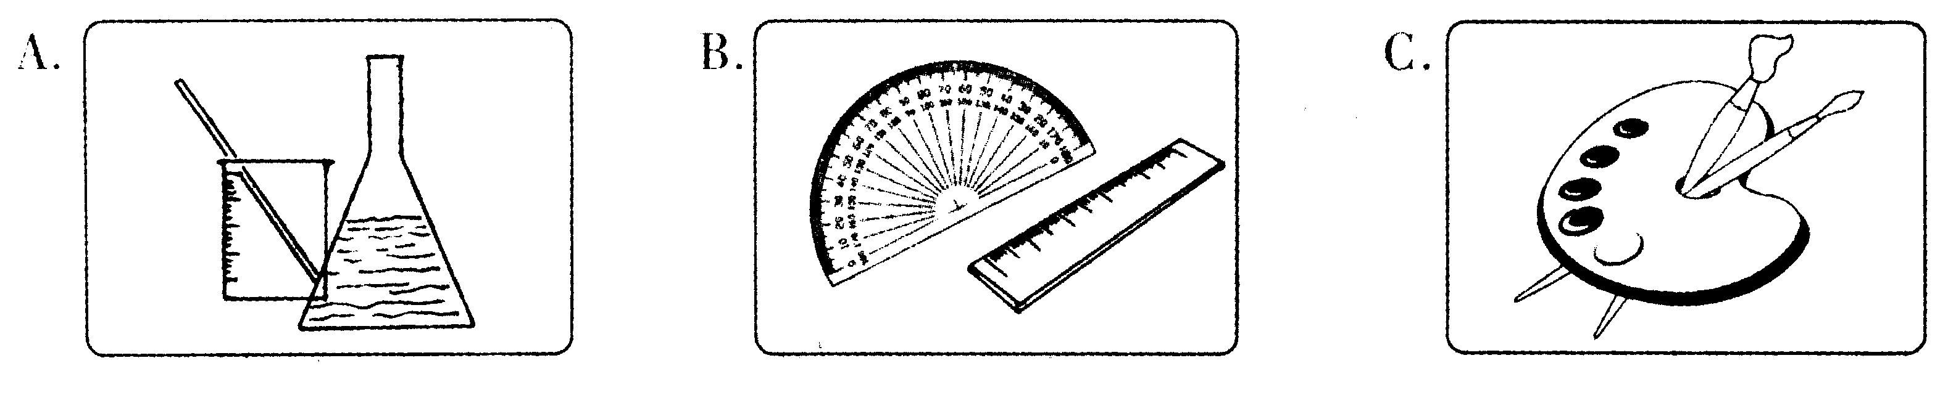
(B)听对话，根据所提问题，选择正确选项。对话读一遍。
6. What will the weather be like the day after tomorrow?
A. Windy. B. Cloudy. C. Sunny.
7. What did the man do in Harbin?
A. He went skiing. B. He went skating. C. He went swimming.
8. Where do the elephants come from?
A. Africa. B. Asia. C. America.
9. How far away is the post office?
A. About two blocks. B. About four blocks. C. About six blocks.
10. Why is Wang Dong getting so fat?
A. He likes sugar and meat very much. B. He doesn't often take exercise. C. He never goes to work on foot.
第二节
听对话，选择正确答案。每段对话读两遍。
听下面一段较长的对话，回答第ll至第l2小题。
11. What's the matter with the man?
A. He finds it difficult to go to sleep at night.
B. He can't sweep the floor.
C. He was seriously ill.
12. How many days has the man been like this?
A. Two days. B. Three days. C. Four days.
听下面一段较长的对话，回答第、l3至第l5小题。
13. Who had the worst morning?
A. DingJun. B. Li Mei. C. The saleswoman.
14. When did Li Mei's daughter buy her a pair of new shoes?
A. Today. B. Last night. C. Yesterday.
15. Why did she go back to change the new shoes?
A. Because the shoes were too small.
B. Because the shoes were broken. C. Because the shoes were too big.
二、单项填空(本题有l0小题，每小题l分，共10分)
从A、B、c、D四个选项中，选出可以填入空格的最佳选项。
16. —I'm going to take my driving test tomorrow.
—- .
A. Congratulations B. I'd love to
C. Good luck D. That's a deal
17. Thanks to the Internet, the world seems to become .
A. smaller and smaller B. small and small
C. more and more small D. smallest and smallest
18. —What do you do Mid - autumn Day?
—-We usually eat a big dinner and mooncakes in the open air.
A. to B. in Cat D. on
19. I'm sorry, but can't you see the sign which says "No
A. parks B. park C. parking D. parked
20. —What's the result of the basketball match ?
—Our team the game by a score of 72 to 68.
A. will win B. won C. wins D. had won
21. exercise every day, my child. It's good for your health. " Father said to Mary.
A. Takes B. To take C. Taking D. Take
22. students will come to study in our school this autumn.
A. Hundred of B. Hundreds of C. Hundreds D. Hundred
23. To our great surprise, the blind girl learned to music so well just by ear.
A. give B. take C. carry D. play
24. —Could you tell me you are going to be when you grow up?
-—An engineer.
A. how B. when C. what D. if
25. At the school sports meet class got more medals than theirs.
A. our B. ours C. we D. ourselves
三、完形填空(本题有15小题，每小题l分，共l5分)
阅读下面短文，理解其大意，然后从26—40各题所给的四个选项中选出最佳选项。
John was so lazy that he stayed home and watched television all day instead of working. One day his 26 saw a "Help wanted" ad in the supermarket window. The supermarket needed 27 to put things on the shelves. She told the manager drat her husband didn't have a job but he was very 28 She told him that John would come to apply for (申请) the job.
29 she got home and told John about the job, he was just watching television attentively. It made her so angry that she 30 the TV and ordered him to go and see the manager of the supermarket. John didn't want his wife to be angry. So he went.
On the way, John drought if the manager 31 him the job, he wouldn't be able to stay home and watch television all day long. He would have to 32 in the supermarket every day.
Then he had 33 . He decided to tell the manager that something was wrong with his shoulder so he 34 not raise his arm above his head. He was 35 the manager wouldn't give him the job. When he arrived at the supermarket, he told the manager that he needed the job. Are you strong? " the manager asked.
John explained that he couldn't raise his 36 above his head. John told him that he 37 an ccident at home while digging in the garden.
"How 38 can you raise your arm?" the manager asked. John lifted his arm 39 "Only this high," he said. "And how high could you raise it 40 the accident? " asked the manager. " This high," said John. And he lifted his arm above his head.
26. A. wife B. daughter C. neighbor D. mother
27. A. everyone B. someone C. none D. no one
28. A. busy B. old C. strong D. weak
29. A. Unless B. Because C. Before D. When
30. A. gave off B. put up C. turned off D. turned on
31. A. sent B. offered C. told D. called
32. A. play B. rest C. work D. shop
33. A. an idea B. a question C. a lesson D. an order
34. A. may B. should C. must D. could
35. A. sorry B. sure C. afraid D. shy
36. A. arm B. leg C. foot D. shoulder
37. A. had B. took C. happened D. got
38. A. low B. high C. far D. long
39. A. a great deal B. very high C. a little D. a lot
40. A. before B. after C. if D. though
四、阅读理解(本题有15小题，每小题2分，共30分)
阅读下面短文，从每题所给的A、B、c、D四个选项中，选出最佳选项。
A
Charlie was spending his summer holidays by the sea. One day he climbed over some rocks. He was looking for some crabs (螃蟹) for supper. He took off his shorts and put them on a rock.
The afternoon went quickly. Time was flying by. Look! The sea was coming in fast. It was over some of the rocks now.
Charlie looked up. "It's getting late. Oh dear! Look at the sea. Where are my shorts now?" he thought. He saw them on a rock.
Oh dear! The rock was an island! Now he must swim and got them.
Charlie jumped into the sea and started swimming. He reached the rock and put his shorts on his head. Then he started swimming back. Oh no! The sea was too strong for Charlie. It was pulling him away from the beach.
"Help!" he called. "I can't get back. "
Luckily, a boat was coming by. The people in the boat saw Charlie and heard his call for help.
"Are you all right?" asked the woman in the boat.
"No! I can't swim back. The sea is too strong. "
The woman stopped the boat and she and a girl pulled Charlie into the boat. He threw his shorts into the boat too. Then they turned the boat Bound and took Charlie back to the beach.
"That was lucky," said the woman.
"Thank you very much," said Charlie.
"Be careful next time," said the woman. "The sea is usually very strong near these rocks. "
"Next time, I'm going to keep my shorts in my bag," said Charlie. "Better safe than sorry!"
41. Where did the story take place? .
A. In the hills B. By the sea C. On the river D. In the town
42. What was Charlie doing that day? .
A. He was watching the sea B. He was looking for seafood
C. He was lying on the beach D. He was helping the people in the boat
43. Before looking for crabs, Charlie put .
A. his shirts in a bag B. his shoes on a rock
C. his shorts in a bag D. his shorts on a rock
44. Charlie cried for help because
A. the sea was carrying him away from the beach
B. the sea was pulling Charlie onto the rocks
C. the sea was getting lower
D. the sea was going out
45. Who saved Charlie? .
A. A man and a girl B. Two men
C. A woman and a girl D. A man and a boy
B
New York, London, Paris and other big cities are exciting places to live in. There are many interesting things to see and do. You can go to different kinds of museums, plays and films. You can also buy things from all over the world.
But there are serious problems in big cities too. It's expensive to live there, and there are too many people in some places in big cities. Every year many people move to the cities to find jobs, to study at good schools and receive good medical care. But sometimes these people cannot find work or good places to live in. Also it is hard to keep the cities safe and clean.
Some people enjoy living in big cities, others do not. Before they move to big cities, they should think about the problems of living there.
46. In big cities people can do all of the following EXCEPT .
A. going to different kinds of museums
B. seeing many kinds of plays and films
C. buying things from all over the world D. living there with little money
47. Which of the following is TRUE according to the passage? .
A. Big cities are not clean and safe enough
B. People can easily find good places to live in in big cities
C. People can always find work to do in big cities
D. All people like to live in big cities
48. From the passage we know that .
A. people in big cities are usually very dirty B. Paris is an exciting place for people to live in C. people will no longer like living in big cities D. big cities don't have serious problems
49. In this passage the writer thinks it is right for people .
A. to move to big cities
B. not to move to big cities
C. to move to big cities without thinking of any problems
D. to move to big cities after they think over the problems of living there
50. Which is the best tide for this passage? .
A. Big Cities B. Interesting Things in Big Cities
C. Good Schools in Big Cities D. New York, London and Paris
C
Have you ever heard an echo of your voice?
An echo is a reflected (反射) sound. Stand in a very large, empty hall with nothing on the walls. Then shout. The sounds you make will hit the walls and come back to you. The walls reflect the sounds. These reflected sounds are called "echoes".
We can use reflected sound to make sound travel farther. Hold a watch about fifty centimeters from your ear. You cannot hear it. The sound of the watch travels a short way in all directions. lt does not travel as far as your ear. You can make it travel to your ear by using a roll of cardboard (纸板筒).
Make the roll of cardboard about fifty centimeters long. Put one end over your ear and hold the watch at the other. Now you can hear the watch because the sound has not gone in all directions. lt is reflected down the roll to your ear.
A megaphone (喇叭筒) works in the same way. It makes sound travel farther. lt reflects the sound into a beam which can travel a long way. In the ship, the sailor uses the megaphone to make his voice travel. Without the megaphone, his voice cannot travel far.
We use reflected sound in many ways. We use it to measure the depth of the sea, for example. Among the animals, bats (蝙蝠) and whales use reflected sound to tell them where they are and what things are near them.
51. What is called "echo"?
A. Very loud voices
B. Very loud voices that are made by man
C. Very loud voices that are made by animals
D. The sound that is made by man or animals comes back from some place
52. We can hear our echoes if we .
A. shout in a small room
B. shout in a large house full of things C. shout in narrow valleys (山谷) D. shout in the open air
53. Which is the right order of hearing our echo in a very large, empty hall? .
a. We hear the reflected sound b. The sound returns to us
c. The sound hits the walls d. We make a sound
A. c, b, a, d B. c, a, b, d C. d, c, b, a D. d, b, c, a
54. From the text we learn that .
A. reflected sound is useful only to blind people
B. people haven't made use of reflected sound yet
C. Bats use reflected sound to fly and get food
D. Whales don't use reflected sound as they live in the sea
55. If you haven't got a megaphone, will help you to make your voice travel farther.
A. a long piece of wood B. a roll of cardboard
C. a thin thread D. a long piece of silk
卷 Ⅱ
五、任务型阅读(本题有5小题，每小题l分，共5分)
第56 第60题是烹饪西班牙煎蛋的步骤，请找出表明每一步骤的相应图片，并将代表
图片的字母A E填入答题卷上的相应位置。
How to cook it:
56. Get the onion and garlic ready.
57. Cut the onion and garlic into small pieces with a knife.
58. Add a litde oil to the pan. Heat (加热) the oil.
59. Cook all the vegetables for about 3 minutes.
60. Beat the eggs with a fork. Add some salt and pepper
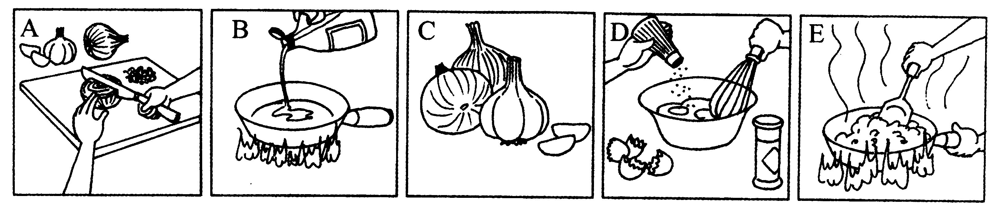
六、看图表达(共1题，20分)
下面四幅图画描述了你某天放学后发生的一件事。请你根据这些图画的内容用英语写
一篇80词左右的日记，时间是2007年6月8日，星期五，天气有雨。日记开头已给出。
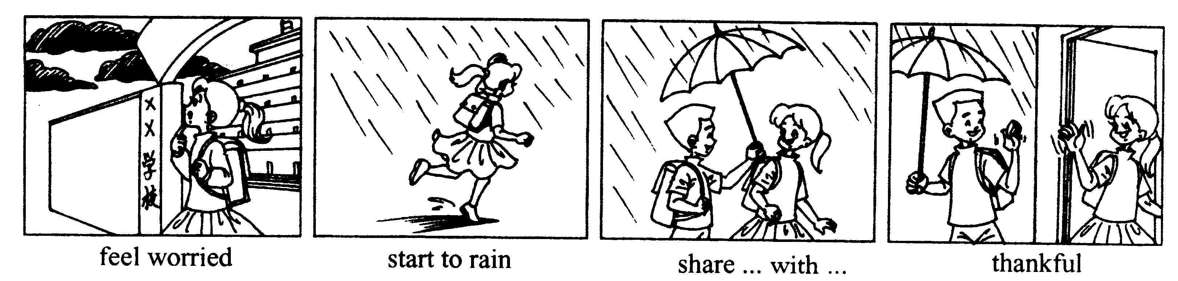
June 8, 2007 Friday rainy
This afternoon, when I walked out of school, the weather changed.

2007年浙江省湖州市中考英语试题参考答案
一、听力(本题有15小题，共20分。其中1—10小题每题l分，l1～l5小题每题2分)
1一58 C C B A 6一l 0 C B A C B 11一l5 A A B C A
二、单项填空(本题有10小题，每小题l分，共l0分)
16—20 C A D C B 21—25 D B D C A
三、完形填空(本题有15小题，每小题l分，共l5分)
26—30 A B C D C 31一35 B C A D B 36—40 A A B C A
四、阅读理解<本题有l5小题，每小题2分，共30分)
41—45 B B D A C 46—50 D A B D A 51—55 D C C C B
五、任务型阅读(本题有5小题，每小题l分，共5分)
56—60 C A B E D
六、看图表达(本题20分)
This afternoon, when I walked out of school, the weather changed. Dark clouds were gathering. I began to feel worried because I didn't have an umbrella with me. It soon started to rain. When I was hurrying home, I heard someone calling me from behind, I turned round and saw Li Ping. He had an umbrella and asked me to share it with him. He walked all the way with me to my home. How thankful I was for his kindness!
1、评分原则：
(1)本题总分为20分，按5个档次给分。
(2)评分时，先根据文章的内容和语言初步确定：其所属档次，然后以该档次的要求来衡量，确定或调整档次，最后给分。
(3)评分时，应注意的主要内容为：内容要点、应用词汇和语法结构的数量和正确性、上下文的连贯性及语言的得体性。
(4)拼写、书写、标点符号是语言准确性的一个方面，评分时，应视其对交际的影响度予以考虑。
(5)英美拼写及词汇用法均可接受。
2、内容要点：
(1)feel worried
(2)stall．to rain
(3)hurry home
(4)hear someone calling me
(5)share an umbrella
(6)be thankfid to
3、各档次的给分范围和要求：
第五档次(17—20分)表达清楚，行文连贯，语言正确。
第四档次(13—16分)表达基本清楚，行文基本连贯，语言有少量错误。
第三档次(9—12分)语言虽有较多错误，尚能达意。
第二档次(5～8分)能写明基本要点，但语言有较多错误，影响意思表达。
第一档次(0—4分)白卷或文不对题，或错误百出，不知所云。
4、说明：
(1)内容要点可用不同方式表达。
(2)对紧扣主题的适当发挥不予扣分。
听力材料
注意：做题时，请先将答案划在试卷上。该部分录音内容结束后，你将有2分钟的时间 将你的答案转涂到答题卡上。第一节
(A)听下面5个句子。句子后有一小题。从题中所给的三幅图画中选出最佳选项，并标：在试卷的相应位置。句子读一遍。
Text 1
John is looking for his umbrella. He wants to go out.
Text 2
Tom learns Chinese by listening to the radio.
Text 3
Miss Yuan is never late for work. She always drives to the office at a quarter past seven.
Text 4
Mr Huang goes to work by school bus in the morning and he has lunch in the workplace.
Text 5
Chemistry is Linda's favourite subject.
(B)听下面5段对话。每段对话后有一小题。从题中所给的三个选项中选出最佳选项，并标在试卷的相应位置。对话读一遍。
Text 6
M: Hello, Linda. There's a dolphin show in the zoo the day after tomorrow. Shall we go and see it?
W: What will the weather be like? I'm afraid it will still be windy.
M: Well, it's windy now but I think it won't last long. The weather report says it will be sunny.
W: OK, let's meet at the No. 13 bus stop.
Text 7
W: Hi, Jay. I haven't seen you for a long time. Where have you been?
M: I've been to Harbin.
W: Really? How do you like it?
M: Wonderful! It's really exciting to go skating on real ice. I want to go there again next vacation.
Text 8
M: Do you like animals?
W: Yes, I like animals very much. I like elephants most.
M: Look at those elephants over there. Where are they from?
W: Those? They're African elephants.
Text 9
M: Could you tell me the way to the post office?
W: vSure. Walk the way for two blocks, turn right and it's about four more blocks.
M: OK, thank you.
Text 10
W: Ls Wang Dong at home?
M: No, he's in hospital.
W: I'm very sorry to hear that. What's the matter with him?
M: He doesn't take enough exercise, so he's getting fat. Now, he has a heart disease.
第二节
听对话，选择正确答案。每段对话读两遍9
听下面一段较长的对话，回答第l l至第l2小题。
Text 11
W: Hello, young man. What's wrong with you?
M: I can't sleep well at night.
W: How long have you been like this?
M: Er, two days.
W: Right, two days. Now open your mouth and say "Ah".
M: Ah. . . And then I feel tired all day at work.
W: Well, don't worry. Nothing serious. But try to go to bed at the same time every night, and get nough exercise. Now let me give you some medicine to help you. Take this medicine three times day.
M: OK.
W: Don't drink too much tea at night. You'll soon be all right.
M: OK. Thanks a lot.
W: You're welcome.
听下面一段较长对话，回答第13至第l5小题。
Text 12
W: Hello, is that Ding Jun?
M: Yes. Hi, Li Mei, How are you?
W: I'm OK, but I just had the worst morning ever.
M: What happened?
W: My daughter bought a new pair of shoes for me yesterday, but they didn't fit me. So this morning I went to the shopping centre near Zhonghua Road to change them for a larger size. I couldn't believe it! The saleswoman was watching TV behind the counter. She didn't help me! When I asked to see the manager, she told me, "Oh, sorry, she's ill at home!"
M: What a terrible shop! What did you do?
W: They gave me a phone number, so I called when I came home. Now I feel better, but I still don't have my new shoes!

天仁英语教师资源交流网

