巧记倒装口诀

倒装其实很好记，记住“闹事”（NAO SHI）就可以。
说明：NAO SHI中的六个字母代表六种情况。
1. N代表否定词。当否定词置于句子开头时，句子要用部分倒装。这些否定词有no, little, seldom, never, not until, not only, neither, nor, hardly, no sooner等词。如：
Little does he know about it.
Hardly had he arrived there when it began to rain.
Not only can he speak English, but also he can write articles in English.
2. A代表as。as (尽管) 引导让步状语从句时，从句要用倒装语序。如：
Fail as he did, he didn’t lose heart.
Child as my younger brother is, he knows a lot.
3. O代表only。only修饰状语置于句首时，句子要用部分倒装。如：
Only in a strange place did he realize how good his home is.
Only when you grow up will you understand me.

4. S代表so和such。当“so…that..”和“such…that…”结构中的so和such位于句首或so表示“也”的时候，句子用倒装语序。 如：
So clever a boy is he that he can work out such a problem in a short time.
Such a lovely day is it that we want to go out for a picnic.
He has learned to send e-mails. So have I.
5. H代表以here为首的表地点、方位等的词或词组。这样的词有：here、there、in、out，off、away、up、down、back。当这些词放在句首时，句子要用全部倒装，即把整个谓语动词提前。
Down fell some apples.
Out rushed the boy.
On top of the hill stands a tree.
不过，对于全部倒装的情况来说，当主语是人称代词时，主谓不倒装。如：
Here it comes.
In he came.
6. I代表if。If引导虚拟条件句时，如把if省略，要用部分倒装。如：
Should you be in trouble, we would help you. (=If you should be in trouble, we would help you.)
Were I you, I would go there with him. (=If I were you, I would go there with him.)
Had he come earlier, he would have met Sharon.

Exercises:
1. ___ can you expect to get a pay rise.
A. With hard work B. Although work hard
C. Only with hard work D. Because he works hard.
2. –Do you know Catherine has gone to Europe?
-I don’t know, ___.
A. nor don’t I care B. nor do I care
C. I don’t care neither D. I don’t care also
3. ____ from the fifth floor when the murderer found he couldn’t escape.
A. Jumped down he B. Down did he jump
C. Down he jumped D. Down jumped he
4. ___ right now, she would get to her office at 9:00.
A. Would she leave B. If she leave
C. Were she to leave D. She were to leave
5. Never ___ forget the moment when I saw you last.
A. I will B. I shall C. shall I D. would I
6. Only under special circumstances ___ to take make-up tests.
- are freshmen permitted B. freshmen are permitted
C. permitted are freshmen D. are permitted freshmen
7. Many a time ___ me good advice.
A. he gave B. does he give
C. he has given D. has he given
8. Here ___ you want to see.
A. comes the comrade B. comes a comrade
C. the comrade comes D. is coming a comrade
9. Little ____ I would see an old friend of mine here.
- I dreamed B. did I dream C. do I dream D. am I dream
10. Not until I began to work ___ it was almost eleven o’clock.
A. did I realize B. I realized C. didn’t I realize D. realize I

Key: 1-10CBDCC ADABA

影印英语作文评点

美国访问学者Jackson教授前来学校作报告。现在请你用英语写一篇简短的欢迎词。内容要点如下：
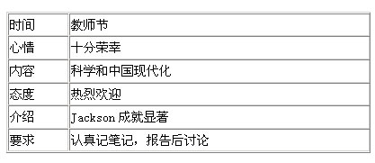
注意：1. 表达连贯，切勿直译； 2. 词数：100左右。
学生习作：
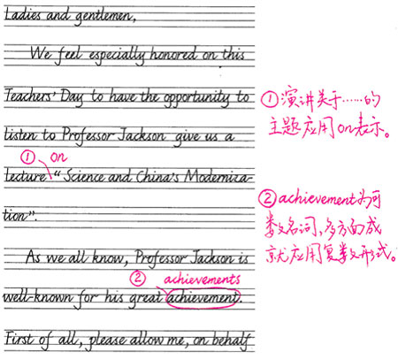

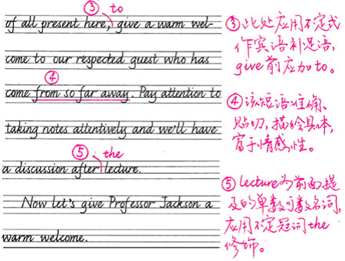
II. 点评：本篇习作为欢迎词，符合高考英语书面表达写作范围要求。As we all know, First of all, and, Now等词的使用使文章语言更通顺,行文更连贯。不定式作目的状语和宾语补足语、定语从句、动名词作宾语等高级表达方式的运用提升了文章的表达档次。然而瑕不掩瑜，本文也存在一些语法方面的不足之处，如冠词错误、介词漏用错误、名词单复数错误等，表明习作者的语言表达能力尚需在今后的实践中进一步提高。
KEYS TO TEXTBOOK(P187)
I will never forget the winter of 1846, when we crossed the Salt Lake Desert. Soon after we entered it, we lost our way. Anyone with common sense knows that people can not go through deserts without water. Our water was getting less and less, and we could not find new water resources. The animals that were too weak to pull their burden were killed. We had to walk out of the desert. For many weeks we had been accustomed to seeing dead animals and abandoned wagons along the road.
The situation was so desperate that no one could take it easy. Each person was only interested in saving himself. Once I got too weak and tired, and was almost left behind, but I managed to keep up with the others.
We had almost lost heart when a valley with fat cattle and horses came into our sight. We knew that we had reached our destination and our days of hardship had come to an end.

