高一Unit 5基础知识检测(60分钟)
一、单项填空(15分)
1. The boy, ____ mother died last year, studies very hard.
A. his B. which C. whose D. that
2. I owe____ to you that I passed the exam.
A. what B.it C. which D. this
3. I’m not sure what ______ he will play in the film, but I think he will act the part of the hero. A. career B. performance C. role D. action
4. I’m afraid ______ her the truth, because I’m afraid ______ her.
A. to tell; of hurting B. to tell; to hurt
C. of hurting; to hurt D. of hurting; of hurting
5. I can never forget the days _____ we worked together and the days ______ we spent happily together.
A. for which; that B. which; when
C. when; which D. on which; when
6. To go on business, I will have to stay _____ for some time, so I will ask someone to ______. A. away; take my place B. off; instead of me
C. off; take the place of mine D. away; take place of me
7. We’ve missed the last bus. I’m afraid we have no ______ but to take a taxi. A. way B. choice C. opportunity D. means
8. I will stay at home and watch the _______ football match this evening. A. living B. lively C. alive D. live
9. He’s got himself into a dangerous situation _______ he is likely to lose control over the plane. A. where B. which C. while D. why
10.－ How do you like the books?
－ Oh, they are wonderful. People here think _____ of the books.
A. little B. good C. a great deal D. badly
11. My father served in the army in _______ when he was in _____.
A. 1950’s; twenties B. the 1950’s; his twenties
C. the 1950’s; the twenties D. 1950’s; the twenties
12. There are six boys and two girls in the classroom; that’s eight _______. A. at all B. in all C. after all D. above all
13. I am leaving _______ Shanghai and my plane takes ______ at 8:30.
A. to; for B. for; off C. off; for D. off; off
14. ____ is known to us, China is a developing country.
A. It B.Which C. As D. What
15. I have two sisters, ____ are doctors
A. both of them B. both of which C. both they D. both of whom
二、完形填空(共20小题;每小题1.5分,满分30分)
During the first week of May I went on a holiday to Sichuan.First,I 16 some photos of interesting places which were not too far away from 17 .I decided to go and see the big Buddha in Leshan and Mountain Elmei. 18 ,I 19 a travel agent whose telephone number I found in a newspaper.He told me that I could go on 20 trip to Leshan and Emei,21 wasn’t too expensive.My friends,xiao Rong and Wei Bin,said they could come with me.We took a few bottles of water,some apples and oranges,which we put into my bag.
The next day,we 22 at five o’clock.First,we went to Leshan,where we climbed all the 23 up the mountain to see the Buddha.The Buddha is really very 24:taller than the highest building in our village.Looking up 25 the large head and down at the large feet 26 you feel so 27l.We Bin took photos of us standing in front of the Buddha.
The next morning,we climbed Mount Emei.There are many old temples and the forest on the mountain is very beautiful.The wild28 are the most exciting thngs on Mount Emei.They are not at all afraid of people.In a second they will come to you and 29 you.The monkey really likes to touch my hair.Xiao Rong took a photo of a monkey that was sitting on my head.The mionkeys 30 sweet,but they 31 be very naughty.A small monkey suddenly put his hand in Xiao Rong’s pocket.Wei Bin took out some 32 and it was 33 to see the monkey eat from his hand.
Finally,towards evening we were on the 34 back to Chengdu.We were all very tired and slept on the bus,35 our trip to Sichuan was really unforgettable.
16.A.shared B.found C.separated D.published
17.A.Sichuan B.leshan C.Chengdu D.Mount Emei
18.A.However B.Therefore C.next D.After
19.A.called B.visited C.experienced D.hunted
20.A.a two-days B.a two-day C.a two days D.two day’s
21.A.where B.that C.it D.which
22.A.got up B.got on c.got off D.got in
23.A.steps B.road C.way D.time
24.A.attractive B.kind C.big D.old
25.A.after B.into C.at D.over
26.A.asks B.makes C.causes D.compares
27.A.warm B.proud C.particular D.small
28.A.creatures B.monkeys C.flowers D.animals
29.A.touch B.lead C.serve D.please
30.A.taste B.feel C.look D.seem
31.A.can B.may C.should D.must
32.A.money B.pictures C.peanuts D.water
33.A.fun B.funny C.a fun D.interested
34.A.road B.way C.air D.bus
35.A.so B.then C.and D.but
三、根据句意、首字母提示及汉语注释写出所缺单词（10分）
36.Zhang Ziyi has played some important r_____in Zhang Yimou's films.
37.He who wins the first place will be given the gold p_____.
38.After a brief(短暂的) p______, war broke out in the Middle East.
39.The holidays bring us h_______.
40.He received a doctor's d______ in his early thirties.
41 Jeon Ji Hyun（全智贤）is a famous a_______.
42.We had better s______ up if we want to get there in time.
43.A Japanese teen, Yuya Yagira, took away the best actor a_______ for his performance in "Nobody Knows".
44.It is generally a_______ that smoking does great harm to people's health.
45.Her friends' encouragement made her d______ to carry on with the research work.
46.The girl started her ______（事业）as a model in 1997 and went on to appear in several little-known series.
47.Their latest _____（动作）film, full of explosions（爆炸）， gun battles and street fighting, may now only appear after 9 pm on TV screens.
48 Jean _____（评论）that the performance last night was much better than usual.
49.The movie_____（行业）had praised the move to protect children from violence（暴力）.
50. Without a proper rating system（分级制度）for films and TV, the new _____（法律）is hard to be put into pratice.
四、短文该错（15分）
Steven Spielberg,his mother was a music teacher,was born in 1.____
1946.When he was still a boy,he started making short films. 2.____
His dream was go to the Film Academy,but he couldn’t. 3.____
The reason why he couldn’t go to there was that his 4.____
grades were low.After studying English,he got a small work 5.____
at a film studio.Here he worked on a short film,it won him 6.____
a job as the youngest film director in the world.This is the 7.____
moment when Spielberg’s career really took off.Now,he is one 8.____
of the top director in the film industry and has many fans in 9.____
China.When asking about the secret of his success,he 10._____
said that he owes it to his wife and children.
五、书面表达（30分）(任选一篇)
作文A.假设你叫李华，你的加拿大笔友James 想了解一下你参加2005年全国中学生英语夏令营的有关信息，请你根据下面的海报给他写一封信，谈谈有关情况和活动意义，并邀请他参加你们的活动。
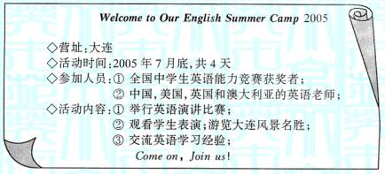 注意：1. 信心须包括以上提供的内容要点，可以适当增加细节，使内容连贯；2. 词数：100字左右；信的开头已经给出，不计入总词数；3. 参考词汇：全国中学生英语能力竞赛 NEPC；交流 vt. Exchange
Dear James,
Nice to hear from you again._______________________
Best wishes,
Yours truly,
Li Hua

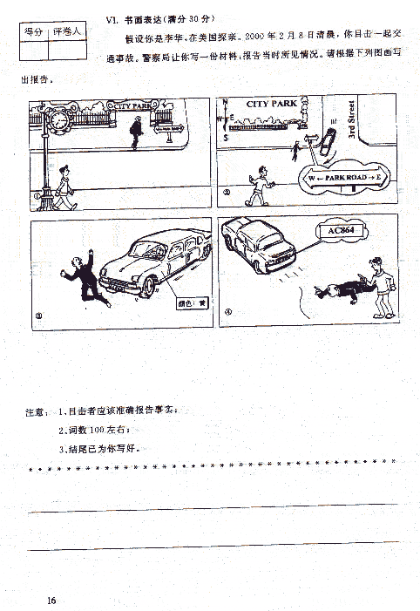
答题纸
姓名________ 考号___________分数________
（1-35题答案涂在答题卡上）36.________ 37.________ 38.________ 39.________40.________ 41.________ 42.________ 43.________44.________ 45.________ 46.________ 47.________ 48.________ 49.________ 50.________
Steven Spielberg,his mother was a music teacher,was born in 51.____
1946.When he was still a boy,he started making short films. 52.____
His dream was go to the Film Academy,but he couldn’t. 53.____
The reason why he couldn’t go to there was that his 54.____
grades were low.After studying English,he got a small work 55.____
at a film studio.Here he worked on a short film,it won him 56.____
a job as the youngest film director in the world.This is the 57.____
moment when Spielberg’s career really took off.Now,he is one 58.____
of the top director in the film industry and has many fans in 59.____
China.When asking about the secret of his success,he 60._____
said that he owes it to his wife and children.
书面表达

高一英语Unit 5基础知识检测答案
1-5：CBCAC 5-10；ABDAC 11-15；BBBCD 16.B 17.C 18.C 19.A 20.B 21.D 22.A 23.C 24.C 25.C 26.B 27.D 28.B 29.30.C 31.A 32.C 33.A 34.B 35.D
36. roles 37. prize 38. peace 39. happiness 40. degree41. actress 42. speed 43. award 44. accept 45. determined 46. career 47. action 48. commented 49. industry 50. law
短文改错答案
1.his---whose 2.正确 3.was go---was to go 4.go to there---go there5.work---job 6.it---which 7.is---was 8.reall---really 9.director---directors 10.asking---aske1．One possible version:
Dear James,
Nice to hear from you again. As you know, this summer vacation, at the end of July, 2005, we winners of NEPC will go to a four-day English Summer Camp in Dalian. Some English teachers from China, the USA, England and Australia will join us. In the camp, we will have some English speaking competition, watch some wonderful performances given by the students and visit some places of interest in Dalian. Besides, we will exchange our English learning experience and talk about our colorful school life in English. I think this summer camp will greatly improve my spoken English and I will make some new friends there. I do hope you will come and join us.
Best wishes,
Yours truly,
Li Hua
2000年高考满分作文
At 7：15 on the morning of Feb.8.2000，I was footing eastward along the Park Road. I was about to reach the T-crossing near the City Park when I noticed an old man coming out of the City Park and was trying to cross the street. Suddenly，a yellow car，which had come down the 3rd Street，turned sharply right at the corner. It was driving so fast that neither the driver nor the old man was able to react effectively. Regretfully，the woman driver did not stop to look after him but fled as quickly as possible. Badly injured as he was，the old man tried to take down the car's number. However I managed it, which was AC864.
划线部分是考生所犯的错误，但是最后还是拿到了满分。因为该考生所使用的很多好的句型极好的反应出其良好的语言功底。我们也可以有准备的去“展示”自己的语言水平。在进入考场之前，我么先演练好自己总结的十大精品句型，如：定语从句，强调句型，so…that, …so that…, too…to…, neither… nor…, either … or…, the more… the more…, not… until…, not only… but also…；同时准备好十大连接词，如：what’s more, furthermore, moreover, however, nevertheless, whereas, therefore, on the other hand, afterwards, in a word

