Is it a Bird? A Plane?

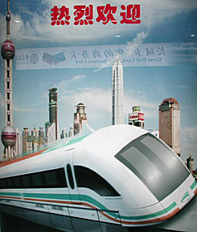
Nope, only Shanghai's flashy new Maglev, the world's fastest train. Way ahead of its time seven decades ago, the still-futuristic magnetic levitation system may yet redefine travel everywhere.
LIKE MANY ON THE MAINLAND, I was on the move over the Chinese New Year. My flight lifted off early on the last morning of the Year of the Horse, touching down at the airport eight minutes later. Yet it never left the ground.
My flight - that's what it was called - was aboard Shanghai's spanking-new Maglev (magnetic levitation) train, the world's fastest, most futuristic passenger line.
Longest-awaited, too, since it's been an astonishing seven decades since the invention of the process that was finally put to a test on the next-to-the-last day of last year, when Premier Zhu Rongji took an inaugural ride with Chancellor Gerhard Schroeder of Germany, which helped fund and build this line. Now, common cadres were having a turn.
Local media called them "joyrides," these series of trial runs to the international airport in Pudong, across the river from Shanghai proper, that add a bit of flash to the Spring Festival. They certainly live up to the billing.
Smiles abound inside the sleek train as, with a breathtaking whoosh, it rockets to 300 kilometers per hour in two minutes flat. Overhead, like a giant scoreboard, an LED blinks out our record-breaking progress till we top 430 kph.
Indeed, the Maglev is faster than any speeding locomotive precisely because it's as much like a plane as any railroad we've known.
True, the train has no wings, but no wheels or engine, either. Transrapid, the German firm that developed the system, describes the Maglev as "the first fundamental innovation in the field of railway technology since the invention of the railway."
Magnets are the attraction. First, powerful magnets lift the entire train about 10 millimeters above the special track, called a guideway, since it mainly directs the passage of the train. Other magnets provide propulsion, and braking, and the speeds - up to 500 kph in test runs; a good 60 percent faster than the renowned Bullet Trains - are attained largely due to the reduction of friction.

