Unit 2 Fit for life
Part One Welcome to this unit
- Teaching aims:
- to talk about doctors,medicaine and healthy problems.
- to talk about different medicines and medical treatments people use in China and the West.
- Procedures
Step I.Lead in and present the new teaching material.
Ask students the following questions:
1.Are you healthy?What kind of diseas do you and your family often suffer from?
2.When you are sick or ill,do you go to see a doctor?
3.If you wouldn’t see a doctor when you are sick or ill,what will you deal with your sickness or diseases?
4.If you would like to see a doctor,do you prefer to see doctors in western medicine or in traditional Chinese medicine?Why?
Step II.Ask students to look at the four pictures and read the sentences below each picture.
(Omitted)
Step III. Discuss the following questions in groups.
1 Have you ever seen a doctor? If so, what happened?
2 Have you ever received medical treatments? What did it feel like?
3 Would you like to do any of the jobs shown in the pictures? Why or why not?
Check the students’ answers to the questions.
Part Two Reading
- Teaching aims:
1.To learn some new words,important phrases in this text.
2.To read the text “Two life-saving medicines” and understand its contents.
3.To learn about the inventions and medical effects of two important medicines(Aspirin and Penicillin).
▲ Procedures
Step I.Learn some new words and phrases about Reading.
四会词汇：historian,recipe,physician,bark,acid,chemist,DR,trial,tabler,milligram, standardize, best-selling,painkiller,author,thin(v.),block,length,contemporary,Scottish,not,transparent,application,name,unable,chemical,purify,quantity,mass,widespread,lung,rapid-ly,powerful,wonder,relief,potential,fundamental.
认读词汇：probability,aspirin,penicillin,salicylic acid,acetysalicylic acid,stroke,vessel, blood vessel,colon,mould,jelly,bacterial,pneumonia,physiology.
词组或短语: open up,heart attack,in large quantities ,mass production,millions of,be made from.
Step II.Listen to the tape and read it fast.
After listening and fast reading,answer the following questions .
1.What are the two medicines mentioned in the article?
2. When was one of the medicines first sold as a tablet?
3. What did Fleming, Florey and Chain share?
Step III. Reading comprehending
Read the whole text carefully again for more details.
A.How well did you understand the details of the magazine article? Answer the following questions. Read the article again if you do not know any of the answers.
1.When did people find that drinking a special tea could reduce fever and pain?
2.When was ASA first made from other chemicals?
3.What other things can ASA help with besides reducing fever and pain?
4.Where did Alexander Fleming find penicillin?
5.What illnesses can penicillin be used to treat?
6. Why were Fleming, Florey and Chain given the Nobel Prize in Physiology or Medicine in 1945?
Ask some students to answer these questions and correct their answers.
B.The timetable below shows the development of aspirin and penicilin.Finish filling it with the information you’ve got from the text.
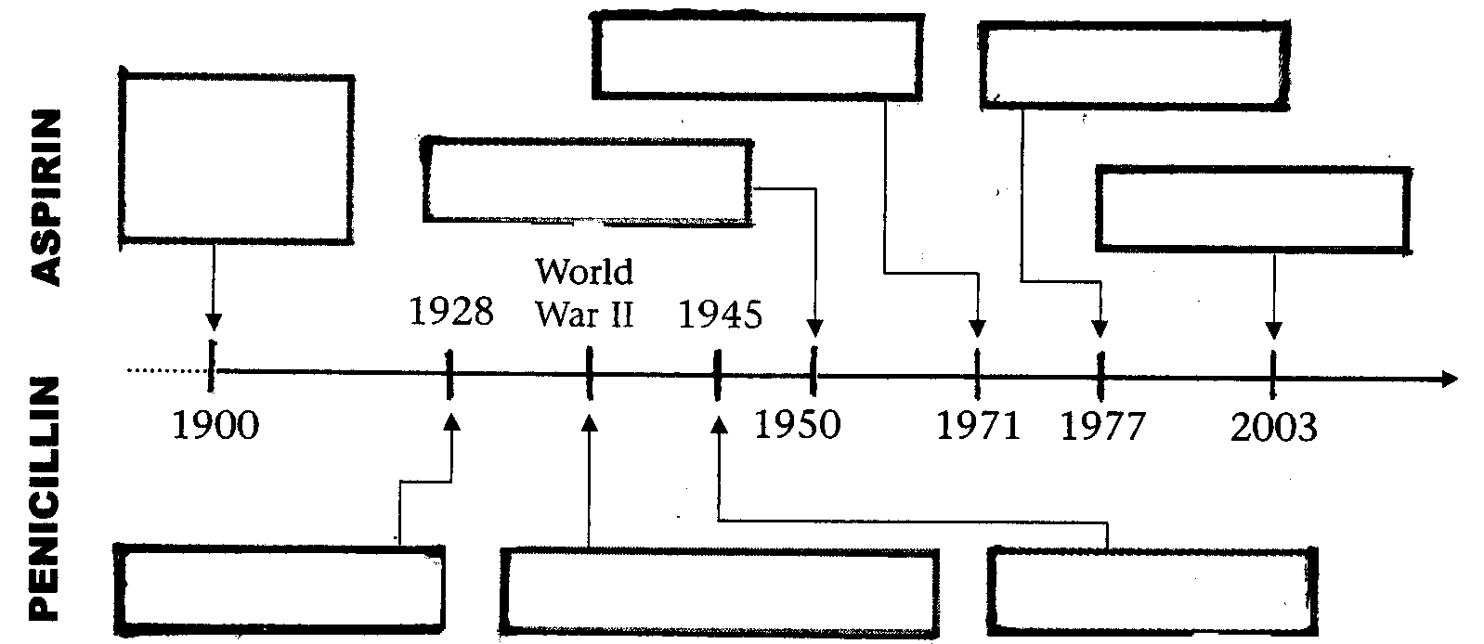
Check the students’ answers.
StepIV Language points.
1.Important words in this text
historian,recipe,physician,bark,acid,chemist,DR,trial,tabler,milligram, standardize, best-selling, painkiller, author, thin(v.),block, length, contemporary, Scottish, not, transparent, application, name, unable, chemical, purify, quantity, mass, widespread, lung, rapidly, powerful, wonder, relief, potential, fundamental.
2.Useful phrases in the text
(1)open up “把……打开”，“（使……）开张/开始营业”。
Mr Johnson’s supermarket opened up last month.
When you open up the window of the apartment,you will the whole view of the town.
当你打开公寓的窗户时，整个街镇的风景尽收眼底。
(2)in large quantities 大规模地，大批量地
After the trial several times, the new material began to produce in large quantities.
(3)manage to do sth 设法做成某时(强调结果已完成)
Poor as the family, they managed to sent the girl to the university.
(4)millions of+可数名词复数形式 表示“数百万的，亿万……”
Every year, millions of people travel to Hawaii from all over the world.
(5)be made from/of “由……制造而成”(强调看不出原材料的通常用from)
Can you tell me this sugar is made from sugar cane or sweet potatoes?
3.Key sentences in this text
(1)Not only has aspirin saved many people’s lives by reducing fever and helping stop pain, but there are also other things that aspirin can help with.(Page 18)
阿司匹林不仅通过退烧和减轻疼痛来挽救许多人的生命，而且它还有许多其他的用途。
句子中由于否定连词not only被提到句首而用部分倒装语序。又如：
Not only can my sister drive cars, but also can play computer well.
我妹妹不仅能开车而且电脑也打得很棒。
(2)However, it was not until World War II that two other scientists, Howard Florey (Australia) and Ernst Chain(German-born English),managed to use new chemical techniques to purify it.(Page 19)
然而，直到第二次世界大战，才由另外两位科学家Howard Florey和Ernst Chain成功地利用某种化学新工艺将青霉素提纯。
本句子是一个强调句型，原来的句子为Two other scientists, Howard Florey (Australia) and Ernst Chain(German-born English),didn’t manage to use new chemical techniques to purify it until World War II.这里强调的是时间状语until World War II.当用it is…that…来强调not…until…结构时，需要把否定副词not与until引导的状语或状语从句一起提前，构成“it is not until…that +原句”。又如：
Jack didn’t realize how important his father’s advice was until he met the trouble.→
It was not until he met the trouble that Jack realized how important his father’s advice was.
知道他遇到麻烦，杰克才意识到他父亲的忠告是多么重要。
(3)If penicilin had not been available, many people would have died from bacterial illnesses or even minor wounds.(Page 19)
要是没有利用青霉素的话，许多人就死于病毒性疾病甚至是轻微的伤口感染。
本句话是一个虚拟语气，说明与过去客观事实相反的情况。又如：
If the doctor hadn’t saved him on time, he would/could have died of the snake’s poison.
要是医生不给予及时治疗的话，他可能就被毒蛇咬死了。
(4)So, although Fleming discovered penicilin, it was over a decade before someone else turned penicilin into the great drug of the 20th century.(Page 19)
因此，尽管Fleming发现了青霉素，直到十年后才由其他人把它制成二十世纪伟大的药物。
句子中用“it is+一段时间+before+从句”，表示“过了……之后才……”。又如：
They arrived at the bus stop at 3:30,but it was almost an hour before the first bus appeared.
他们在三点半来到车站，但是又过了一小时第一辆公交车才出现。
The earthquake took place in August.It was not long before the citizens in the city rebuilt their homes.
那次地震是在八月发生的，不久这个城市的市民就重建了家园。
Step V. Language practice
1.Match the words and expressions on the left with their meanings on the right.(D)
1.physician (line 9) ____________ a.modern, of present time
2.bark (line 10) ____________ b.happening in a lot of places
3.painkiller (line 19) ____________ c.a medical doctor who does not perform operations
4.thinning (line 24) ____________ d. amounts of something
5.contemporary (line 37) ____________ e. the skin of a tree
6.transparent (line 39) ____________ f.to make pure
7.purify (line 48) ____________ g.a type of medicine used to reduce pain
8.quantities (line 49) ____________ h.clear and able to be seen through
9 .widespread (line 50) _____________ i.making a liquid less thick
Ask some students to present their answers
2.Fll in the following passage with the given words or numbers (E) (The passage is omitted)
(Omitted)
Step VI.Discuss the following questions with the language knowledge and information in the text.
Useful expressions about expressing or asking for one’s opinions.
It is amazing that… I (don’t) think/believe that…
I’m (not) sure that… I (don’t)agree with you
Do you know of/about…? Do you know that…?
What do you think of….? How do you like…?
In my opinion,… How/what about…?
Discuss the following questions in pairs.
1.What do you think the world would be like if there were no medicines?
2.What harm,if any,do medicines do to people?
3.Do you believe that “wonder drugs” will be invented to treat diseases like AIDS in the future?
Check the students’ answers.
Part Three Word power
- Teaching aims:
1.To review and enlarge students’ vocabulary about diseases and medicines.
2.To talk about the importance of medicines and about keeping healthy.
3.To improve students’ abilities of oral expressions.
▲ Procedures
Step I.Read the passage in Part A and write down common diseases.
Common diseases:
Childhood diseases:measles and chickenpox.
All age disease :Influenza/flu
Elderly diseases:cancer,diabetes and heart disease,heart attacks,strokes.
Diseases spread by insects:malaria,colera,yellow fever and typhoid.
Step II. Look at the pictures below in PartB and read the sentences or phrases.Match the pictures with the different ways we use medicines.
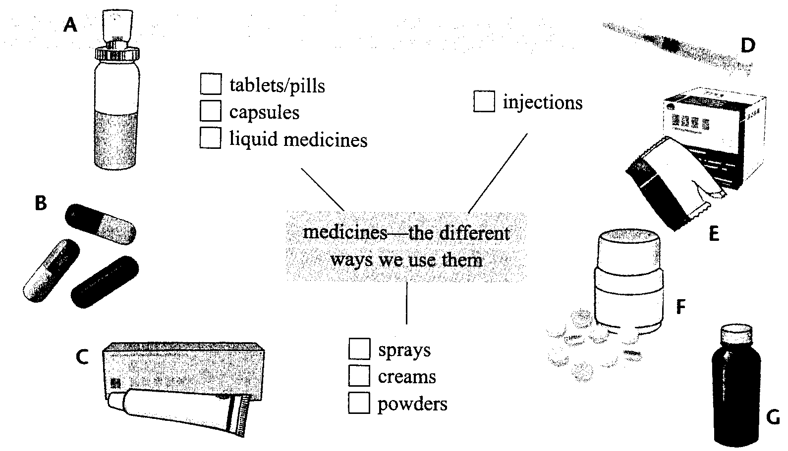
Check the students’ accomplishments.
Step III.Fill in the blank with information you’ve got from Parts A&B.
Noteg for project
Diseases
1.Childhood diseases include ________ and __________.
2.________ can be caught at any time in your life.
3.________ occurs when the replacement of cells goes wrong.
4.________ develops when there is too much sugar or too little sugar in the blood.
5.If you are overweight and eat the wrong foods or do not take enough exercise, then you could develop ________. This can result in a ________ or a ________.
6.When you travel, you can get diseases such as ________, _________, _________ or _________.
7.There are many ways in which medicines can be used on the body.
They can be taken by mouth ( ________ / ________ / ________ / ________, ________ ), through the skin with a needle by ________ or put on the skin using a ________ or ________.
Check the students’ accomplishments.
Step IV. Discuss the following questions about in groups.
Match the places found in a hospital below with their purposes. Write the correct letters in the blanks.
Place Purpose
1.ward a.where patients sleep
2.emergency room b.where operations are carried out
3.X-ray room c.where patients see the doctor
4.operating theatre d.where patients who need urgent treatment go
5.consulting room e.where patients register or find out information
6.reception f.where pictures of body parts are taken
7.ICU g.where doctors look after some part of a patient's head
8.ear,nose and throat (ENT) department h.intensive care unit
Check the students’ accomplishments.
StepV.Discuss the following questions in groups.
1.What kinds of diseases do all-aged people usually suffer from?
2.What kinds of diseases do children and old people easily suffer from?
3.What kinds of diseases can be spread by people?
4.What kinds of diseases can be spread by insects or other animals?
5.Do you prefer to take medicines or have injections when you are ill?
6.Which do you prefer,Traditional Chinese Medicine or Western Medicine?
Ask some students to answer these questions.
Part Four Grammar and usage
- Teaching aims:
1. To learn formations and usage of English phrasal verbs.
2. To learn some phrasal verbs and their usage.
3.To improve students’ skill of oral and written expression.
▲ Procedures
Stop I.Learn new words and phrases about Grammar.
词汇：split,enquiry,ward,handful,annual,arran-gement,receptionist, detail ,pleasure.
词组或短语：put through,decide on,look around,put off,turn up,fill in,split up,a handful of,take down.
Step II.Review learn the usage of phrasal verbs we have learned before.
Write down phrasal verbs beginning with the following verbs as many as possible.
bring:bring in,bring up,bring back,bring out
break:break away from,break down,break into,break out,break up,break in
call:call in,call on,call at,call out,call up,call back,call for
come:come on,come along,come in,come about,come across,come into,come across,come out,come back,come down, come up with
get:get in,get away (from),get back,get up,get into,get down,get out of,get off,get on,get through,get rid of,get hold of,get in touch with
keep:keep away (from),keep on,keep up with,keep off ,keep in touch with
look:look at,look down,look back,look around,look about,look into,look through,look over,look up to,look down on/upon,look out (of),look out (for)
make:make up,make out,make use of,make up for
run:run away,run into,run out of,run away from,run after
take:take away,take into,take in,take out,take over,take,on,take off,take down,take hold of
turn:turn on,turn off,turn up,turn down,turn out,turn in,turn into,turn over
Check the students’ answers.
Step III.Learn formations of English prepositions:
According to the lists of phrasal verbs above,let’s analyse the formations of phrasal verbs.
1.动词+副词 大部分短语动词都以这种形式构成。例如：put through,decide on,look around,put off,turn up, split up等。
2.动词+介词 许多短语动词以这种形式构成。例如：fill in,come into,run after,talk about,look for,pass through,agree with,care for等。
3.动词+副词+介词 例如：look out of,break away from,make up for,get along with,come up with,look down upon等。
4.动词+名词+介词 例如：pay attention to,make use of,take care of,put an end to,keep in touch (with),make friends with等。
Ask students to give other examples according to each type.
Step IV. Introduce and learn usage of English phrasal verbs in practice:
We’ve learned formations of English phrasal verbs,do you know how we can use phrasal verbs? Judge the following sentences right or wrong.Correct the mistakes if they are wrong.
1.The earthquake was broken out when most people were sleeping that night.
2.The girl turned off the light before she left the classroom.
3.The student found a new word and he began to look up it in the dictionary.
4.Jim is ill,so you can look him after at home today.
5.How are you getting along with your study at school?
Key to the exercise above:
1.was broken out→broke out break out表示“爆发，突然发生”是一个不及物的短语动词，因此不用被动语态。
2.正确。turn off是一个及物性质的短语动词，名词作其宾语，可以放在动词与副词之间，也可以放在副词之后。
3. look up it→look it up 当人称代词作动副词短语的宾语时，则必须放在动词和副词之间。
4.look him after→look after him 由动词和介词构成的短语动词，不管它的宾语是名词还是人称代词都放在介词后。
5.正确。
根据上面的练习，分析短语动词的用法：
一.由“动词+副词”构成的短语动词用法：
这种形式的短语动词中一部分属于及物动词性质，需要带宾语如turn on,give up,take up,put off等，也可以用被动语态形式；而另一部分却属于不及物性质，通常只用主动语态如come back,get away,look out,break out等。
1.We will put off the sports meeting because it is raining.→
=The sports meeting will be put off because it is raining.
二.属于及物性的“动词+副词”短语动词，当其宾语是名词时既可以放在动词与副词之间，也可以放在副词之后；但是如果宾语是人称代词(it,them,her,him等)时则必须把宾语放在动词和副词之间。例如：
1. 尽管这次机会很好，但她还是决定放弃这次机会。
正确：She decided to give up the chance though it is good.
正确：She decided to give the chance up though it is good.
2.那些书已经破旧了，你可以他它们扔掉。
错误：The books are broken and you can throw away them.
正确：The books are broken and you can throw them away.
三. 由“动词+介词”、“动词+副词+介词”、“动词+名词+介词”构成的短语动词用法：这三类短语动词由于此为都含有介词，因此它们都为及物性质短语需要带宾语，而且无论是名词还是代词作其宾语都要置于介词后。例如：
1.Though he has not enough money, he cares very little for it.
尽管他没有足够的钱但是他也很少考虑它。
2.At the conference ,the man came up with a good idea about the activity.
在那次会议上，那个人提出一个有关活动的好主意。
3.Natural resources are very limited,so we must make good use of them.
自然资源非常有限，因此我们必须充分利用这些资源。
四.大多数及物性质的短语动词都可以转换成被动语态形式，但有些及物性质的短语动词(主要是由某些不及物动词如come,go,get,run等构成的短语动词)则没有被动语态形式。
1.The whites shouldn’t look down upon the blacks.→
The blacks shouldn’t be looked down upon by the whites.
2.The slave tried to run away from the slave-owner’s farm. →
[错误] The slave-owner’s farm tried to be run away from by the slave.
由“动词+名词+介词”构成的短语动词转换成被动语态有两种形式。例如：
You should pay much attention to your speaking.→
a.Your speaking should be paid much attention to.
b.Much attention should be paid to your speaking.
Step V.Practice.
1.Classify the following phrasal verbs according to “verb+adv.”, “verb+prep.”, “verb+adv.+prep.”, “verb+noun+prep.”
Bring out, call back,call for,come up with, get out of,get off,get on, have a look at,keep up with, look about,look into,get hold of,look through,look over,look up to,look down on/upon, keep in touch with ,look out (of),look out (for),keep track of,keep off , make use of, turn into, take away,take into,take in, run into,run out of,pay attention to.
“verb+adv.”:
“verb+prep.”:
“verb+adv.+prep.”:
“verb+noun+prep.”:
Key to the exewrcise above:
“verb+adv.”:bring out,look about,look around,look over,look up,look out,keep off,call back,get off,get on,take away,take in.
“verb+prep.”:look about,look into,look through,turn into,call for,take into,run into.
“verb+adv.+prep.”:come up with,keep up with,look down upon/on,get out of,look out of,look out for,get out of,run out of.
“verb+noun+prep.”: have a look at,get hold of,keep track of,keep in touch with,make use of,pay attention to.
2.Translate the following sentences into English with phrasal verbs given in brackets:
(1)我想记下你的电话号码，请说慢一些。(take down)
(2)你能把我的电话接到格林先生的办公室吗？(put through)
(3)公司已经就那项计划作出决定。(decide on)
(4)那名妇女在院子里四下张望一番，发现里面一个人都没有。(look around)
(5)无论发生什么事，我们都不会推迟会议。(put off)
(6)到火车离开车站的时候，他都没有出现。(turn up)
Key to the exercise above:
1.I’d like to take down your telephone number,please speak a little slower.
2.Could you put me through Mr Green’s office?
3.The company has already decided on the project.
4.The woman looked around in the yard,but found nobody.
5.Whatever/No matter what happens,we will never put off the conference.
6.He didn’t turn up even when the train was leaving the station.
Part Five Task
- Teaching aims:
1. To learn new words and useful expressions
2. To learn how to listen tocurrent situations
3. To listen to the tapes about talking about current situations.
4.To learn how to make an interview with a doctor.
5.To learn how to write a radio script
6.To improve students’ abilities of listening reading,speaking,and writing through Task.
▲ Procedures
Step I. Learn some new words and useful phrases about Task.
词汇：secondary,secondary school,eyesight,cm/centimetre,book stand,halfway,booklet,adjustable.
StepⅡ.Skills building1 Listening skills
Discover useful structures for expressing something important or unimportant while listening.
When we listen to news programmes on the radio or TV,the news about current situations usually becomes what we focus on.Then how can we get the important information about current situations?
If you are listening to a TV report about a current situation, you will need to listen for the following:
1.the current situation (This may be a problem.)
2.an explanation of the situation (This may include facts and figures to support the explanation, and probably a definition of the topic.)
3.reasons why the situation exists
4.how the situation can be recognized and the problems solved
You will also hear key words associated with the topic. You need to think about the reasons that you need to understand the situation and how you will use the information. Will you need to change the information or will you use it as it is?
Finally, you need to think about how you will record the information that you will hear.
Step III.Listening practice.
Listen to the tapes about talking about current situations in PartsA (Page26).
Take notes of important imformation while listening to the tape.
After listening to the tape and taking notes,fill the following forms with important imformation you’ve got.(Part A)
Suppose that you are a reporter for your school radio station. You have decided to report on the current problem of short-sightedness, which is common among Chinese teenagers today.
Listen to a TV programme on the problem and take notes on the information given.
Problems increasing number of Chinese students with(1)________________.
Facts (2)_________________________number of eye doctors in the streets
Figures rate: primary-(3)_______%; junior high-(4)_______%; senior high-(5)_______%
increase over 2 years (Taiyuan,.Shanxi):
primary-(6)______%;→(7)_________%;
junior high-(8)_______%;→(9)_________%.
Definition caused when eye is unable to focus on(10)________objects; resulting in an unclear (11)_________.
Reasons students do a lot of(12)_________;read in(13)___________;do not read in well-lit (14)____________.
Solutions studente need more(15)_________; understand how eyes can be (16)__________.
Check the students’ notes.
Step IV.Reading and listening skills
Read an article on the school website about what No. 1 Secondary School has been doing to help protect students' eyesight. Read the following article, and then fill in the table below with the measures this school is taking. Write the correct letters in the column on the left.(Part B)
a.adjusting computer monitors and
b.providing book stands
c.changing type of paper
d.publishing a booklet to help parents make changes in the home
e.adjusting lighting arrangements
f.introducing adjustable chairs
f.teaching students how to hold a book
g.getting student' eyes checked regularly by a doctor
h.asking students to look out of the window halfway through lessons or other activities
i.reminding students to do eye exercises both at school and at home
j.looking out for students with eyesight problems
No. 1 Secondary School | No. 9 Secondary School
Check the students’ accomplishments.
Step V. Listening skills
Now listen to a radio announcement about what No. 9 Secondary School has done to help protect students' eyesight. Using the information from the announcement, complete
table above. Write the correct letters in the column on the right.(Part C)
Check the students’ accomplishments.
Step VI. Skills building 2 Talking and speaking skills Making an interview.
Learn some tips for making an interview.
When you are conducting an interview, you need to structure and organize your interview and your questions in a certain way.
a.The first thing you need to do is to introduce yourself and to thank your guest for agreeing to be interviewed, e.g.,
Good morning/afternoon, my name is ... First, I'd like to thank you for agreeing to
this interview.
b.Then you need to say why you are doing the interview and what you want to find out, e.g.,
I am doing this interview to get/gather information for ... I would like to find out
information about...
c.After this, you can start to ask questions. The questions should be grouped so that you ask general questions first and then more detailed questions, e.g.,
What is the current situation regarding young people and short-sightedness? (general)
Could you tell me some specific things that children or parents can do to help protect children's eyesight? (specific)
Now practise making an interview with a doctor about what parents and students can do to protect students' eyesight. Find a partner to be the doctor and do the interview. When you finish the interview, you should change roles.
Useful sentence patterns and important advice to help you.
1.I would recommend that ... This is because...
2.If this is done, then ...
3.I suggest that parents and teachers look out for...
4.I agree that it is a problem but here are some ways in which we can help.
5.We strongly suggest that ...
6.At school, students should ...
7.At home, parents should make sure their children are/are not ...
8.Every year, students' eyes should be tested to identify any problems.
9.Students should not read in bed.
10.Check that children are not rubbing their eyes, squinting, frowning,sitting too close to the television or doing badly at school.
11.Students should tell parents about any problems they are having with seeing words on the blackboard.
12.Good lighting is needed at home.
Ask students to practise making the interview in pairs.
Step VI.Skills building Writing skills
Writing a radio script.
Learn some tips for writing a script.When writing a script,you need to include:
1.who you are
2.what the subject is
3.the opening
4.explanation of what the topic is(eg.short-sightedness)
5.background information,including the current situation
6.reference to other sources(doctor’s interview,what schools are doing about the problem etc.)
7.recommendations
8.closing(thank people for listening)
Writing a radio scrip for a programme on short-sightedness for the school radio station.Use the information in skills building 2 to help you.Before you send in the radio script,have a discussion with your partner on how to improve it.
Part Six Project
- Teaching aims:
1. To learn new words and phrases about Project.
2. To read the article Exploring Chinese acupuncture and understand it correctly.
3.To learn about the features and great effecct of Chinese Acupuncture in Traditional Chinese Medicine.
4.To discuss and list the advantages and disadvantages between Traditional Chinese Medicine and Western Medicine.
5.To write an oral report about Traditional Chinese Medicine.
▲ Procedures
Step I. Learn some new words and phrases about Project.
四会词汇: magic,needle,art,sharp-edged,swollen,arrowhead,sharp, sword,silver, stainless, steel, fine,point,insert,symptom,pulse,wrist,function,heartbeat,overeating,herbal,relieve,unclear,let out, stainless steel, energy channel.
认读词汇: acupuncture,pottery,acupuncturist,surgical, site,spinal cord .
Step II.Discuss the following questions about in groups.
1.Do you know about Chinese acupuncture?
2.Have you seen magic needles? If so,describe what they look like.
3.How do you know doctors use acupuncture to treat patients?
Step III. Listen to the tape and then read through the passage.Then answer the following questions.
1.What does this article talk about?
2.What’s the main idea of the Paragraphs 1&2?
3.What’s the main idea of Paragraphs 3&4?
4.What’s main idea of Paragraphs 5&6?
Check the sutdents’ answer.
Step IV. Discuss the following questions about the article.
1.How long has Chinese acupuncture been developed?
2.What have stainless needles/magic needles been developed from?
3.How many acupuncture points on human body at first? And how many points now?
4.How do acupuncturists check the patients’ case?
5.What influence does Chinese acupuncture have on western people today?
Ask some students to answer these questions and check their answers.
Step VI.Project
I.Discuss the following questions about Chinese medicine.
1.What are your thoughts on acupuncture?
2.What are the possible benefits or disadvantages of acupuncture over other treatments?
3.What aspects of acupuncture are discussed in the article?
4.What traditional Chinese medicine (perhaps one herb or treatment) do you want to focus on in your oral report?
5.What aspects do you need to find out about, e.g., history, past uses, current uses, acceptance in the West, etc.?
6.Where can you find information on the subject?
7.Who will write the draft of the oral report?
8.Who will present which parts of the report?
Ask some students to answer these questions and check their answers.
II.Combine the information with the previous discussion and write an oral report about Chinese medicine and give your own opinion.

